April 2012

’69 CLASS CORRESPONDENT

CAPT Bob Gravino
2 Summer Street
Ipswich, MA 01938
(978) 356-0825 (H)
E-mail: rcgravino@aol.com
Web: http://www.uscga69.org

MIKE BILLINGSLEY was in Ipswich in February attending a retreat, and spent an afternoon with KATHY and me. MIKE still lives in Hopkinton, Massachusetts and serves as the rector of two Episcopal parishes west of Boston. JUDY works for a small pharmaceutical company developing oncology drugs. He sent me some photos of BILLINGSLEY activities in 2011, the first from a Hurtigruten cruise in May to see the Norwegian Fiords. They sailed from Bergen to Kirkenes and back. High points included crossing the Arctic Circle with subsequent baptism with ice water by King Neptune and a midnight turning of the ship in the tiny Troll Fiord. Their cabin was right over the motor for the bow thrusters, which were used every time they came into port – about every two hours since this was a ship delivering supplies to the coastal villages. “JUDY got very little sleep due to the noise and vibration, but the old Coastie slept like a baby.” The BILLINGSLEYS had a number of family gatherings during the year, including a Maine Windjammer Cruise with daughter Tammy, her husband Rick and grandchildren Kaitlyn and Michael. They live in Georgia, so the waters of Penobscot Sound were mighty cold for their one and only swim call. MIKE did find just the right hat in Camden for an “Old Salt” photo. He also had a sabbatical which included a trip to France and a hike from the heart of Normandy to the Abby of Mont St. Michel, a walk of more than 50 miles. He saw the Tour de France roll by – 200 cyclists in 13 seconds, and walked the labyrinth at the cathedral in Chartres.

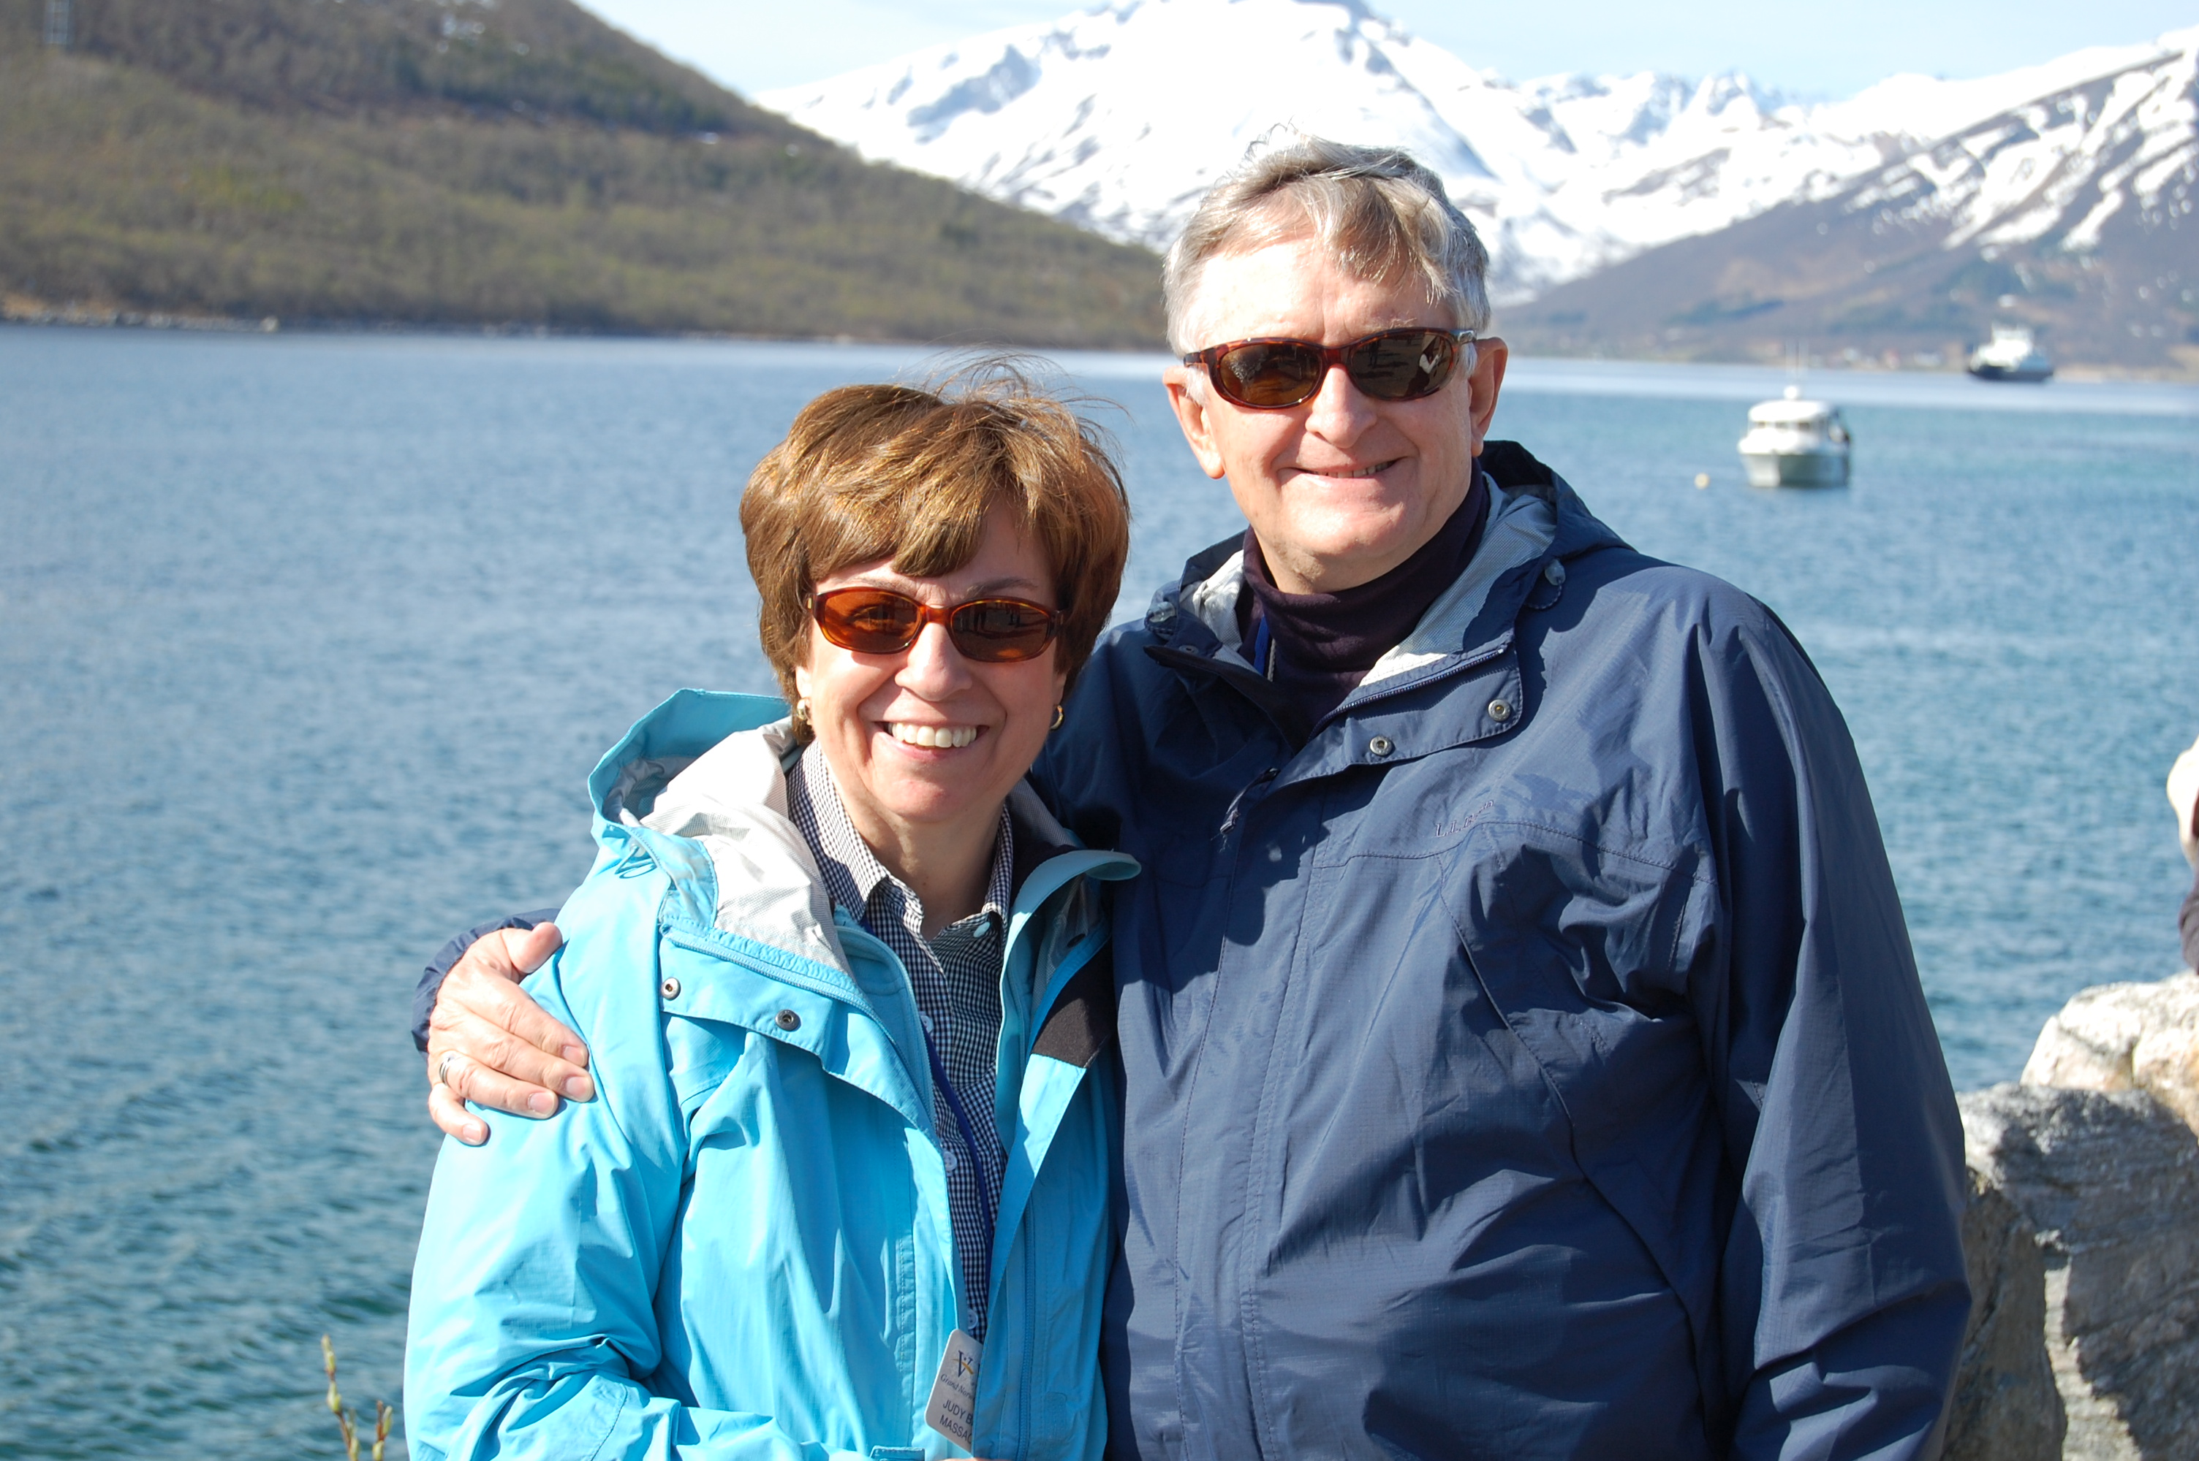

1969: MIKE & JUDY BILLINGSLEY on Norwegian Cruise

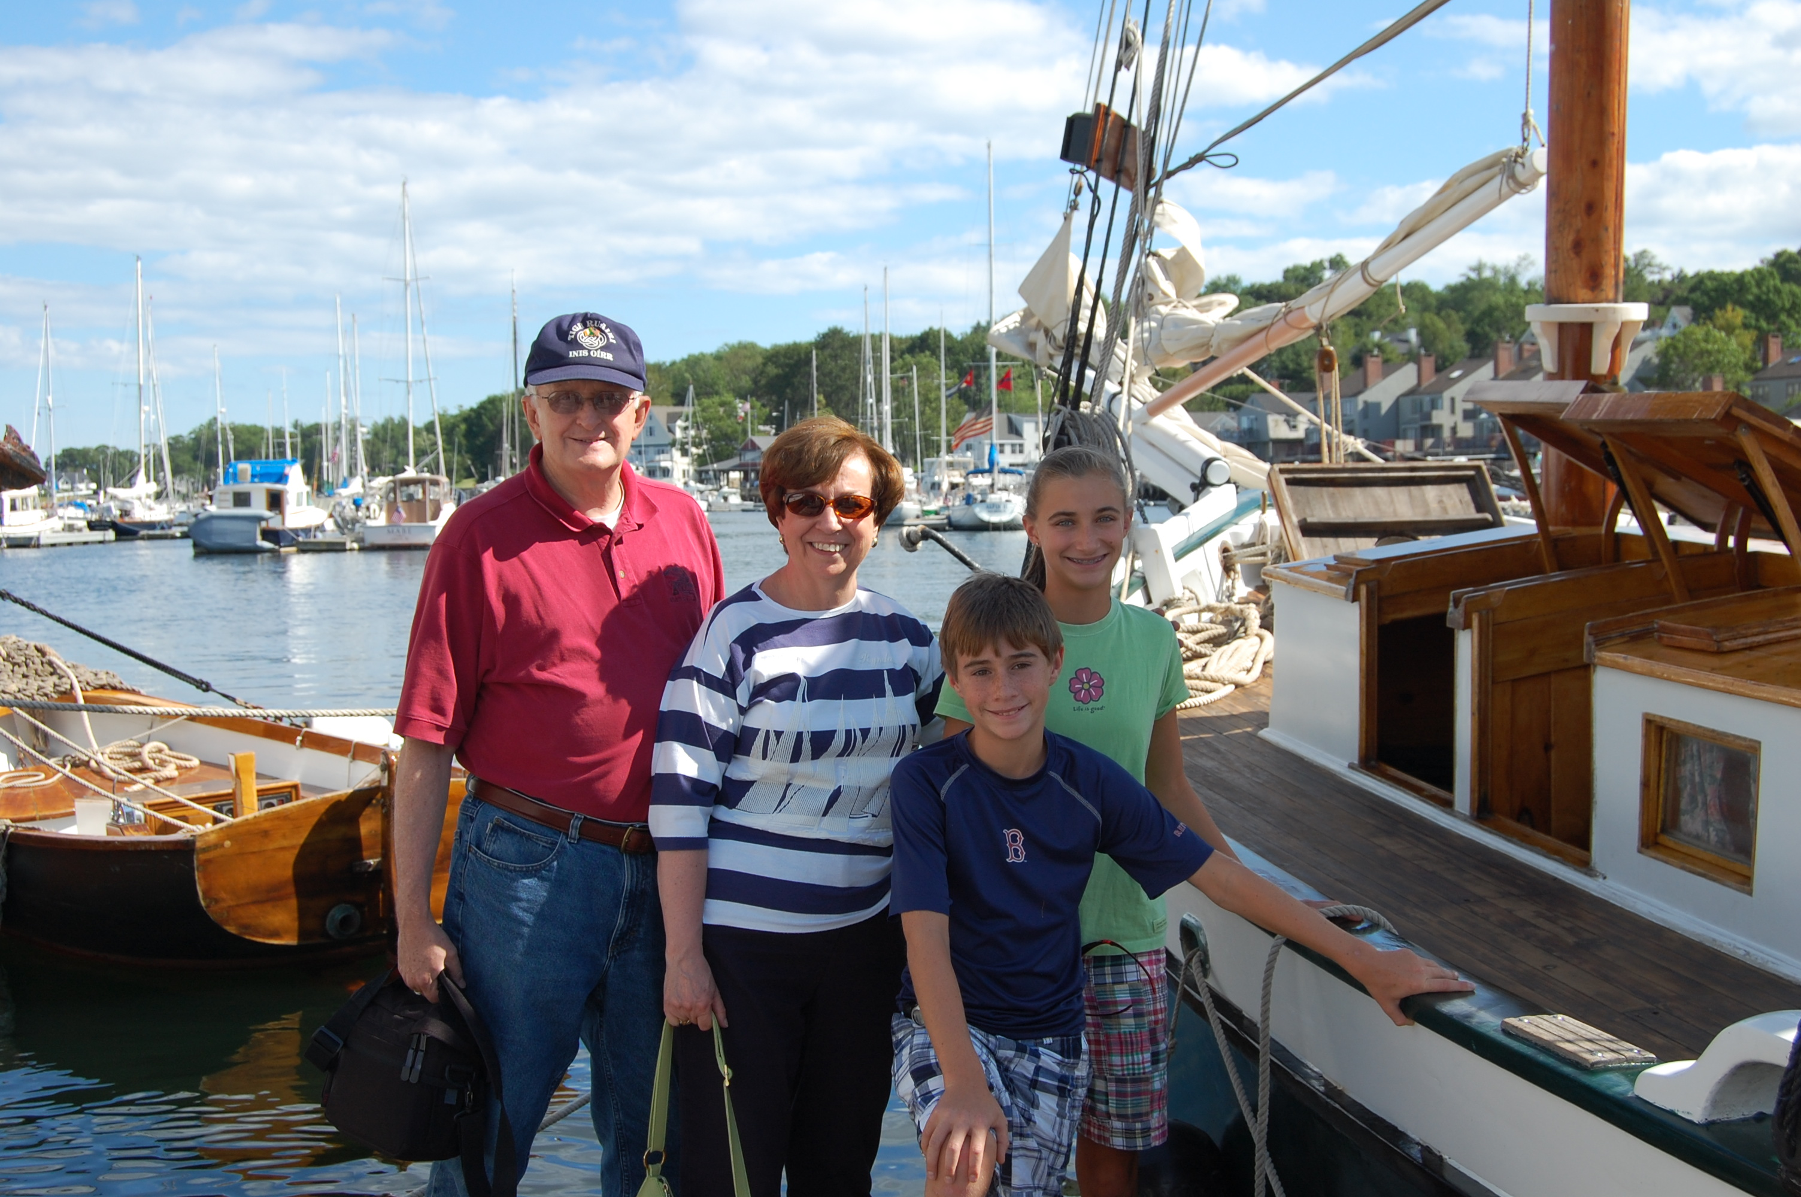

1969: The BILLINGSLEY Maine Windjammer Cruise

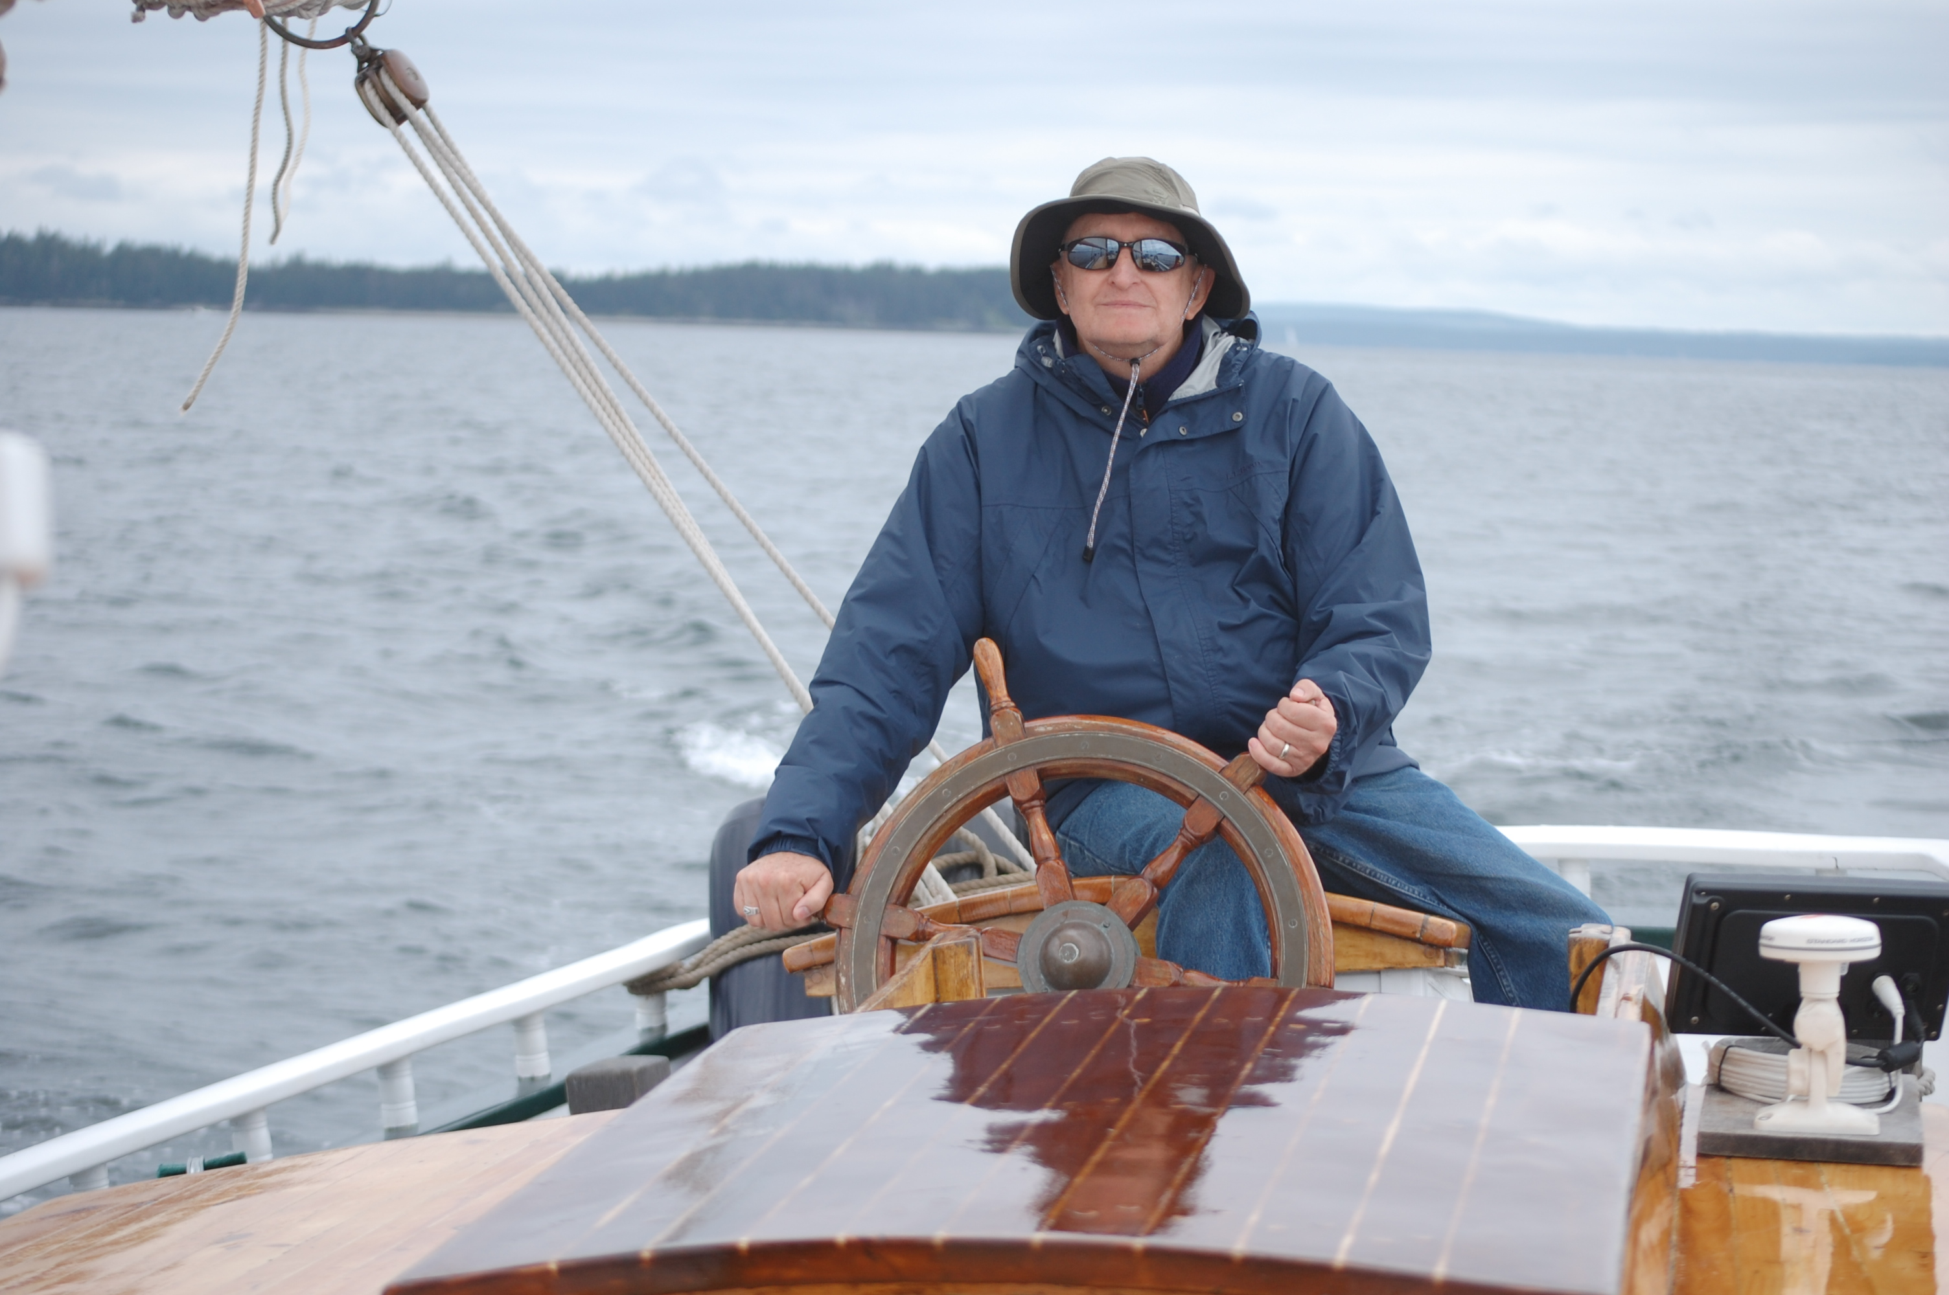

1969: CAPT BILLINGSLEY, the Old Salt.

FOREST HETLAND sent a note and photos on a recent trip he and PAT undertook. "Did you ever notice that as you get older, time seems to speed up? That’s the way it has been for PAT and me. At the end of January and into February, we spent two weeks in Chiang Mai, in northern Thailand, doing land clearing for a children’s home expansion. The hardest parts about the trip were the long flights and not really knowing what day it was. During our 11 hour layover in Seoul, South Korea, we were able to visit our nephew-in-law who works for a government contractor to the US military. Besides the land clearing we did take some time off from the work to go ride elephants and see some of the sights. If you are interested in where we were, please go to http://www.remembernhu.org/. On the return layover in Seoul, we toured the city and discovered that Seoul has at least as many coffee shops as Seattle. We left Chiang Mai at 89˚F and arrived in Seoul at 16˚F then to Seattle at 51˚F. The trip was truly amazing, culturally as well as emotionally.”

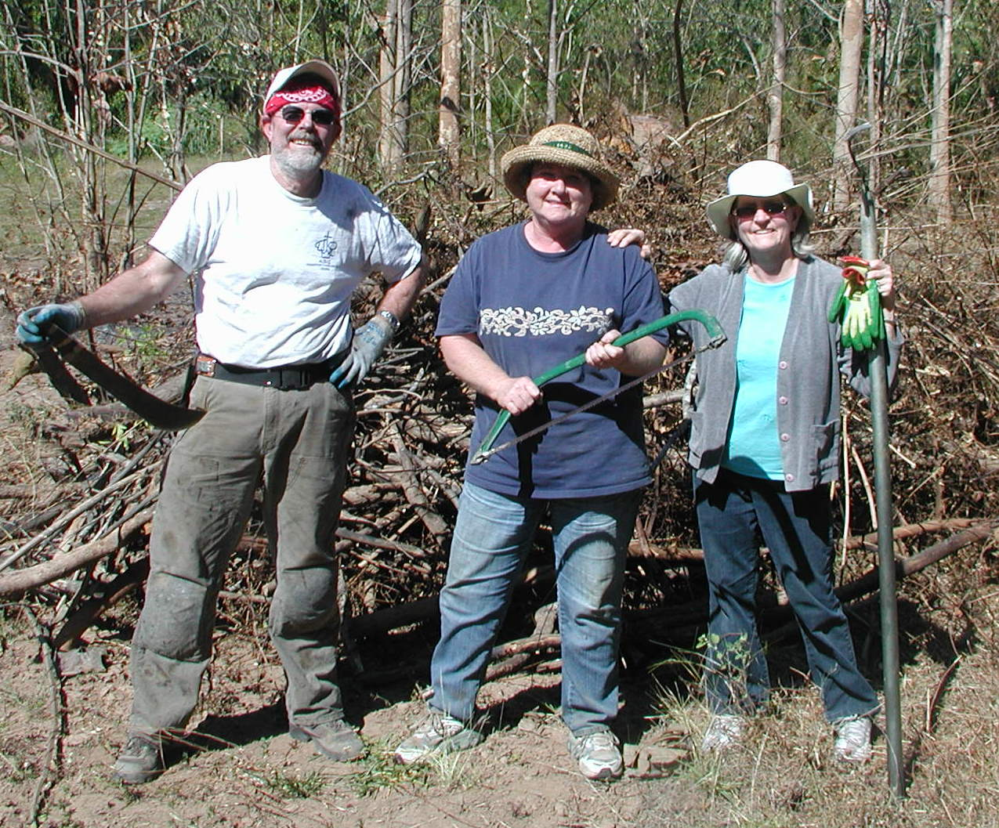

1969: FOREST & PAT HETLAND clearing land in Thailand



1969: The HETLANDS enjoying the sights from an elephant

JOHN MINER commented on the photo of JIM and CINDY BURK in the February 2012 edition of the Bulletin. “For those of you who may not remember, JIM BURK was the manager of the Academy soccer team. I see from the picture in the last Bulletin that he has another 11 “players” to manage. Kind of like herding cats, JIM? At least this time he was smart enough to get a pretty assistant (or maybe a supervisor?) by his side to assist.”
The following news on MIKE MIERZWA was printed in The Journal of Commerce on February 14, 2012. “The Port of Galveston named Captain MICHAEL J. MIERZWA as its new port director, effective February 16. MIERZWA, who has been deputy port director of the Port of Galveston for the last six years, succeeds Steve Cernak, who left the port to head the Port of Everglades in Florida. As deputy director of Port Galveston since 2005, MIERZWA managed port operations and facilities. For the five years before that he was the manager of the Texas Cruise Ship Terminal on Galveston Island. He has over 30 years executive-level marine transportation management, operations and logistics experience in both the public and private sectors. MIERZWA is a 29-year veteran of the U.S. Coast Guard, retiring with the rank of captain in 1998. His last assignment in the Coast Guard was as the chief of Staff for the 14th Coast Guard District in Honolulu, Hawaii. He was also the chief of operations for the Coast Guard in Alaska and commanding officer of two Coast Guard cutters.” Congratulations, MIKE!
BOB GLYNN sent a photo of his four year old grandson Liam. “The picture shows my attempt to drown-proof him.” I hear BOB has been talking to Liam about the Coast Guard’s Rescue Swimmer program. Compare BOB’S photo in the 1969 Tide Rips – see the family resemblance?


1969: BOB GLYNN'S grandson Liam training to be a CG Rescue Swimmer

BRUCE GRIFFITHS reported on a trip that took GAIL and him out of San Diego to the East Coast. “We just got back from a nice week in South Florida with JOHN and LESLIE MINER and JIM and CINDY BURK. JOHN arranged for us to stay at the Coast Guard recreational facility at Hillsboro Lighthouse. We dodged alligators at Everglades National Park, kayaked in the mangroves near Key Largo, and consumed adult beverages every evening. The weather was superb; in the 70’s and 80’s every day. A good time with good friends. I include a group photo; if you look closely there’s an alligator behind JOHN.” I’ve also included a GRIFFITHS’ Christmas family photo. He may not have the number of grandchildren that JIM BURK has, but it appears that BRUCE is giving him a run for the number of children and significant others.

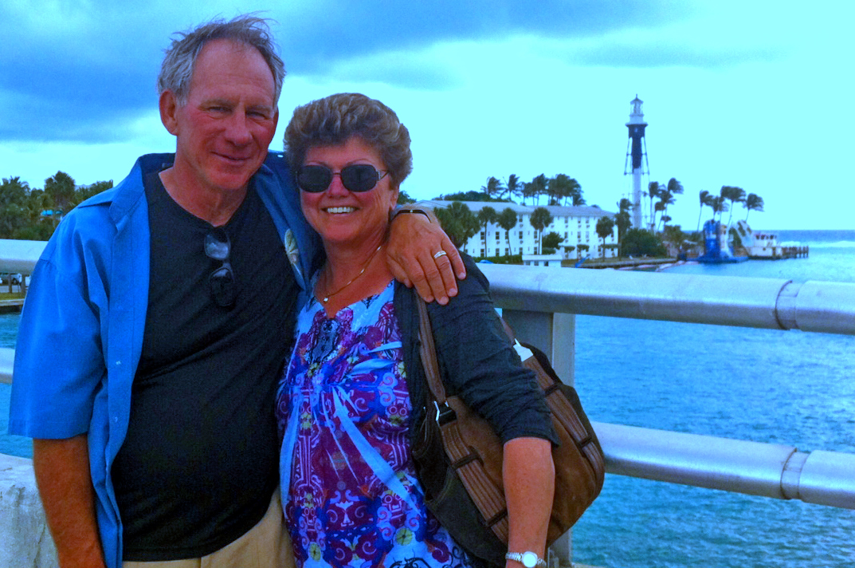
1969: BRUCE & GAIL GRIFFITHS at Hillsboro Lighthouse

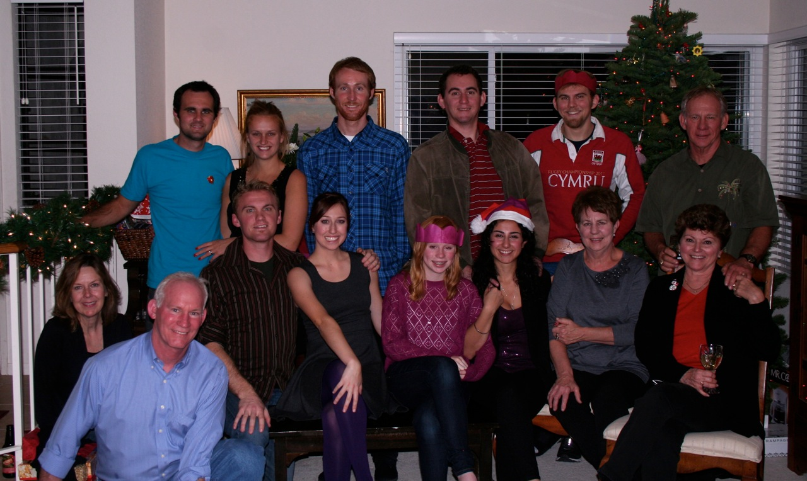
1969: GRIFFITHS Christmas Family Photo

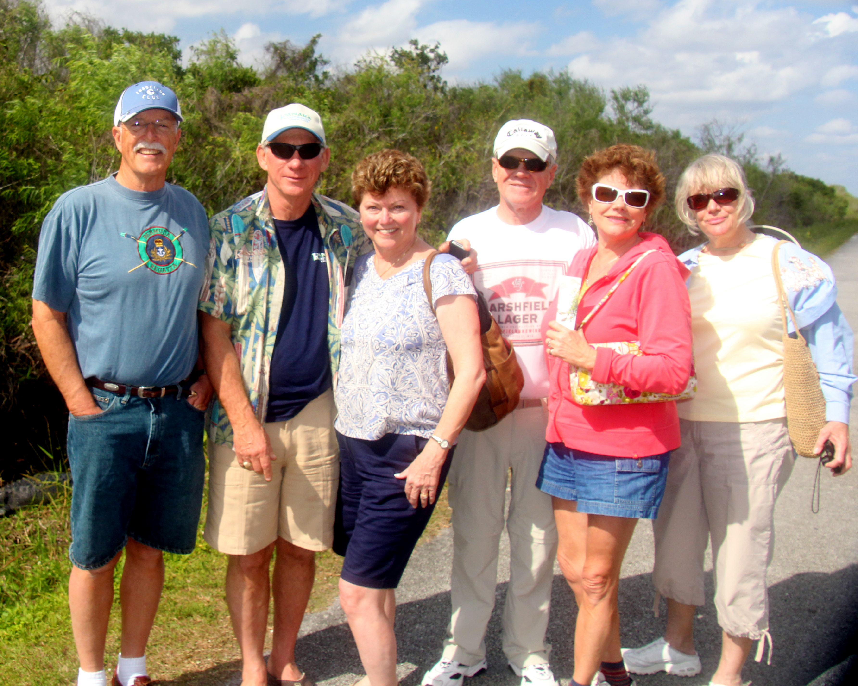
1969: GRIFFITHS, MINORS & BURKS in the Everglades

The following news on JIM HULL was published in The Maritime Executive on February 3, 2012. “Ridge Global, an international provider of security and risk management services, announced the launch of Flag Bridge TM, a new service focused on maritime risk and sovereignty management. The Flag Bridge team includes an elite cadre of former U.S. Coast Guard admirals and distinguished maritime professionals, including Admiral Tom Collins, 22nd Commandant of the Coast Guard; Vice Admiral JIM HULL, former Coast Guard Area Commander; and Rear Admiral Norm Saunders, former Coast Guard District Commander. Flag Bridge is organized to provide high-level strategic consulting services in both the public and private sectors. ‘It is an honor to bring a team of this caliber to market,’ said former Department of Homeland Security Secretary Tom Ridge, president and CEO of Ridge Global. ‘Our experts have distinguished themselves individually as leaders in the areas of maritime safety, security and environmental management, and we are fortunate to be able to offer their collective knowledge and experience to address challenges in the global maritime domain.’ ‘It is incredibly rewarding to be able to join forces with my former Coast Guard colleagues to contribute to global maritime prosperity,’ Admiral Collins added.” Congratulations, JIM!
A group of Broadway aficionados gathered at the Academy’s newly renovated Leamy Hall Auditorium on the evening of February 25 to attend the Cadet Music Department’s production of the musical comedy A Funny Thing Happened on the Way to the Forum. If you have never been to a cadet musical before, I highly recommend the experience. It is nothing like the skits that we produced as cadets in the hallowed corridors of Chase Hall. Those in our party included BOB & SUE POKRESS, KATHY & BOB GRAVINO, DOUG & JANET BROWN, Greg & Jane Ketchen (CGA ’70) and GARY & NANCY PAVLIK. The pit orchestra was composed of members of the U.S. Coast Guard Band, and the cast featured cadets, active duty and retired officers, Academy civilian faculty and Coast Guard family members. The Officers’ Club provided an excellent dinner before the play, and our group settled in for an evening of refreshments and good conversation at the Mystic Marriott Hotel and Spa following the event. It was a very enjoyable time, and nothing like anything that we ever experienced during our times at CGA!
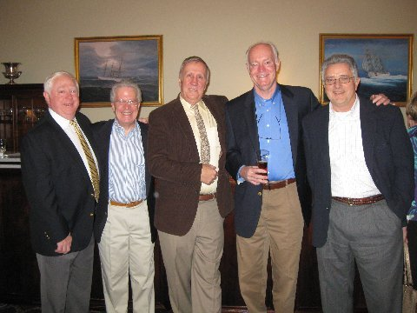
1969: A Funny Thing Happened on the Way to the Forum

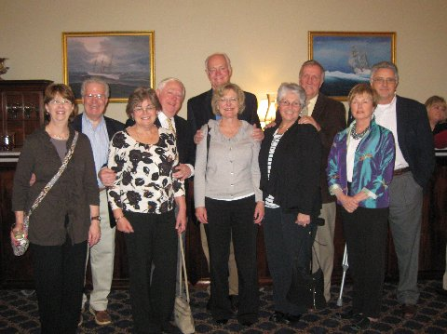
1969: POKRESSES, GRAVINOS, BROWNS, Ketchens & PAVLIKS at the Academy Officer Club.

DOUG BROWN retired in December 2011 as Professor of Marine Engineering at the U.S. Merchant Marine Academy, Kings Point, New York. One of his lasting legacies at USMMA is the Solar Energy Program that he started and which continues on as one of the premier programs of its kind. DOUG and JANET have two sons. David, a 2004 graduate of the U.S. Air Force Academy, recently left active duty and is employed as a cost analyst in defense contracting. Zach, a 2009 graduate of the U.S. Merchant Marine Academy and Coast Guard officer, transferred from the CGC Sherman in 2011 to Naval Flight training in Pensacola, and recently completed primary training. Zach is married and has a three month old son, Samuel Douglas Brown. DOUG’s immediate plans include catching up on projects around his Glen Cove, Long Island home and spending time at their summer cottage on Prudence Island, Rhode Island.

