April 2015
’69 CLASS CORRESPONDENT

CAPT Bob Gravino
2 Summer Street
Ipswich, MA 01938
(978) 356-0825 (H)
E-mail: rcgravino@aol.com
Website: http://www.uscga69.org

John Miner sent proof that classmates in the Virginia Tide Water area don’t let the weather get in the way of outdoor activities. “Woody Stoeger invited a group of avid golfers to join him at the Kings Mill River course in mid-January. The day before the temperatures had reached the 50's, but on that day they were in the low 40's with a wind chill that felt more like the 30's. The team of Stoeger, Grosse and Miner narrowly defeated the team of Huber, Vlaun, Shaw and Adamchak. A rematch is planned for warmer weather.” The photo John sent was in color, and his pants were a sight to behold. When asked to comment, John replied “they are the direct result of the recent Huber/Miner Scotland trip to the Old Course.”

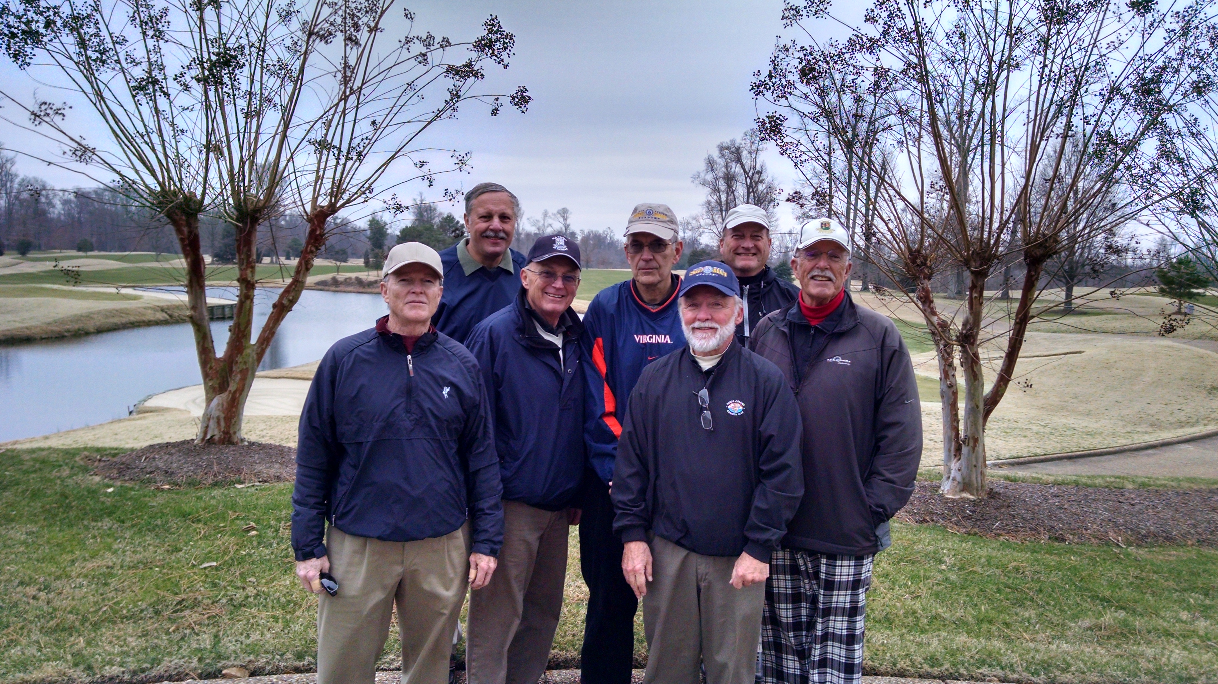

1969: Winter Golf in the Virginia Tidewater Area

Not to be outdone by classmates playing golf below the winter snowline, my grandson Finn Russell (age 10) will be joining me for this year's Rotary Polar Plunge to eradicate Polio on a Saturday morning in March in Gloucester. The Plunge into the Atlantic Ocean was scheduled for January 31st, postponed to February 7th, and again postponed to March due to the severe snowstorms and accompanying winds that hit New England beginning in late January. If the weather in New England keeps up this trend, I may rent Jim Smith’s garage in Key West next winter.

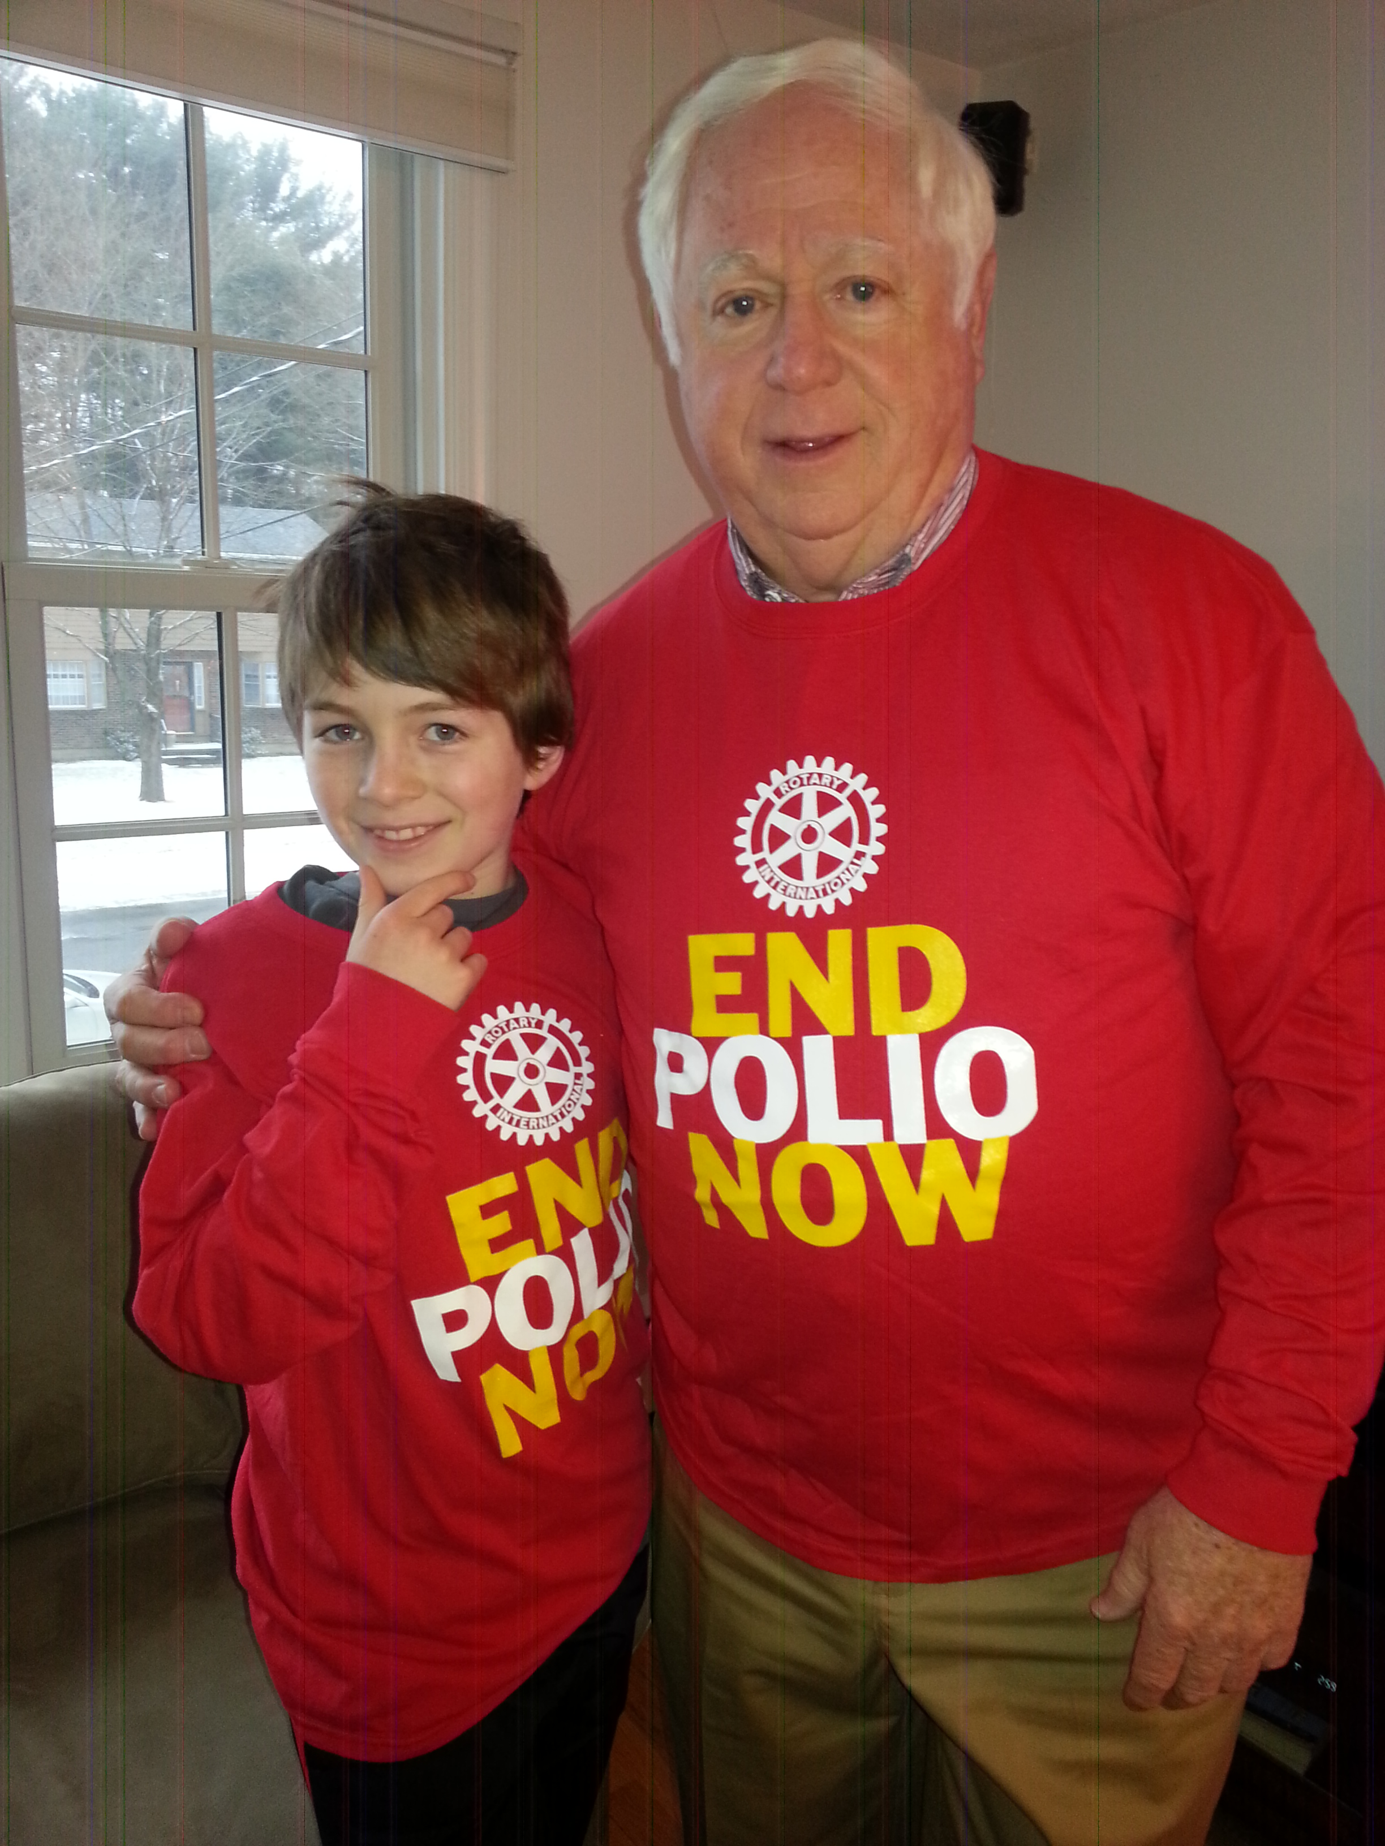

1969: Bob Gravino and grandson Finn warming up for the Boston Rotary Polar Plunge for Polio

Rich and Pat Losea moved down the street in Chesapeake, Virginia to a gated over 55 community on a golf course. Their new address is 542 Strathmore Lane, Chesapeake, VA 23322, and new email is rlosea@verizon.net. Rich is recovering from his second knee replacement. He took advantage of a Northrop Grumman RIF at the Joint Staff Suffolk and retired in February, giving him more time for his “baby” (see the attached photo). Reminds me of the Connecticut license plate that Paul Prokop had on his ’69 Chevy Corvette when we graduated: CGA 69.

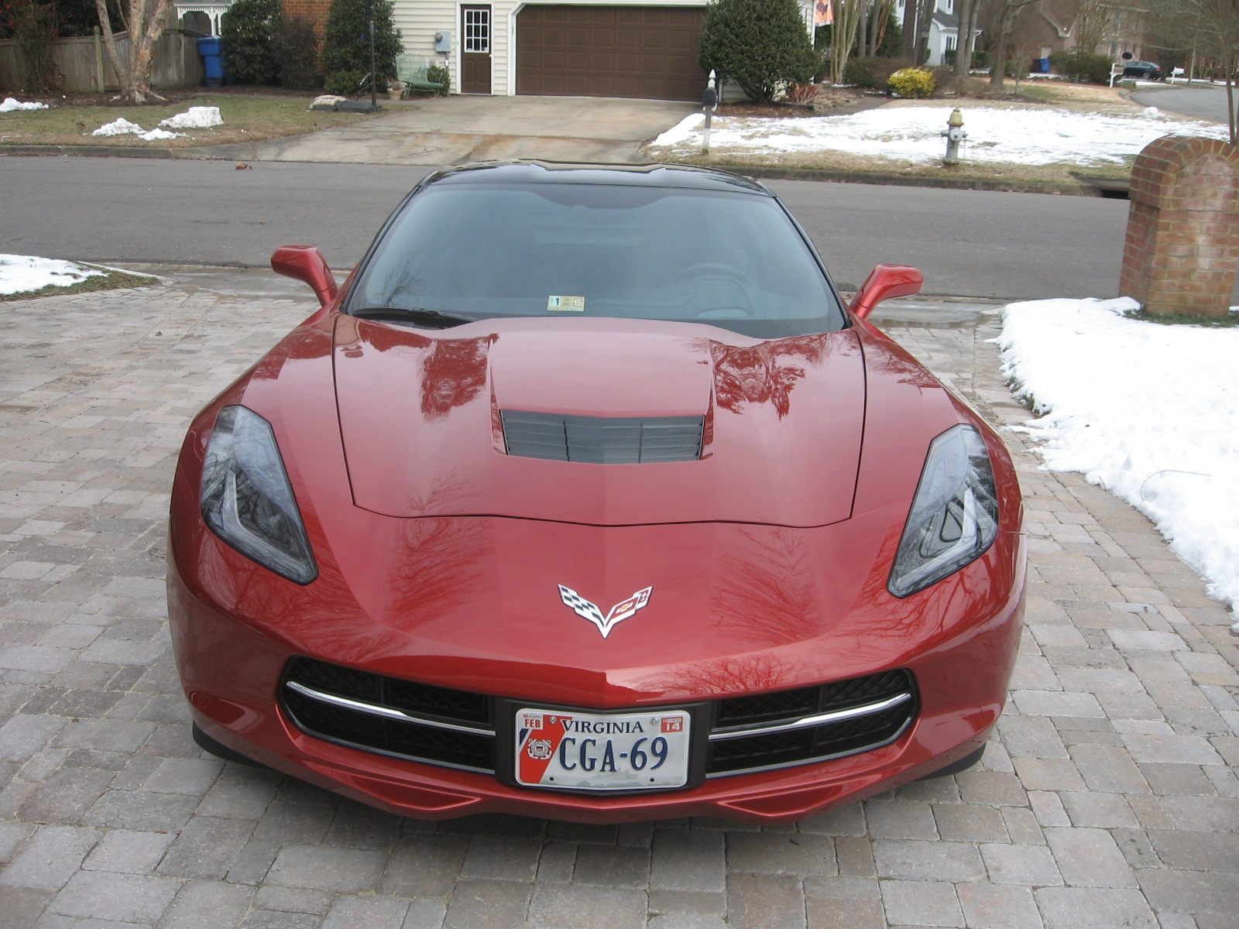

1969: Rich Losea's CGA '69 Baby

Jeff Robbins and I attended the annual meeting of the Link In The Chain (LITC) program in mid-January at the Academy in New London. Eileen Foye Kelly, Director of Alumni Relations at the Association, other Alumni Association and Academy staff, and cadets explained the program. Classmates from the local New London area will be alumni coordinators for the Class of ‘69: Paul Bodenhofer, Wayne Gronlund, Jim Gynther, Jeff, and Bob Thorne. Our first event will be Reporting-in Day for the Class of 2019 on June 29, 2015. The program provides a tradition of linking Coast Guard Academy alumni with current cadet classes. This link is between classes separated by 50 and/or 10 years. The first classes to be linked were 1961 and 2011. More recently, the classes of 1967/2007 and 1968/2008 have linked with the classes of 2017 and 2018. The concept of LITC is that Academy alumni of classes approaching their 50th and/or 10th anniversary of graduation link with cadets and their parents, sharing advice, ideas, and a historical perspective on the Academy and the Coast Guard. First year opportunities for the classes to interact occur at Reporting-in Day and the Swearing-In Ceremony, 4/C Shoulder Board Ceremony, Swab Summer Parade Review, and Promotion Ceremony at the end of Swab Year. Expect to hear more about LITC in the future.

Jerry Hale represented Valley Forge Military Academy and College at the National Prayer Breakfast in Washington, DC, in early February. President Obama was the guest speaker. Jerry also sponsored four Valley Forge Military Academy cadets from China in the National Student Leadership Conference that ran concurrently with the National Prayer Breakfast activities. Representatives from 130 countries participated in the Conference.

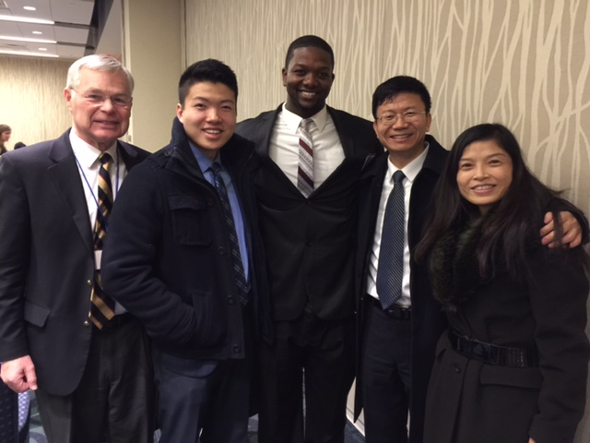

1969: Jerry Hale and Valley Forge Military Academy attendees at the National Prayer Breakfast in Washington, DC

In early December a request was sent to the Class from Dave Humphreys asking for help with his 8 year old grandson’s Salem, Oregon elementary school project seeking decorated snowman drawings from each state. Included is a photo of Daniel’s Class Snowman project, showing several great Coast Guard snowmen in the mix. Dave and Daniel send their thanks to everyone who participated.

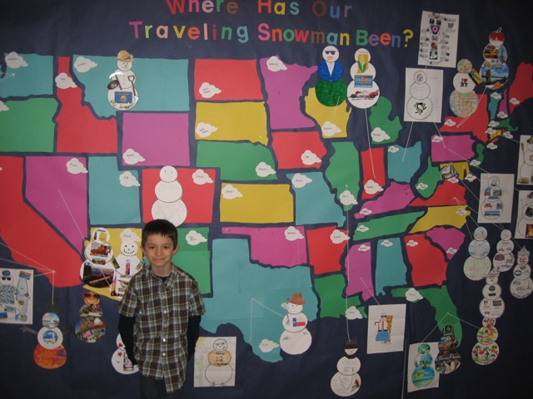

1969: Dave Humphreys' grandson's Coast Guard Snowman Project

These Notes are written in mid-February as Massachusetts experiences one of the harshest winters on record for snowfall and low temperatures. The photo of Bob Pokress is to remind those of us here in New England that it won’t be long until Opening Day at Fenway and a return to more enjoyable outside activities.

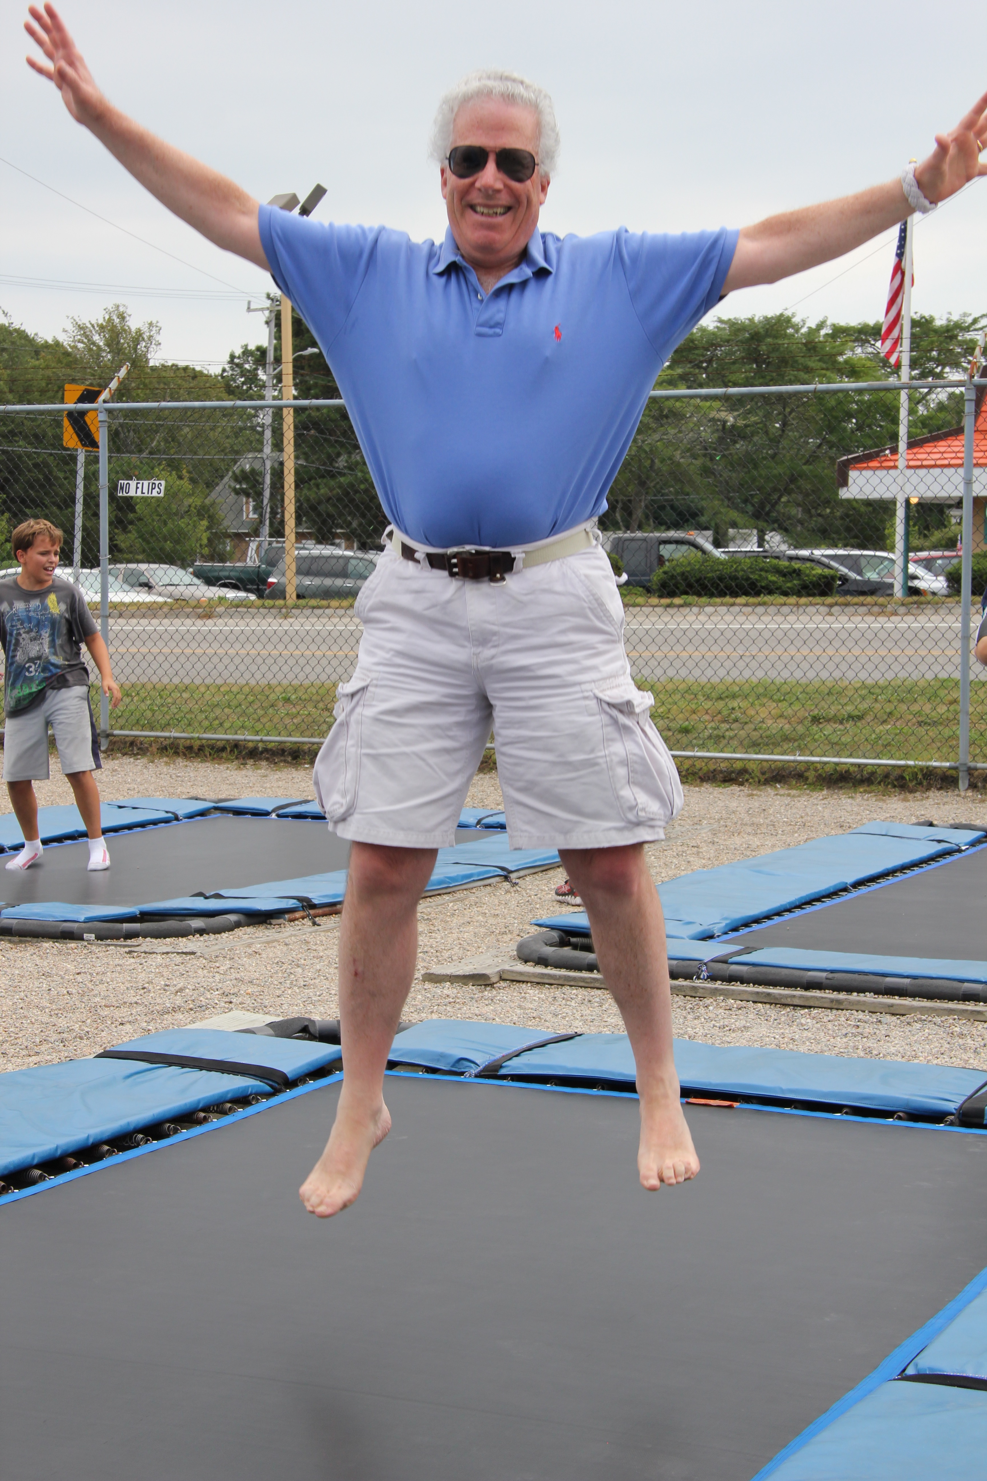

1969: Bob Pokress welcoming the arrival of Spring in Massachusetts
Fantastic news from Pat Garrity about Paul. “Paul has been determined to be cancer free by both his surgeon as well as his oncologist. We went to Dana Farber for a PET scan in mid-February, and his oncologist declared the scan 'perfect', and we don't have to see him again for three months. We had seen the surgeon in January, and don't have a return appointment until January 2016. It has been a long journey to get to this point, but we have been so blessed to have had the support and love of so many family and friends. We could never be able to put into words how much all your prayers and positive thoughts have meant to us. Thank you.”

