April 2016

CAPT Bob Gravino
2 Summer Street
Ipswich, MA 01938
(978) 356-0825 (H)
E-mail: rcgravino@aol.com
Website: http://www.uscga69.org

George and Gayle Bond are settled in New Orleans and attended their first Mardi Gras parade, which started within blocks of their home. It is the first time they have done urban living; they are enjoying it. George says that sitting in their backyard in New Orleans is quieter than sitting outside their former home in suburban Stafford, Virginia. George completed the four year program for his Education for Ministry and took on the position of Chief for the Mentoring Branch in the Coast Guard Auxiliary. He still teaches AUXLAMS and AMLOC, and is revising the AUXLAMS course to resemble the Coast Guard LAMS course that all Coast Guard enlisted must complete to make E-6.
Bruce Griffiths and Tim Cenna reunited in San Diego for an evening of sea stories. Tim’s daughter recently moved to La Jolla.

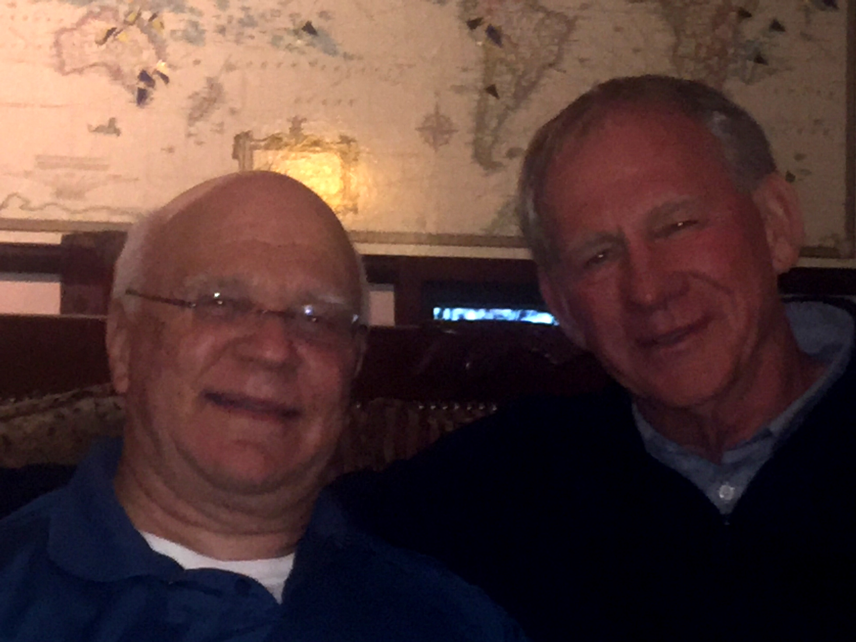

1969: Tim Cenna & Bruce Griffiths in San Diego

Bruce and Forest Hetland were in Southeast Asia in January, but were not able to meet up during their travels. Bruce and Gail were visiting Saigon, Vietnam and Siem Reap, Cambodia, returning to some of the places Bruce visited while deployed on his first assignment out of the Academy. Forest and Pat live in a small town, Doi Saket, about 18 km northeast of Chiang Mai, Thailand, where they serve as team trip coordinators for a mission group.
I had two opportunities to visit the Academy in March. On March 2nd the Academy Alumni Association hosted an Establishment and Ribbon Cutting Ceremony for the Red Bird MCX full-motion aviation simulator that was purchased by The Class of 1949 for cadets and the Academy’s Aviation Club. Attending were VADM Charlie Ray (CGA ’81), Ancient Albatross #25 and PACAREA Commander; Dave Andrews, Ed DeMuzzio and Rudy Peschel, illustrious aviators and members of the Class of’63); Academy Superintendent RADM Jim Rendon (CGA ’83), Assistant Superintendent RADM Jack Vogt (CGA ’87), and Commandant of Cadets CAPT Melissa Rivera (CGA ’91 and former CO of CGAS Kodiak). Honored guest and representing the Class of 1949 was CDR Frank “Pop” Shelley, the Class Correspondent for CGA ’49 and one of about a dozen aviators from the Class of ’49. Their Academy photos proudly hang in the Aviation Simulator Room in Chase Hall. Another famous member and aviator from the Class of 1949 is our own Arne Soreng, who was traveling the west coast and unable to attend the ceremony.

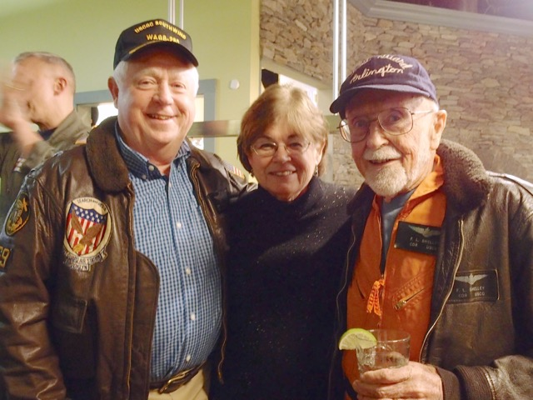

1969: Bob & Kathy Gravino with Pop Shelley (CGA '49) at Simulator Ribbon Cutting Ceremony

When not fronting for The Gents or giving guest lectures at the Academy, Bob Pokress is running for an elected position.
The Gents had a gig in North Caroline in late January to raise money for cadet musical activities, and Bob served as their sound man, sending along a photo of Dave Anderson, Jim Smith, Barry Kane and himself.
Two weeks following the simulator ribbon cutting ceremony, I returned to New London to attend a guest lecture by Bob in Professor Eric Johnson’s Operations Research course to 2/c cadets in Satterlee Hall. The subject of the lecture was “Burke’s Theorem”, named after Paul Burke, a mathematician who spent his career doing research in probability and statistics theory in the Operations Research Department at Bell Labs that Bob directed between 1980 and 1984. Burke’s mathematical theorem, proved in 1956, is the foundation for computer and microprocessor technology today. Bob’s lively presentation kept the attention of instructors, students and myself throughout his talk. Bob and I met Wayne Gronlund for lunch at Mr. G’s and talked about Wayne’s volunteer work in Emergency Management and Communications in Connecticut and Rhode Island.

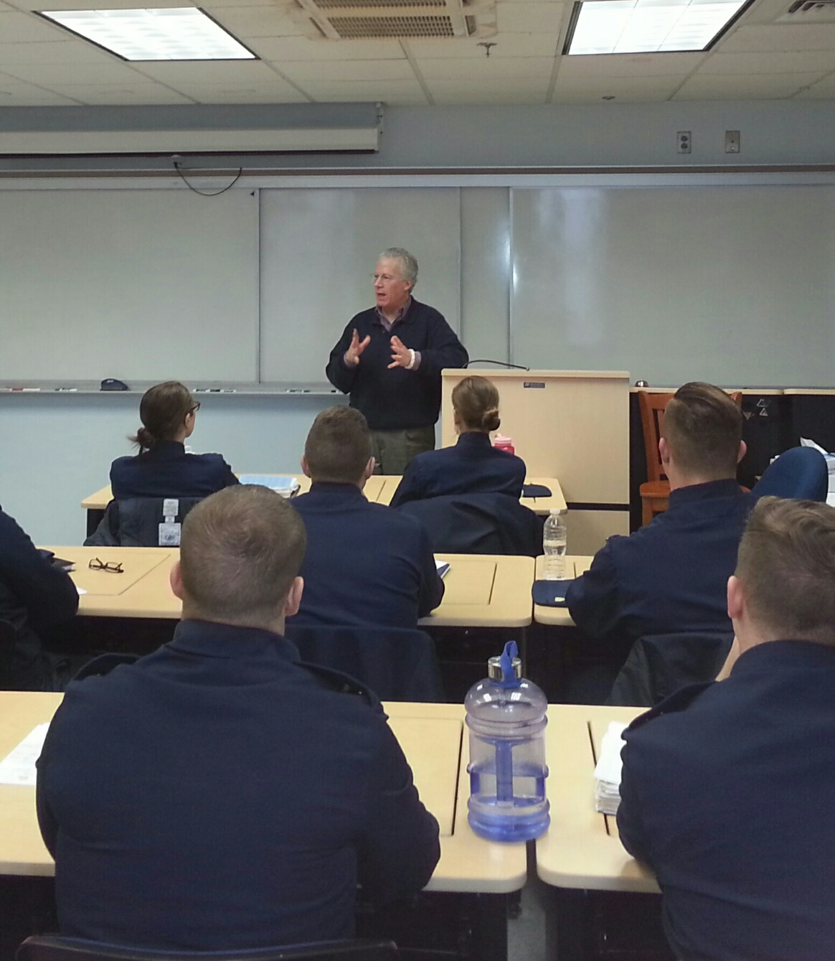

1969: Bob Pokress lecturing at the Academy

Bob is running in late March for the School Board in Andover, Massachusetts. One of his supporters is Joe Ponti, CGA ’61.

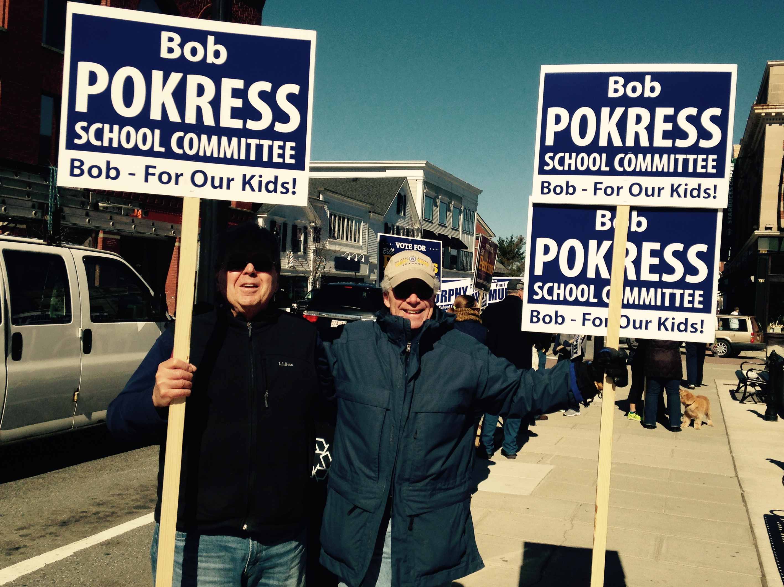

1969: Bob Pokress & Joe Ponti (CGA '61) getting out the vote

Jim Smith sent in the following about his connection to The Finest Hours. “I had a tour as Deputy Group Commander at Woods Hole, where Station Chatham was one of our units. All Cape Codders remember the Pendleton rescue and Bernie Webber, even 64 years later. Here’s a footnote to the story! Senior Chief Jack Downey (a legend in the 1st Coast Guard District) was OINC of Station Chatham when I was Deputy. Later I returned to Boston and Jack Downey was a Master Chief and OINC at Station Brant Point (Nantucket). MCPO Jack Downey took the original 36-footer of Pendleton fame and completely restored it while at Nantucket. I’ve got a photo to prove it! I ran the March 1995 Nantucket Marathon in a blizzard while MCPO Jack Downey was OINC at Brant Point. Instead of congratulating me upon finishing, MCPO Jack Downey said something like ‘I used to think that the stupidest thing I ever heard was when Saddam Hussein’s two sons-in-law asked if they could return to Iraq after leading a failed over-throw of the Iraqi leader. Saddam said sure. They returned, and Saddam executed them. But now I think you running 26 miles in a Nantucket blizzard is the stupidest.’ Like I said, a legend.”

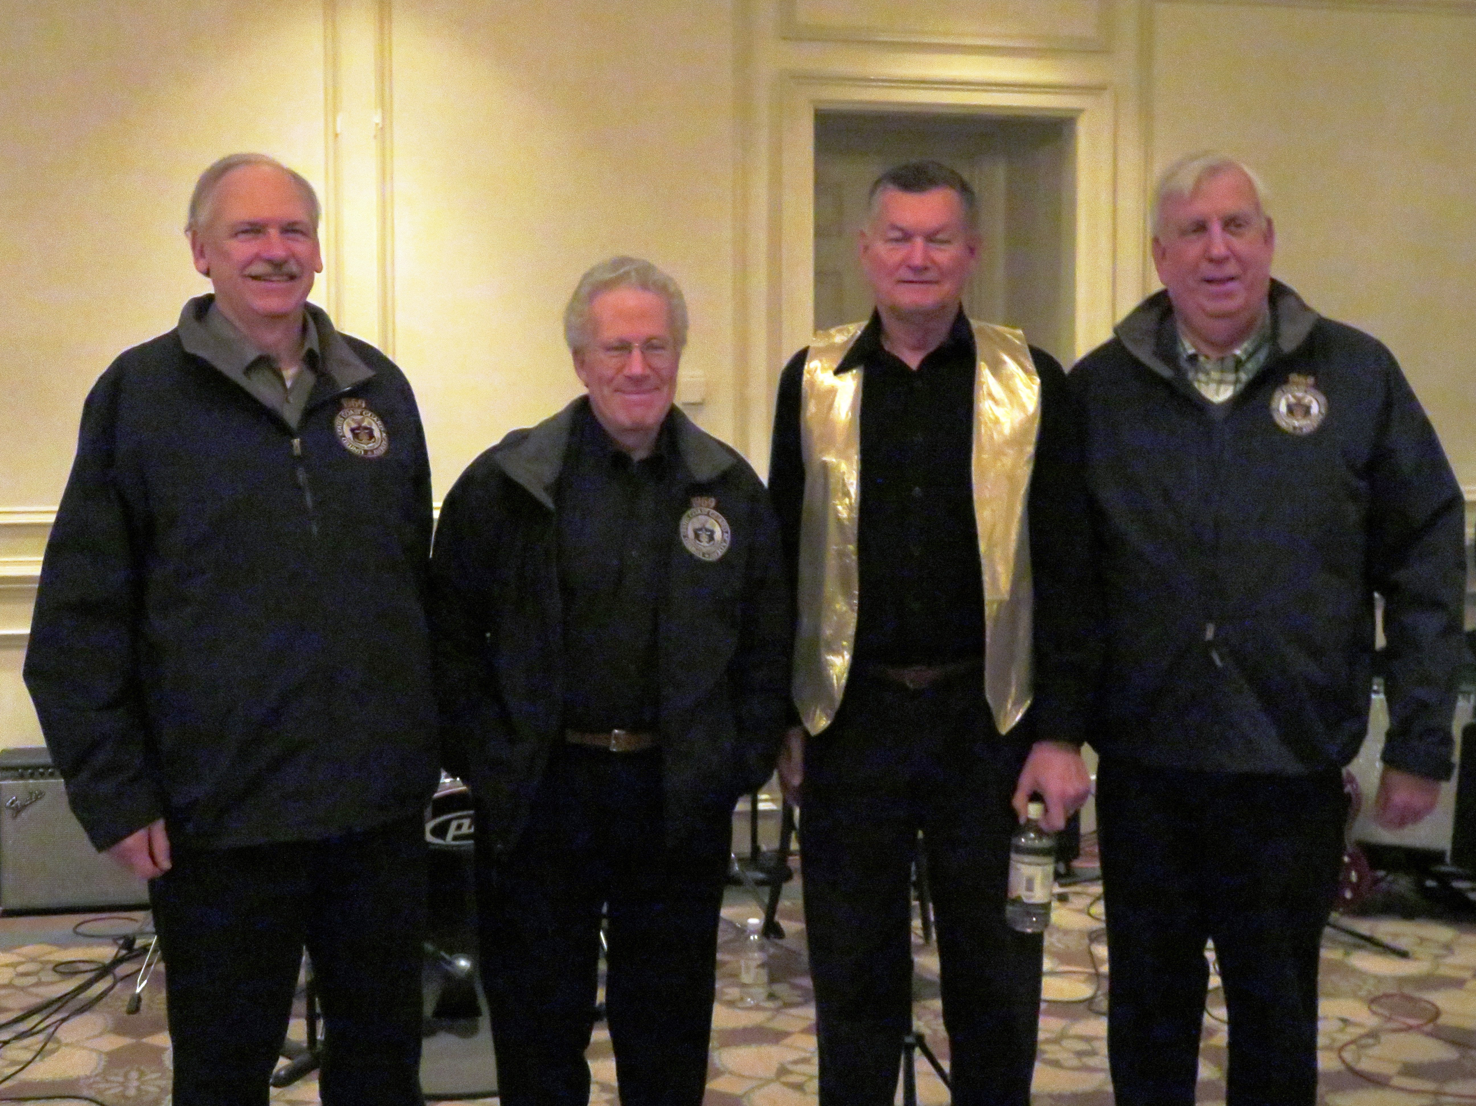

1969: Dave Anderson, Bob Pokress, Jim Smith & Barry Kane with The Gents

Jim Pennington has a new e-mail address: pennjames8618@gmail.com.
“My cadet number was 8618. Or maybe that was my Chase Hall mailbox number, or my aviator number.” Chris Kreiler says that was his cadet number.
Jim and Shirley Gynther and Wayne Gronlund and friend Debbie attended the Class of 2019 4/c Formal Dinner and Dance in March. Wayne passed that he and Jim participated in the unveiling of the Class of ’19 Crest (the class-designed side of their class ring). The Class of 2019 designed the compass rose in the crest to point to 069°, in recognition of their special Link In The Chain relationship with our class.
Mike and Judy Billingsley sent a card noting a recent move and change of address: “We thank you for your love, support, and prayers while we served our Lord in Jerusalem for 2 years of our 12-month agreement! It was a wonderful experience. Our new home will be near daughter Tammy and her family. The welcome mat will be out and we look forward to your visit. Love and blessings.” Their new address is 102 Waterlace Way, Fayetteville, GA 30215. (678) 815-8986.

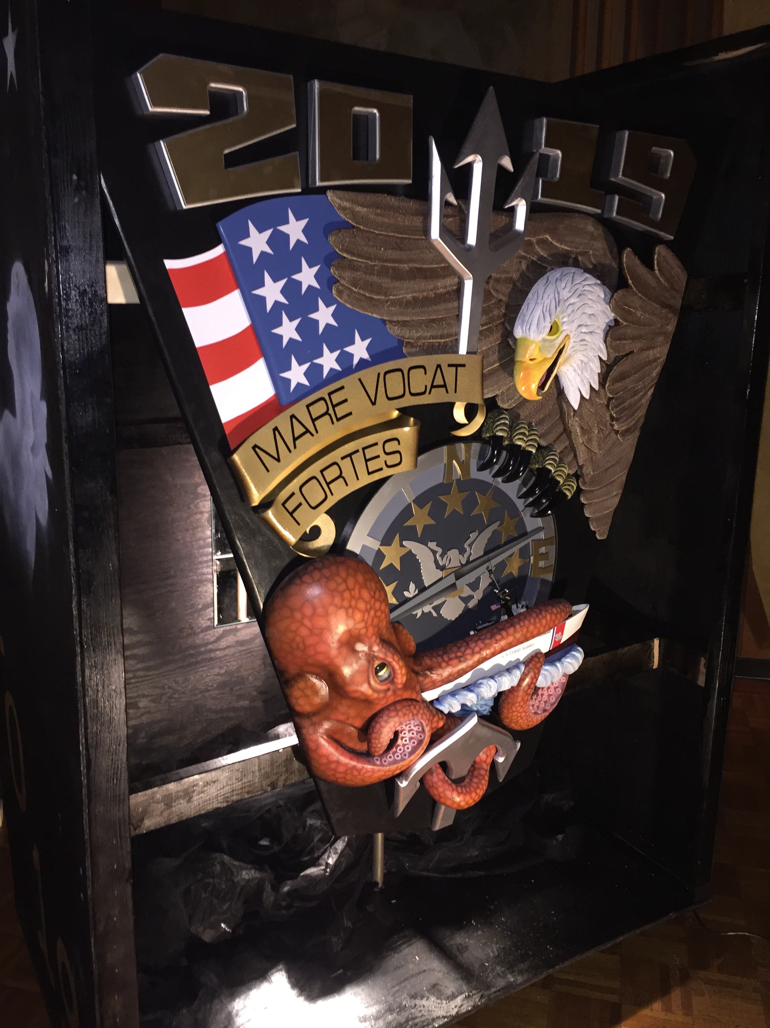

1969: Class of 2019 Ring Crest with 069° on compass rose

