April 2023
’69 CLASS CORRESPONDENT

CAPT Bob Gravino
P.O. Box 158
Georgetown, ME 04548
(207) 371-2765 (H)
E-mail: rcgravino@aol.com
Website: http://www.uscga69.org

Bill and Lisa Bissell sent a family photo taken on Maui (younger son Matt, Bill, Lisa, daughter-in-law Julianna, and older son and Julianna’s husband Jeff) and an update on their past year’s activities. “Our highlight of 2022 was a family trip to Maui in November to celebrate our 50th wedding anniversary. Despite some trepidation about our sons diving off cliffs, our trip was relaxing. We attribute that to the warm weather, outstanding snorkeling, great food, and nightly Mai Tai consumption. We again spent summer at our house on Branford Harbor in Connecticut. The high points were a five-day visit from our sons and daughter-in-law, celebrating my mother’s 100th birthday, and boating. We also visited the Chapel at the Academy where we were married in 1972. I had cataract surgery in the spring, and it is the first time since 1967 that I have had 20/20 vision. Lisa returned to in-person Jazzercise classes after a two-year hiatus and gardens in California and Connecticut; I get plenty of exercise digging holes for plants in rocky Connecticut. For exercise, I prefer tennis and bicycling. Lisa’s sister and her husband live in Shelter Island on Long Island, and we spent time with them in both Branford and Long Island. Our last trip to Shelter Island at the end of September included a sailboat race off Shelter Island with us crewing for an old yacht club friend of ours. The vessel was a fiberglass hull ‘Atlantic’ one-design, a 30’ keel boat designed by Starling Burgess in 1929. Our crew was an 80-year-old helmsman, a 72-year-old cockpit man, and a 75-year-old foredeck man. Experience was our strong point; nimbleness, speed, and strength did not score as high. We took First Place in our class that included J-24’s and beat six other larger competitors on corrected time. The major factor was a fickle sea breeze that kept the fleet on a close reach for most of the race. Unlike the modern design boats that kept trying unsuccessfully to set spinnakers, the Atlantic’s large jib was perfectly designed for a close reach. We set our chute on the last long leg, and with the wind finally filling in, we made up our time on the larger boats. We finished the race 15 minutes before the five-hour expiration limit; many boats did not.”

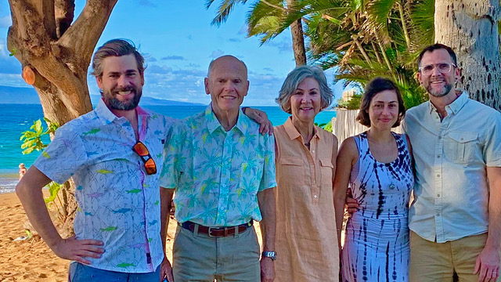

69: Bill & Lisa Bissell and Family on vacation in Maui

John Curtis sent along an update. “Howie Waters and I had grand plans for skiing this season. It started with five days at Vail, Colorado, in mid-December 2022 with a large group from Minnesota that Tom McGrath ‘62 introduced us to. The Vail trip was epic. Our next scheduled ski trips were to Whistler, British Columbia in mid-February and Mammoth Mountain, California in mid-March. But these trips didn’t happen. While skiing on January 31st here in Washington State, I fractured my left tibia when I crashed trying to avoid hitting an 84-year-old blind skier. That is no sea story. The fracture is healing well and the crutches and leg brace will soon be unnecessary. It’s questionable if I will be able to ski again this season. Last year I skied 43 days, this year is half of that. Bummer.”

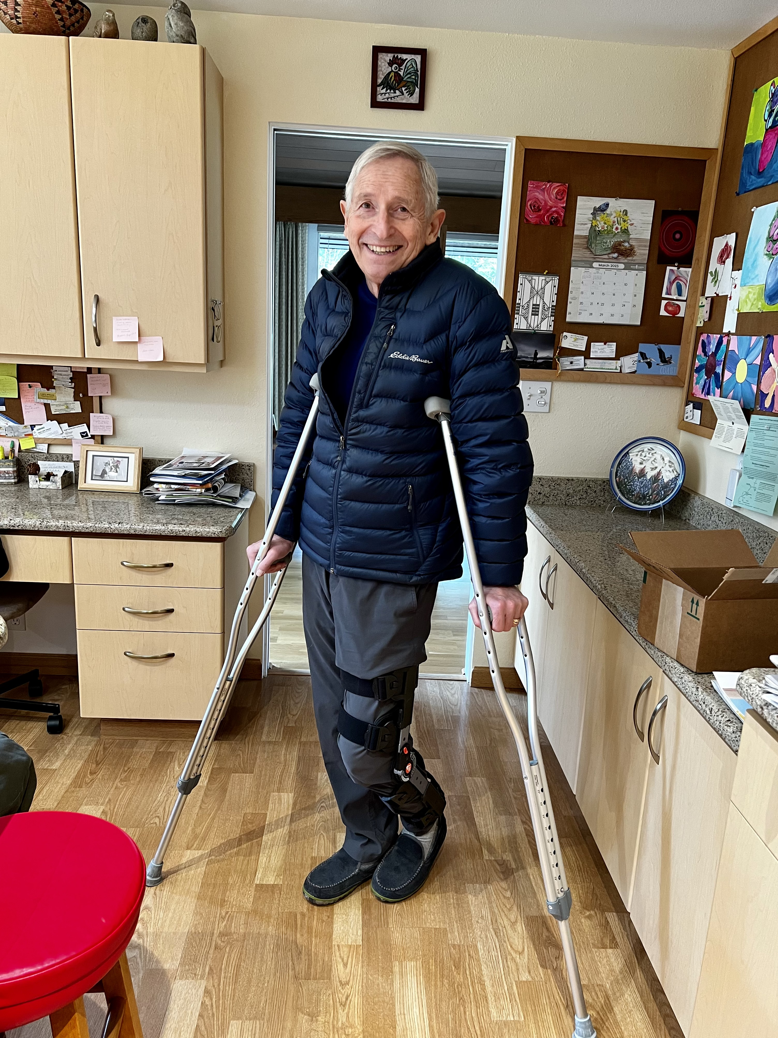

69: John Curtis on crutches

John Curtis commented on Fred Schmitt’s identification of crewmembers from the CGC Staten Island’s 1970 Arctic West deployment to Alaskan waters included in the February/March Bulletin. “I believe the fourth crewmember in the photo is Bill Prelle ’67, and the Dave Potter in the photo is the Officer Candidate School Dave, not Dave Potter from ‘68. As to why I am not in the photo, I was probably attending to the two ship’s service steam boilers that were giving me fits that entire deployment.” Fred’s response: “John, you might be right on both counts. I’m sure Dave Potter is the OCS graduate, but less sure about the fourth crewmember. It could be Bill Prelle or Rudy Peschel.” Anyone else have thoughts on the unidentified crewmembers?
Our thanks to Paul Bodenhofer for volunteering to begin planning for the 55th Class Reunion in 2024. An e-mail (55th Reunion Bulletin #1) was sent to classmates on the Class of ’69 e-mail list, but if you missed it, here are the details from Paul. “It is time to start planning for our 55th Reunion. Homecoming in 2024 is October 19th. Please let me know if you tentatively plan on attending and how many will be in your group. This does not commit you, but will be helpful for us. Our class fund, for deposits and other incidental expenses, is severely depleted. At the moment we have just a little over $1,000.00. Any donation to the fund would be greatly appreciated. Please send a check made payable to Paul Bodenhofer at 9 Champlin Hill Court, Niantic, CT 06357. If you have suggestions for class activities or other aspects of homecoming, please contact me (pbodenhofer@gmail.com, 860 739-0647/landline, 860 303-6406/cell). Also let me know if you would like to be part of the homecoming committee.”
Dan Carney found an old photo of a high school basketball game in which he and his high school in Sag Harbor, New York were competing against Shelter Island High School. “The player standing next to #5 on my team is Lawson Brigham from the Class of ‘70. #5 and I were co-captains of the team. Our coach ran it like a football team. #5 was Captain of the Offense and I was Captain of the Defense. My job was to guard the opposing player who was the highest scorer regardless of the position he played.” Dan is #15.

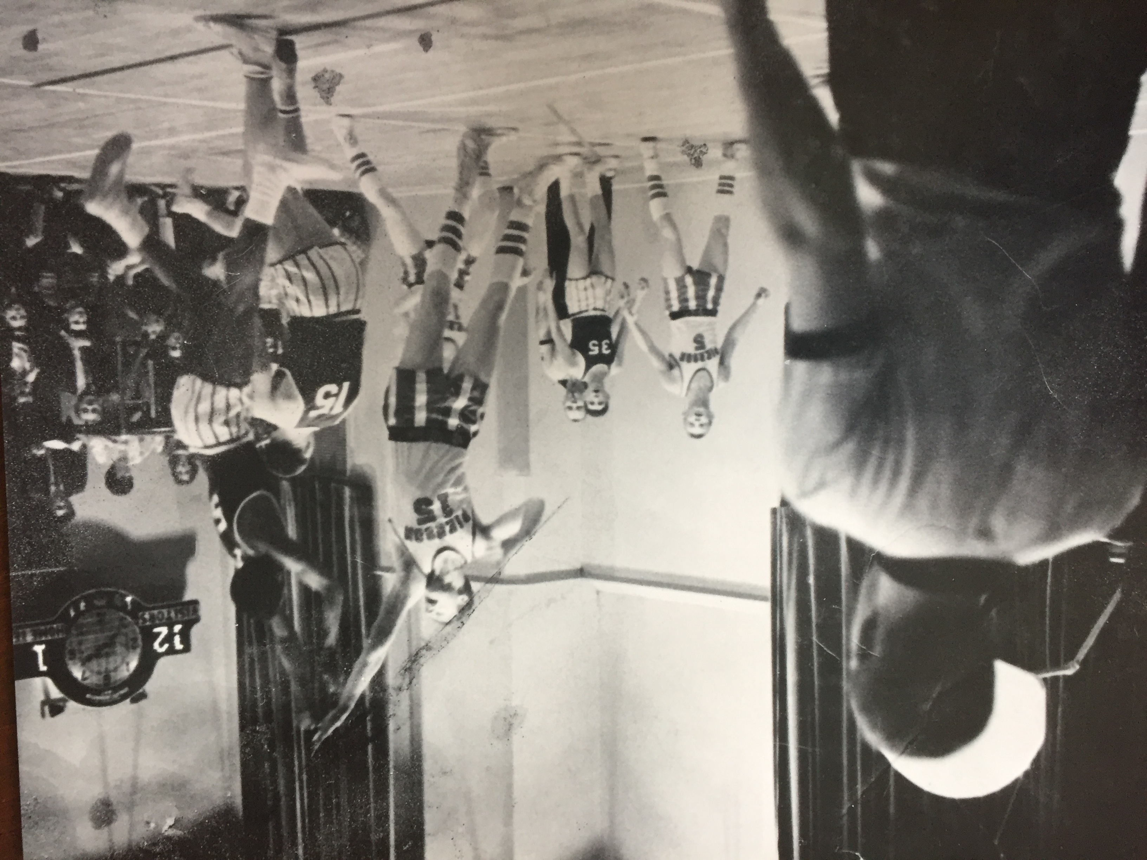

69: Dan Carney & Lawson Brigham '70 as high school basketball competitors

Stu White is adding up frequent flyer miles. “Friends and I took a trip in January on the Le Bellot, a Ponant Cruise line vessel, which had 150 passengers for the trip and a capacity of about 180 plus the crew. We toured the city of San Jose and bused to Punta Arenas on the west coast of Costa Rica to embark on the Le Bellot. We visited the Curu Wildlife Reserve, the oldest protected park in the country; Quepos and the Manuel Antonio National Park, Costa Rica's smallest national park; the Rio Seco Rainforest, a 400-acre private property; Cebaco Island for snorkeling, before arriving in Panama City where we visited the colonial city of Casco Antiguo, the Bio Museo designed by Frank Gehry, and the Mira Flores Locks. The next day we transited the Panama Canal. The transit took most of the day passing through the Miraflores Locks, the Pedro Miguel Locks, and sailing on Gatun Lake, through the Gatun Locks and into the Caribbean Sea at Colon. The last day we traveled to Tocumen International Airport in Panama City for our return.”

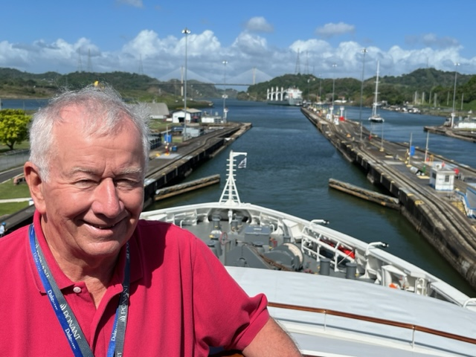

69: Stu White cruising on the Panama Canal

To continue the discussion of classmates who are, or were, members of Rotary International, the following classmates responded. Fred Schmitt was past president of the Norfolk Sunrise Rotary Club, before relocating to Banner Elk, North Carolina. “I was a Paul Harris Fellow at the time we moved. I have not rejoined a club in the Banner Elk area as I have numerous other civic involvements.” Ted Colburn was a Rotarian in Connecticut for thirteen years. “Great organization.” Dan Carney is a member of Rotary in Leonardtown, Maryland. “I hounded the Club for five years to start a Flags for Heroes fundraiser. They finally adopted the project last year, and now in our second year, we are on track to raise $10,000!” Jim Robinson is a Rotarian in Georgetown, Texas. Rod Schultz: “I'm an Odd Fellow in Honolulu - but then, you know that.”
Jim Smith, is a member of Key West Sunrise Rotary. “You'll like this! It's a Rotary Club band! Three members of Key West Sunrise Rotary began jamming, and now we've done several gigs. Lead guitar and singer is a Key West attorney who paid his way through law school by performing one-man shows in Chicago. Our bass player (also keyboard) is an MD and is also from Chicago. They both moved to Key West at about the same time but didn't know each other in Chicago. They are twenty-five years younger than me and they play songs I've never heard, but they also like Tom Petty, Rolling Stones and some of the classic music-makers. And we do ‘Margaritaville’! We call ourselves The ManGrooves, sort of like Mangroves. We play at club meetings, installations, and fundraisers, the most recent a brew fest where beer makers set up booths and the public sampled their wares. The Gents played at the brew fest in 2011, and like the night The Gents played, our band got better and better the more the participants drank!”

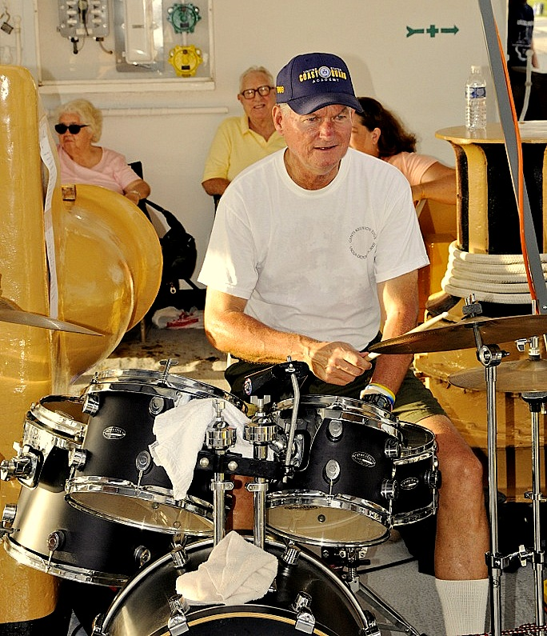

69: Jim Smith performing with the Key West Sunrise Rotary Club Band

Bob and Sue Pokress and Kathy and I visited the Portuguese island of Madeira in early March. Beautiful scenery, friendly inhabitants, wonderful and inexpensive restaurants and accommodations, and fantastic microclimates to visit on the volcanic island. Knowing that the CGC Eagle’s long summer cruise includes a port call to Madeira’s capital city of Funchal in May, we submitted a pre-welcome photo for members of the Classes of 2024 and 2026, which is printed in the Where have you been section of this Bulletin.

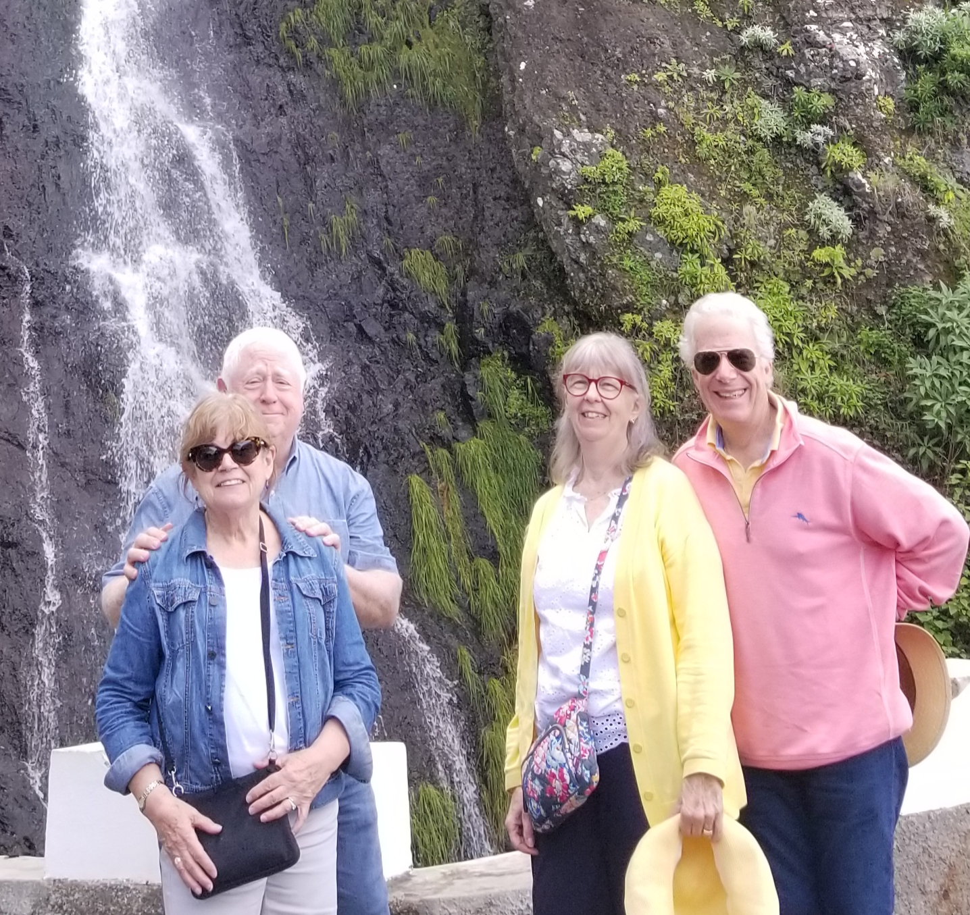

69: Kathy & Bob Gravino and Sue & Bob Pokress enjoying the scenic beauty of Madeira

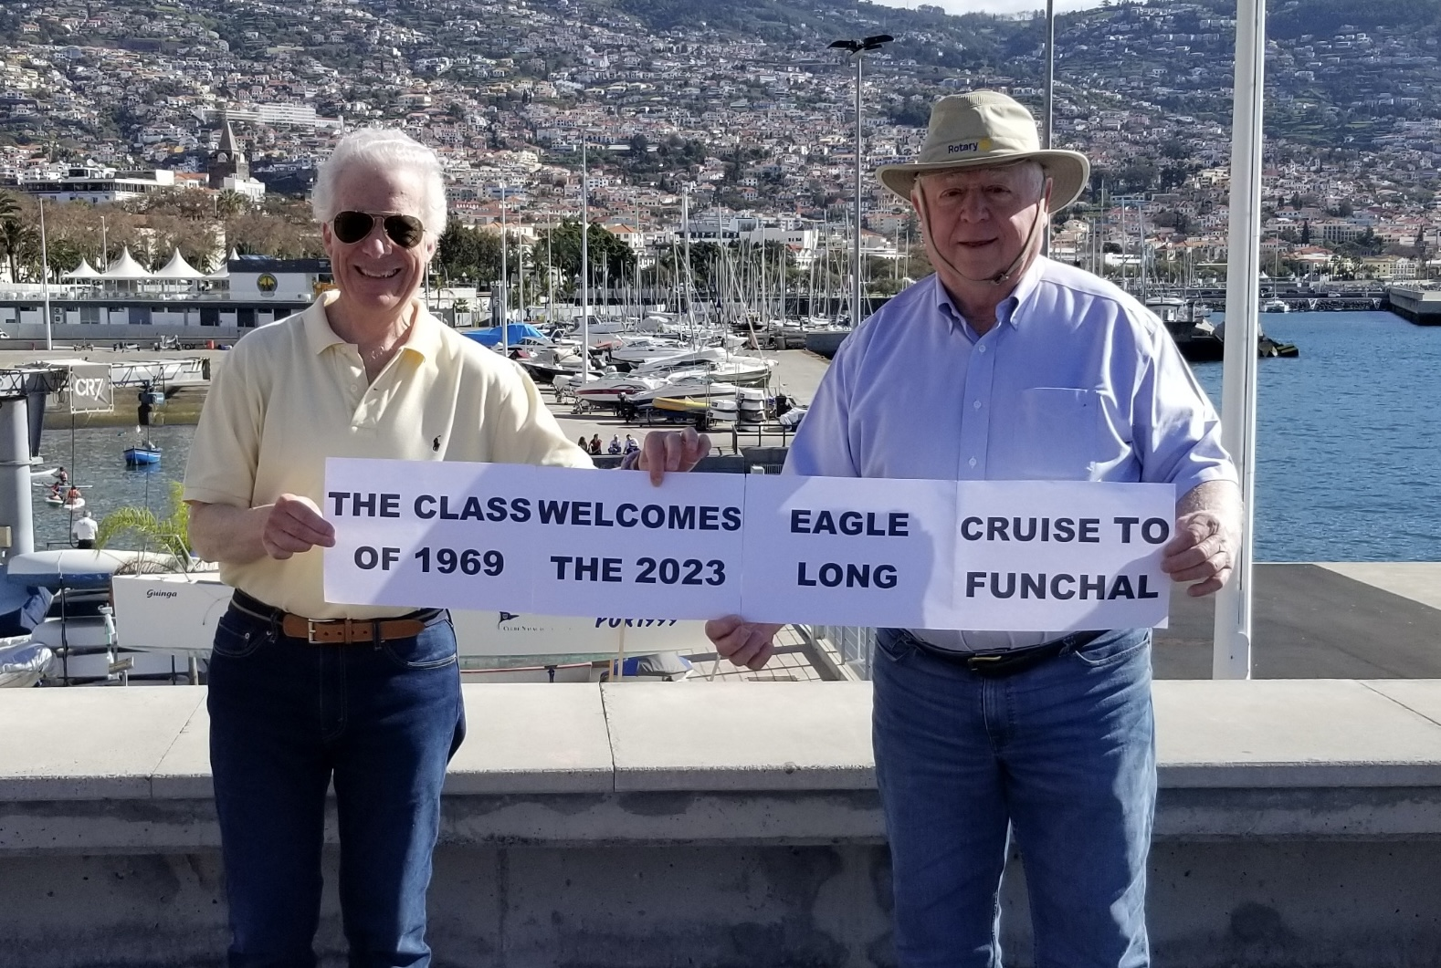

Bob Pokress '69 & Bob Gravino '69 send a pre-arrival welcome to the CGC Eagle 2023 long summer cruise and the Classes of 2024 and 2026 for their May port call to the city of Funchal, capital of Madeira.

