August 2018
’69 CLASS CORRESPONDENT

CAPT Bob Gravino
2 Summer Street
Ipswich, MA 01938
(978) 356-0825 (H)
E-mail: rcgravino@aol.com
Website: http://www.uscga69.org

In Memoriam
Richard John Losea
May 29, 2018

In Memoriam
Nancy James Pavlik
June 21, 2018

The Class suffered the loss of a good friend and classmate with the death of Rich Losea in May in Chesapeake, Virginia. Richard John Losea was born in Brooklyn, New York, and grew up in Old Lyme, Connecticut. After a year of college experience in Boston, he returned to the New London area in 1965 prepared for the Academy way of life after his Navy ROTC experience at Tufts University. At the Academy, he invested his time on the soccer field, on the Tide Rips staff, and in the management curriculum. He earned a Masters of Science-Financial Management from the Navy Post Graduate School in Monterey, California; a Masters of Arts-International Relations from Salve Regina College in Newport, Rhode Island; and he was a graduate of the Naval War College in Newport. Rich retired from the Coast Guard as a Captain with 26½ years of service and from the Department of Defense Joint Staff after 18½ years of service. He was the Commanding Officer of the Coast Guard Cutter Point Arena, the Coast Guard Pay and Personnel Center, and Coast Guard Group Milwaukee. He also served on the Board of Chesapeake Integrated Behavior Services and the Board at ABNB Federal Credit Union. Rich is survived by his wife, Patricia Mary Losea; son, Thomas Losea of Chesapeake, Virginia; and a sister and brother. Rich was interred with military honors at Chesapeake Memorial Gardens in Chesapeake.
John Miner, Don Grosse, Al Hindle, Charlie and Sue Huber, Rich and Beth Vlaun and Greg Shaw attended Rich's funeral. The service was conducted by the 5th Coast Guard District Chaplain and presentation of the flag and taps was provided by 5th Coast Guard District Petty Officers.
Greg Shaw sent me Al Hindle’s e-mail (ahindlejr@cox.net) and telephone number; send me an e-mail if you want Al’s number. Greg also noted that the Boston Red Sox needed Mokie back soon! You can take the boy out of Boston, but you can’t take Boston out of the boy!
Two members of the Class of ’70 sent thoughtful comments on Rich’s death. From Kent Kirkpatrick: “I relieved Rich on the Point Arena in the summer of 1972. He was a wonderful person. I received a great boat with a well-trained crew. Can't ask for more. For some reason I remember that he recommended The Duck Inn in Norfolk for local seafood. I can picture him and Pat sitting outside on their deck with a PBR and an order of soft-shelled crabs. May he rest in well-deserved peace.” From Casey Edwards: “Rich was a great guy. I am very sorry to hear this.”
It is with deep regret and sorrow that I inform the Class of the death in June of Gary Pavlik’s wife, Nancy. Nancy James Pavlik, born in Hartford, Connecticut in 1949 and a resident of Middletown, Rhode Island, died after a long battle with breast cancer. Nancy obtained a BA in English from Connecticut College for Women in 1971, and a Masters of Library Sciences from UC Berkeley in California. In earlier years, she was a talented and enthusiastic downhill and cross-country skier. For the last ten years, Nancy's favorite past time was being with her grandchildren: Madelyn and Cole Kneip, and Townsend and Anderson Bowman. Other favorite activities were cruising on Ocean Drive in her Thunderbird convertible; the view of Second Beach coming down Tuckerman Avenue; and lunches outside at Castle Hill Inn. Nancy and Gary were married for 47 years and have three children: Dr. Emily Pavlik Kneip, MD; Meriel Bowman; and Alexander Pavlik; and four grandchildren. Donations in Nancy’s name can be sent to the Brighton Center in San Antonio, Texas (www.brightonsa.org), an organization providing services for her specially-abled grandson. Gary can be reached at 1140 Green End Avenue, Middletown, RI 02842.

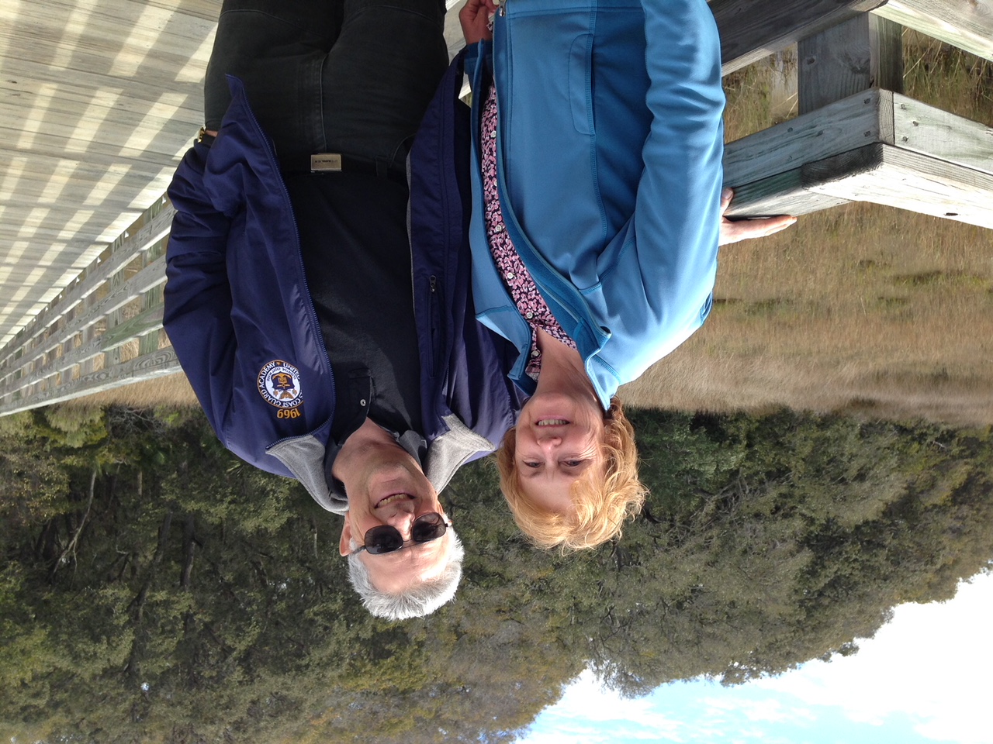

1969: Gary & Nancy Pavlik in 2015 on Hilton Head

Russ and Alana Askey, Doug and Janet Brown, Rube and Reen Olsen, and Bob and Susie Pokress attended Nancy’s memorial service.
Chris Kreiler sent the following after reading the June/July 2018 Classnotes column. “A comment on Bill Bowen’s high school classmate. The Class website has all of the former classmates in the order that they left the Academy. I think there were 288 appointments with 254 showing up. The website does not list those who did not show up, which is probably the case with Bill’s classmate.”
Chuck Talar gave an update on his recent activities. “Thanks for forwarding the e-mails regarding the Class and the Academy. Making good on the Class Gift pledge has been in the back of my mind but did not seem to make its way to the front. One e-mail prompted me to do that. My recollection is that the pledge was $1969.00, so I've now sent in my check. I'm still teaching in the Graduate School of Theology at the University of Saint Thomas in Houston. Earliest retirement for my diocese is 75, which is okay; after multiple stents (8), I'm fine. I reside in a large parish north of Houston, and I'm to a point academically where I have an expertise that gets invitations. Got to Venice a year ago last October, Belgium last September, this November to conferences in Milan and France. A once-a-year international trip is about all I want to make at this juncture.”
Fred Wilder sent in a photo of the Wilder clan at their beach house in St. Teresa, Florida. All sixteen family members (eight adults and eight grandchildren) gathered for the week of July 4th and enjoyed fishing, skiing, tubing, and rocking on the porch.
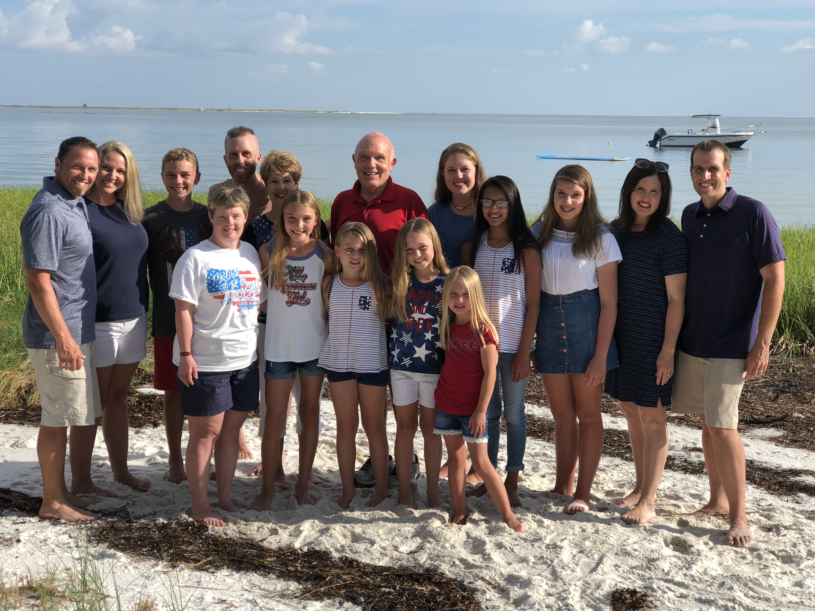

1969: Fred & Terry Wilder and family at the beach in St. Teresa, Florida.
Bob Pokress went whitewater rafting on the Kennebec River in Maine with his two 11 year-old granddaughters, Jane and Dani (Jane is son Matt’s youngest and Dani is daughter Becca’s oldest). In photo #1, their raft is entering “Maytag”, a Class IV rapid; the three of them are on the starboard side of the raft, Jane #2, Dani #3, and Bob #4. Photo #2 was taken immediately following the first when the raft entered the rapid and went vertical, leaving everyone hanging upside down and tucking toes into the raft’s thwart to remain in the raft. They rafted the Kennebec in July when the dam is opened on the river where the rafting begins, tripling the river's flow to do the annual stress test of the dam’s turbines.

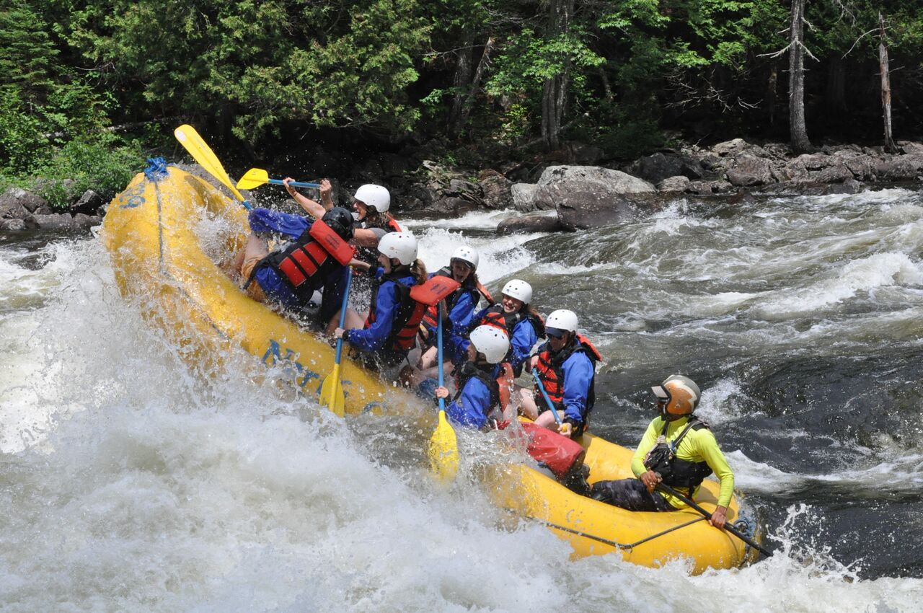

1969: Bob Pokress & granddaughters whitewater rafting on the Kennebec River



1969: Bob Pokress & granddaughters whitewater rafting on the Kennebec; where did they go?

The Griffiths and Burks return to Wisconsin each summer to Bruce and Jim’s childhood haunts to enjoy the area where they spent their pre-Academy years. This year they met in De Pere, Wisconsin, a suburb of Green Bay, where they visited the Scray Cheese Company, a family-owned cheese manufacturer dedicated to keeping small, local businesses alive. Scray Cheese has a shop where visitors can buy cheese and other products and eat their products while watching cheese being processed in adjacent production facilities. Bruce called their lunch “the squeakiest pizza we’ve ever eaten.” I asked Bruce how his recently overhauled mobile home was doing. “Our ancient Winnie (22 years old - 150,000 miles - visited 40 states) is still chugging along! Although, unlike me, very few original parts!”

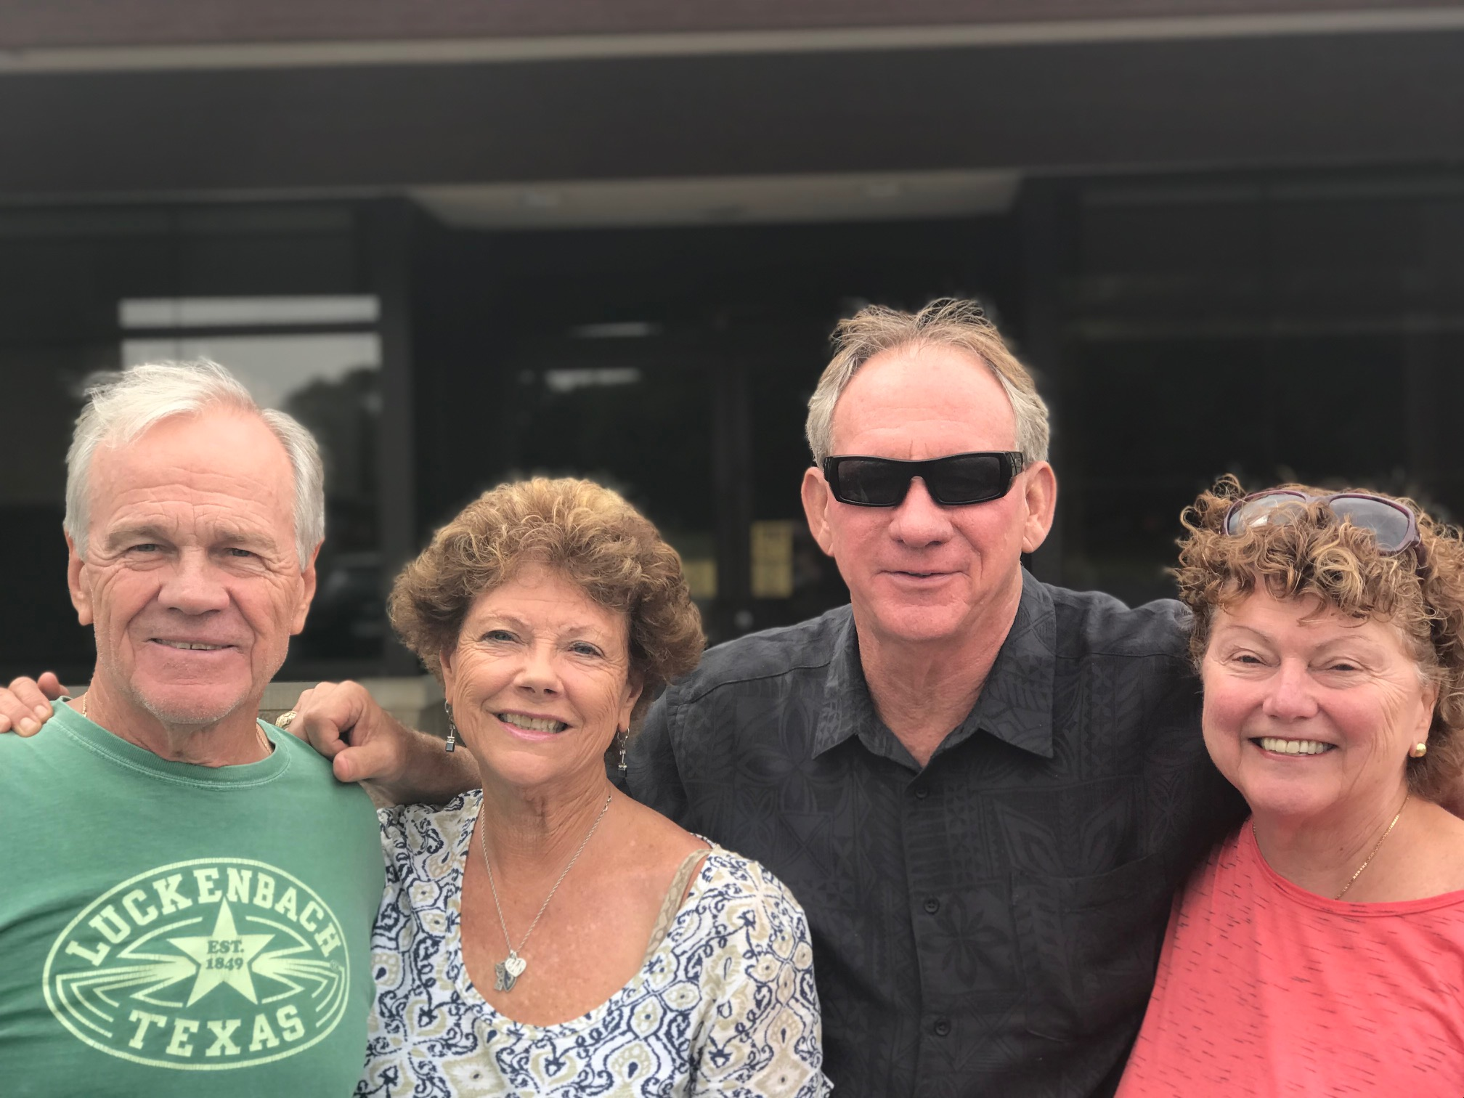

1969: Jim & Cindy Burk and Bruce & Gail Griffiths in Wisconsin

Fred Schmitt is President of the High Country (North Carolina) Chapter of the Military Officers Association of America (HCCMOAA). The MOAA Chapter recently dedicated the Watauga County Veterans Memorial after a three year effort involving many community partners. Fred sent a photo of the memorial and a press release from the dedication. "On July 4th, the High Country MOAA Chapter and the Town of Boone, North Carolina, unveiled and dedicated the Watauga County Veterans Memorial. The ceremony was the culmination of a three year effort to design, construct, install and raise funds for this project. HCCMOAA came up with the concept and developed the strategic plan which took the project from vision to fruition. The stainless steel sculpture titled Time and Honor was chosen from 19 proposals submitted in response to a regional competition. The sculpture is in the form of an ellipse increasing in size from left to right and culminating in five pillars which honor our five armed forces. The ellipse prominently features the words ‘Duty Honor Country’, the West Point motto long ago adopted by all services to reflect the determination, perseverance and dedication of all who serve this great country. Knee walls surrounding the sculpture depict the dates and lives lost in the Revolutionary War, Civil War, WWI, WWII, Korean War, Vietnam War and current and future conflicts in defense of freedom. These are the most prominent of the 82 conflicts in which one or more of our services have fought. A third wall dedicates the monument to all veterans who served and acknowledges the contributions which made the memorial possible."

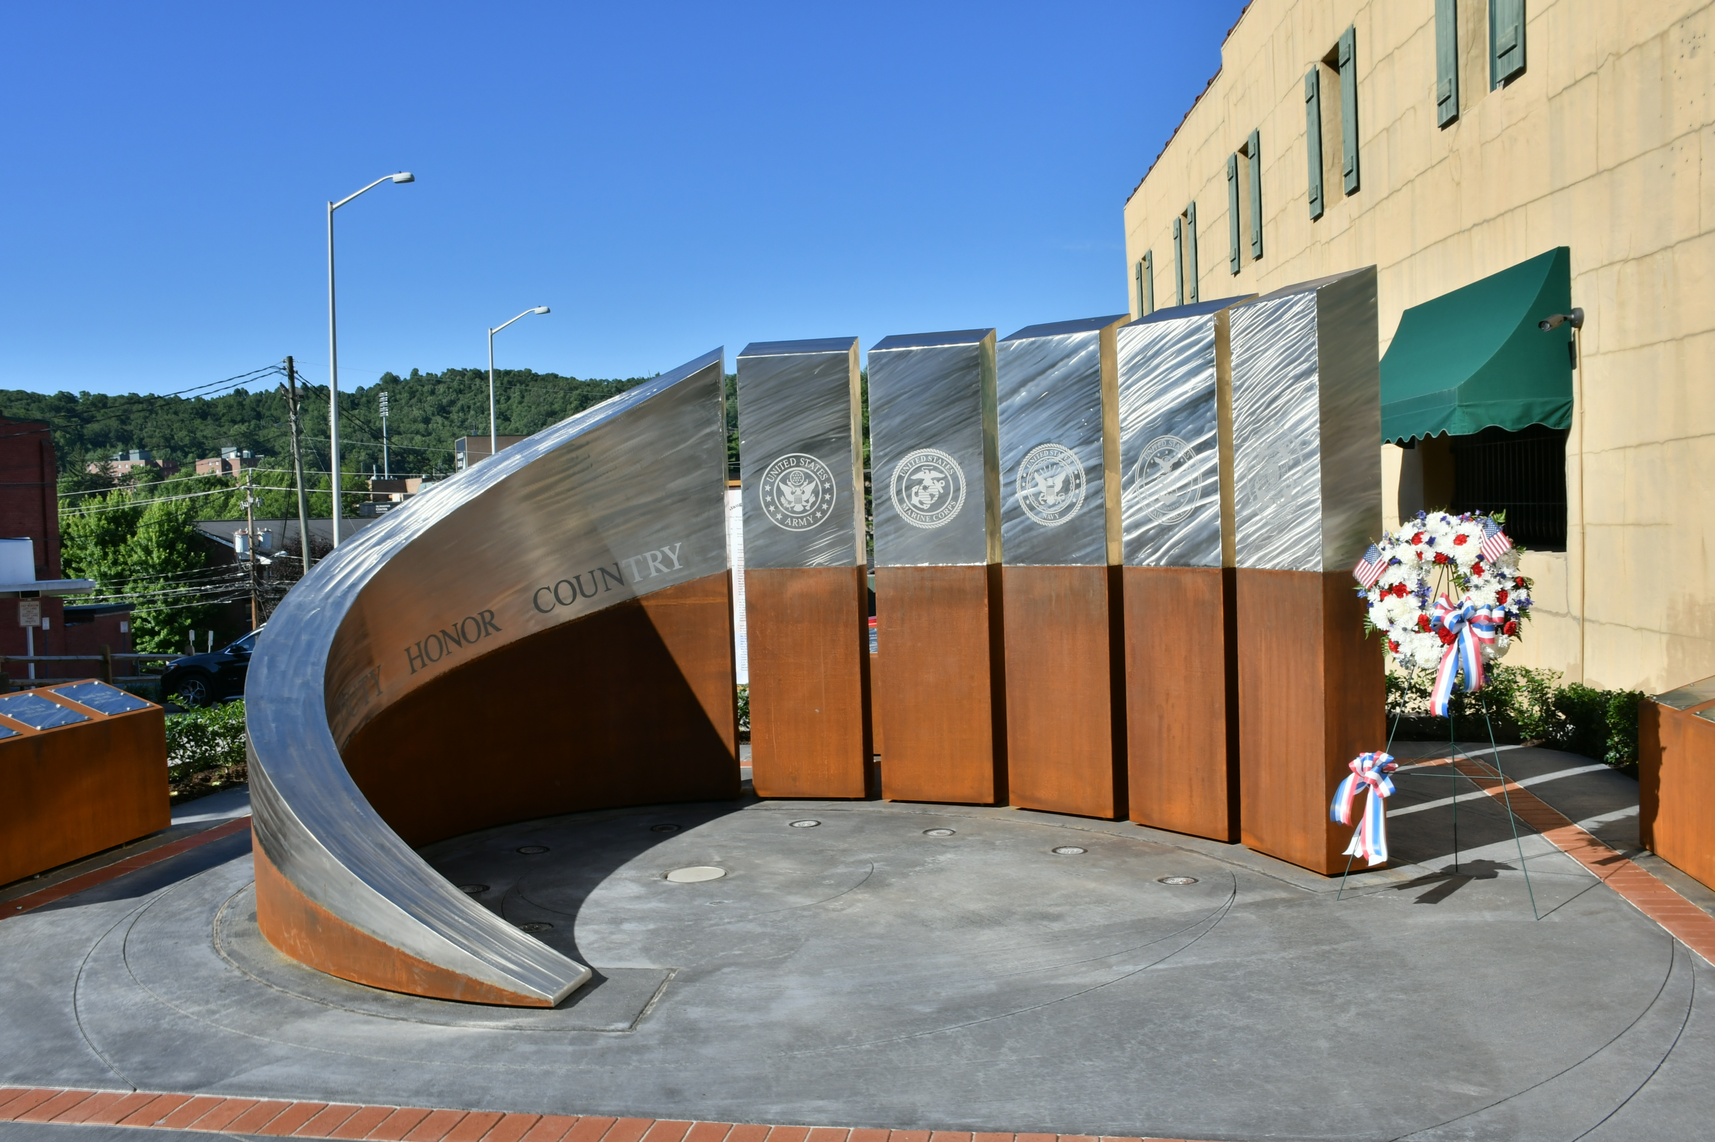

1969: Watauga County Veterans Memorial

