August 2023
’69 CLASS CORRESPONDENT

CAPT Bob Gravino
P.O. Box 158
Georgetown, ME 04548
(207) 371-2765 (H)
E-mail: rcgravino@aol.com
Website: http://www.uscga69.org

George Flanigan sent a family photo of granddaughter Jeanie’s recent graduation from the University of Pittsburg. “Jeanie is shown with her Master of Science degree in Pharmaceutical Sciences to go with her previous Pharmacology Doctor degree that led to her license as a pharmacist. This was the first post-COVID graduation ceremony for our family; Jeanie and granddaughter Marisa both missed their Bachelor’s ceremonies and son Sam missed his Master’s graduation. Cathy and I are presently on a tour riding the Rocky Mountaineer train from Vancouver to Banff, then we tour Banff National Park by bus. Western Canada has some beautiful mountains. We toured southern France and Paris in March and saw some new sights, but unfortunately got caught in their strikes.” Shown in the photo are George, Cathy, Jeanie, son David, and Marisa.

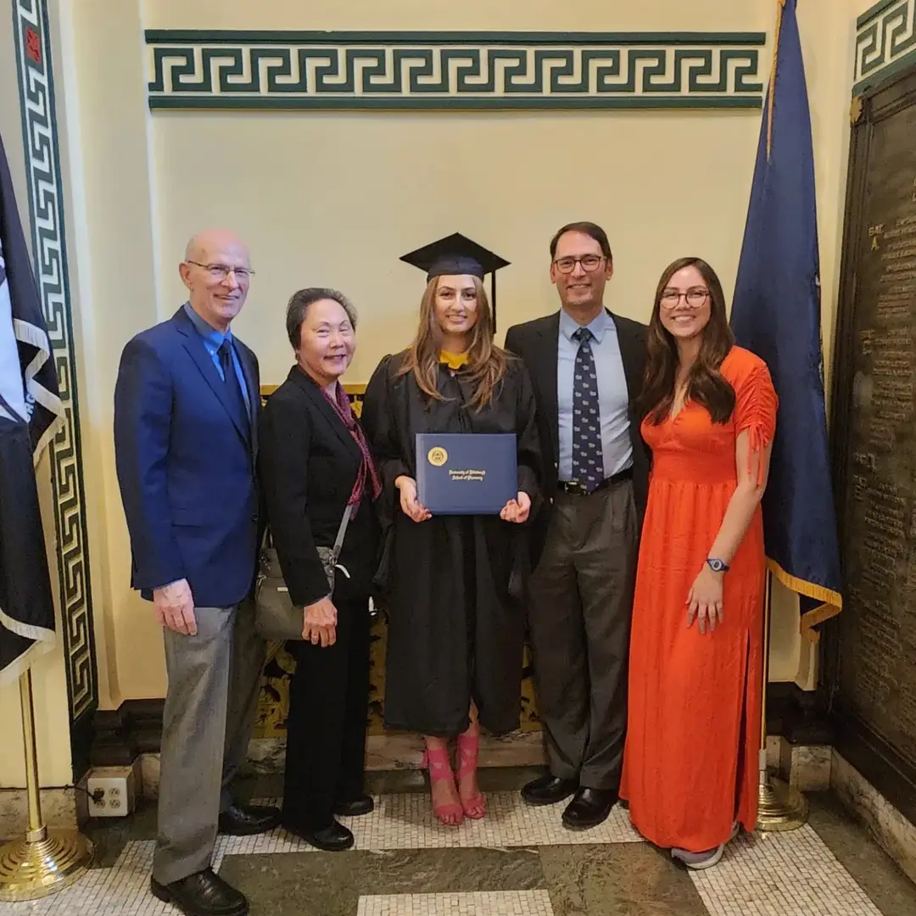

69: George & Cathy Flanigan and family at granddaughter Jeanie's college graduation

Bob and Carmel Belote make frequent trips to Ireland and schedule these flights across The Pond to spend quality time with family. “Most of Carmel’s family live in Ireland, and since her mother is 94 and living by herself, we try to go over two or three times a year. We were over earlier this year in March and April, during which our son, Kevin, his wife, Rachel, and daughters, Ada and Maeve, joined us for a week. Our daughter, Kerry, her husband, Sean, and their children, Connor and Kate, flew to Ireland for a week on June 10th, but then Sean had to go back to work, so we joined Kerry and children for a week in Paris, and several more days back in Ireland before returning home. The Paris trip was a real vacation for Carmel and me, since Kerry and Kate planned every day’s activities well in advance, and all we had to do was follow along. It was a challenge trying to keep up with them! Carmel and I live in Sun City Peachtree in Griffin, Georgia. We moved there ten years ago, after spending nine years in Sun City Hilton Head, South Carolina. We made the move to be closer to kids and grandkids, since they all live in Atlanta. Our main activity is golf and visiting family, but we have three other couples that we go to dinner with once a month, and we occasionally go on golf trips with them as well. We’re planning a two-week trip to Florence with them in 2024.”

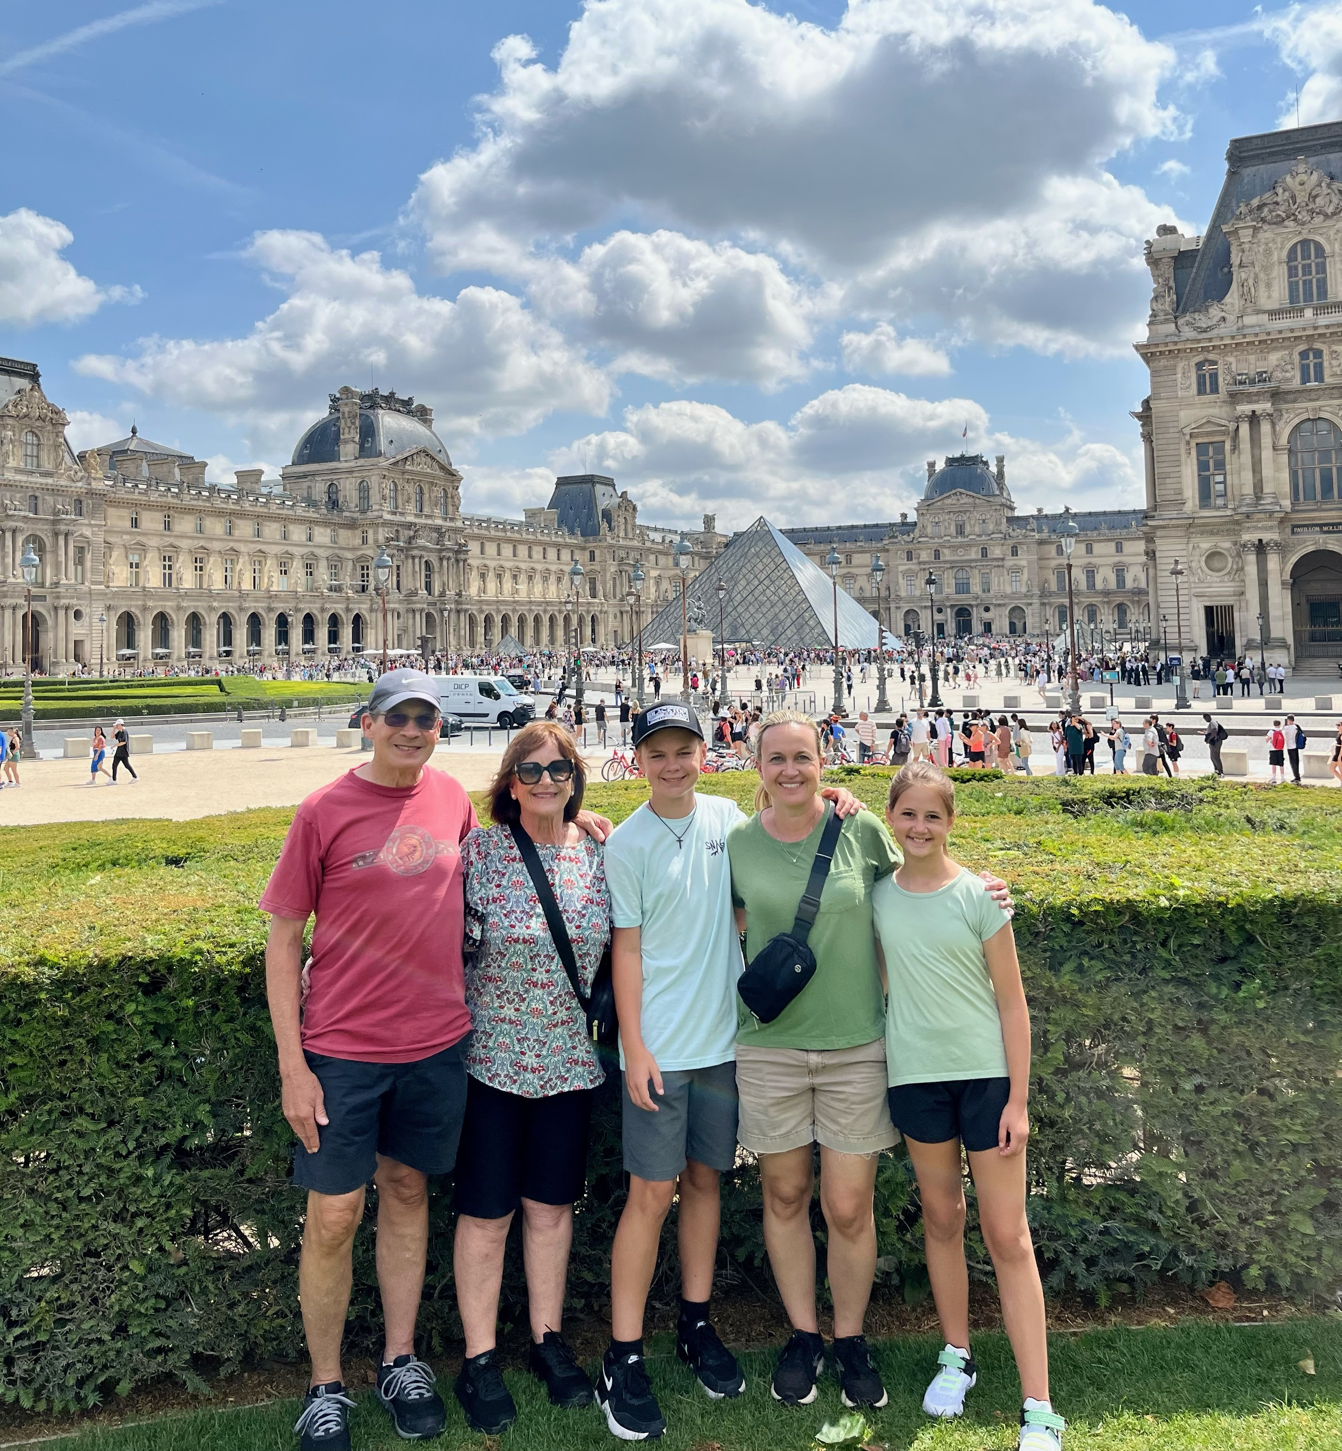

69: Bob & Carmel Belote in Paris with daughter Kerry and grandchildren Connor and Kate

George and Gayle Bond are moving from New Orleans to Kentucky. “We have sold our house with closing on August 9th, and a local mover is packing and moving us to local storage as we relocate to Lexington, Kentucky. We had thought that our relocation to New Orleans from the Northern Virginia suburbs of D.C. years ago to help with grandchildren would be our final move, as son Andrew and husband Nick thought it would be their last move. But Nick was offered a job as number two in the HIV division at the University of Kentucky’s Chandler Hospital, and Andrew became the academic advisor in the University of Kentucky School of Agriculture working with the forestry students. Our grandchildren are Jules and Finch, and are the reason Gayle and I were here in New Orleans and now heading to Lexington. Will we miss New Orleans? Not the heat or the hurricanes, but yes, the residents of the city. The transition has started as Gayle has an appointment with her new oncologist in Lexington and I am looking for groups to occupy my time.” George has a new e-mail address: gdbondii@gmail.com.
Paul Prokop shared a valuable lesson from our time at the Academy. “I was saddened to read of the passing of CAPT Al Bridgman ‘54, but was reminded of a valuable operational lesson learned in which he played a major role. It was our third-class cruise on board the CGC Yakutat and then-LCDR Bridgman, the Academy legal officer, was our summer Commandant of Cadets. It was time for boat drill after noon quarters – bright sun, 80 degrees, flat calm seas. We got the standard, lengthy briefing on safety in boat lowering – pay attention to the person in charge of the lowering detail, don’t do anything until ordered to do so, hold onto the man ropes while being lowered (everyone boarded at the boat deck level and rode the boat down to the water’s edge). Based on my vast operational experience as a new third-class cadet, I clearly remember thinking this is a waste of time – what could go wrong in these conditions? Ten minutes later, the motor surf boat was hanging/twisting by only the rear falls, some of the boat crew (all cadets) were clinging to the man ropes, the remainder were quickly drifting aft beyond the stern and people were shouting man overboard. Once the personnel in the water were retrieved and the boat secured, LCDR Bridgman started a ‘green book’ investigation, took statements, determined the facts and instituted corrective action. I remember being impressed by his prompt and effective action, especially for a lawyer (I was unaware of his previous operational experience). I have never forgotten the lesson learned that things can go south without warning and that you must always be ready to respond appropriately (and saw it repeated in different circumstances in the years since, both in and out of the Coast Guard).” Included is a photo of Paul and Molly, who live in River Ridge, Louisiana (New Orleans) and summer in the Grand Traverse, Michigan area.

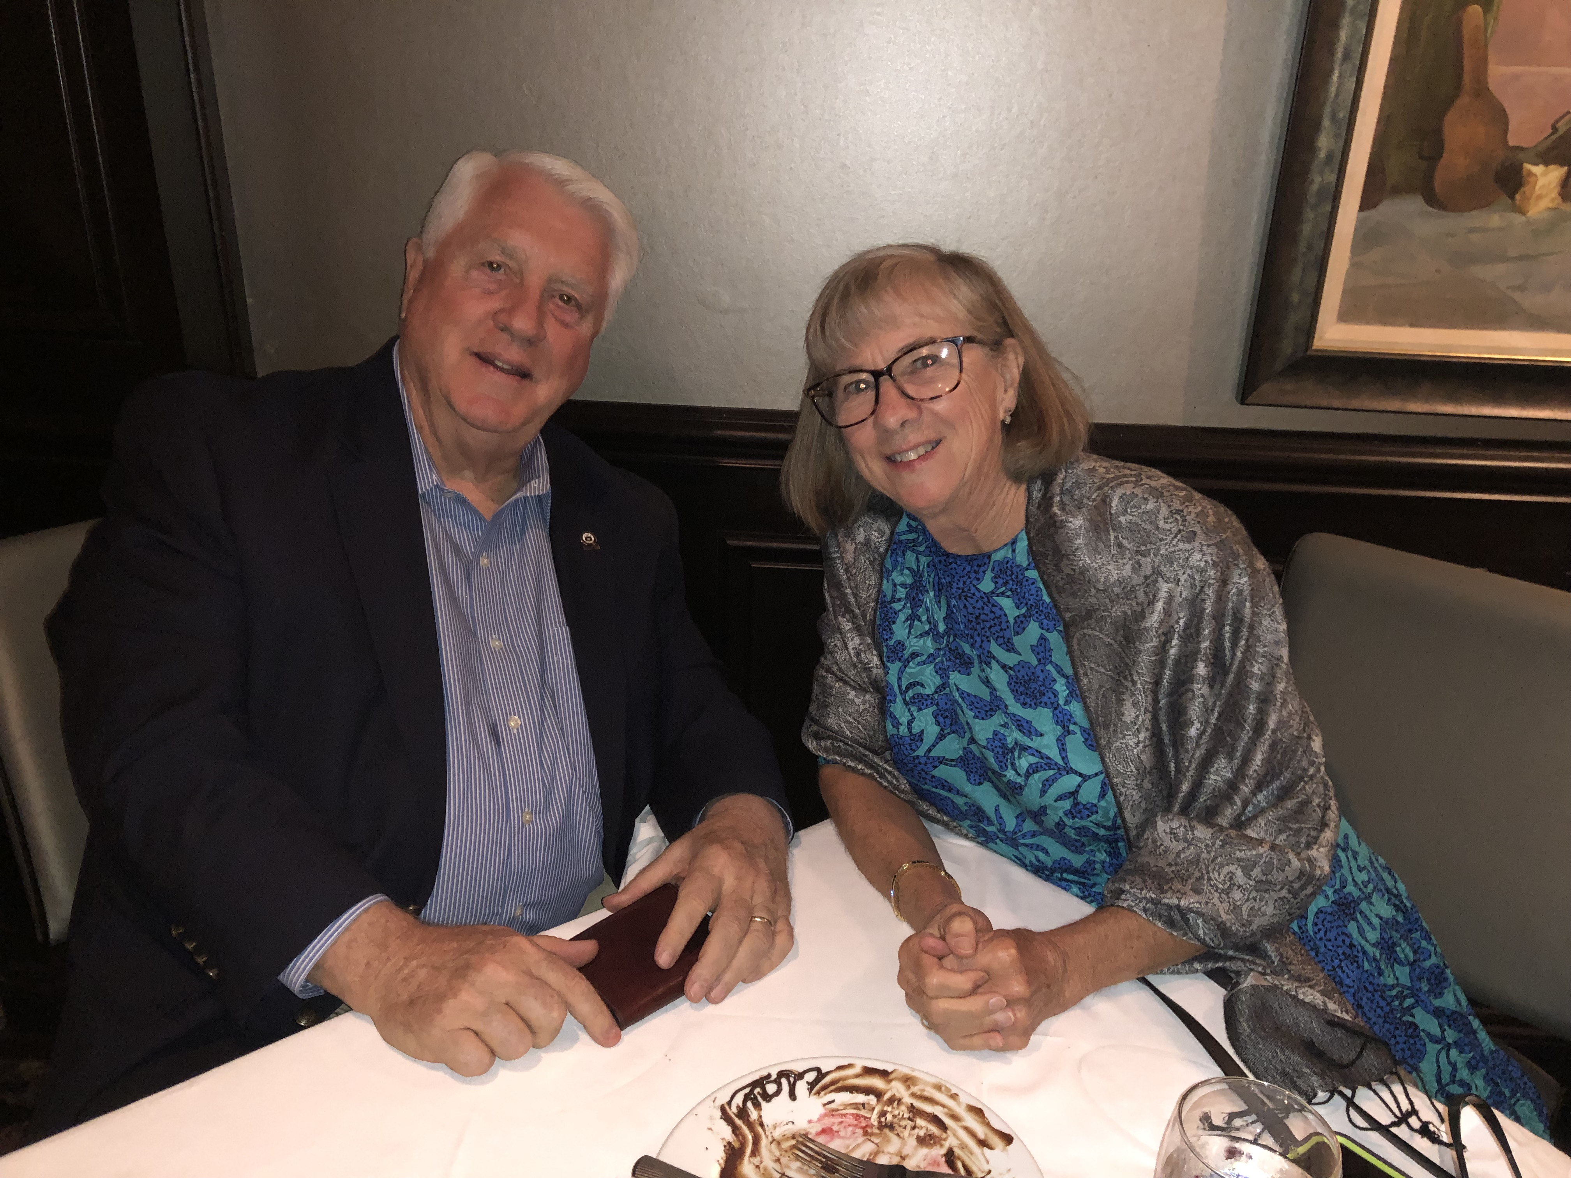

69: Paul & Molly Prokop

I was asked by the Coast Guard Aviation Association (Pterodactyls) to compile a listing of the designation dates of when classmates completed the flight training program at the Naval Aviation Training Command in 1971, and received the following from Mike Moore. “There is a back story to my completion date. Early in June 1971 I was informed by my instructor, after I passed the dreaded B-26 Check Flight, that I would fly on every available day so I would complete training before June 25th (last winging ceremony date in the fiscal year). The Navy did not have sufficient funds to complete any Navy students but could complete Coast Guard, Marine Corps, and foreign nationals prior to that date, so I received my wings with five Italian Navy guys on June 25, 1971. It turned out that I flew over half of the TS-2A syllabus flights between the 1st and 23rd of June.”
Who were those sixteen classmates who received designation as Coast Guard Naval Aviators? Stu White, Ted White, Paul Garrity, Drew Gerfin, Chuck Wadey, Fred Pryor, Ron Greto, Glenn O’Brien, Mike Moore, Bob Belote, Mike Billingsley, Jim Pennington, Bob Gravino, Vince Kinal, Forest Hetland and Chris Kreiler.
A special acknowledgement and thanks to Pat Garrity for all her efforts and dedication to the Coast Guard Museum in Barnstable on Cape Cod. Thanks to Pat, Paul’s aviation greens are hanging in a glass case in the Museum, bringing back good memories of Paul, Coast Guard Aviation, and the distinctive uniform of the Brown Shoes in the Coast Guard.
Ron Greto celebrated Father’s Day by taking a photo of the males in his family. Shown in the photo are Ron, son Michael, and grandsons Joseph (age 16) and Thomas (age 10).

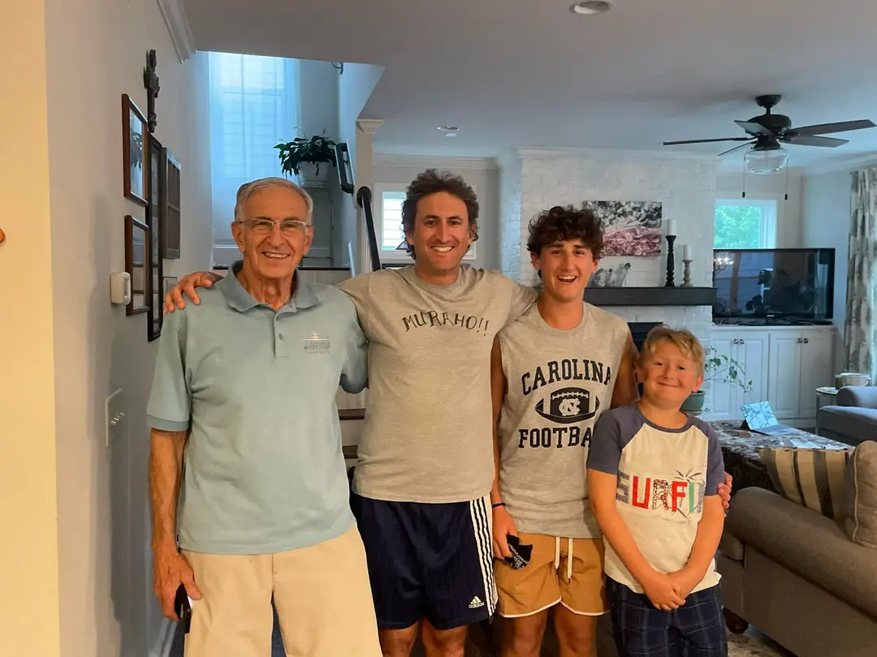

69: Ron Greto, son Michael, and grandsons Joseph and Thomas

Chris and Judy Kreiler took a cruise in May from Los Angeles to Fort Lauderdale, with major port stops in Puerto Vallarta, Panama City, and Cartagena. Chris commented that the ship was small enough to fit through the historic locks and that there were no pumps at any of the locks; water flow into and out of the locks operated on gravity. A photo of Chris in Puntarenas, Costa Rico is included in this edition of The Bulletin’s Where have you been with your Bulletin.

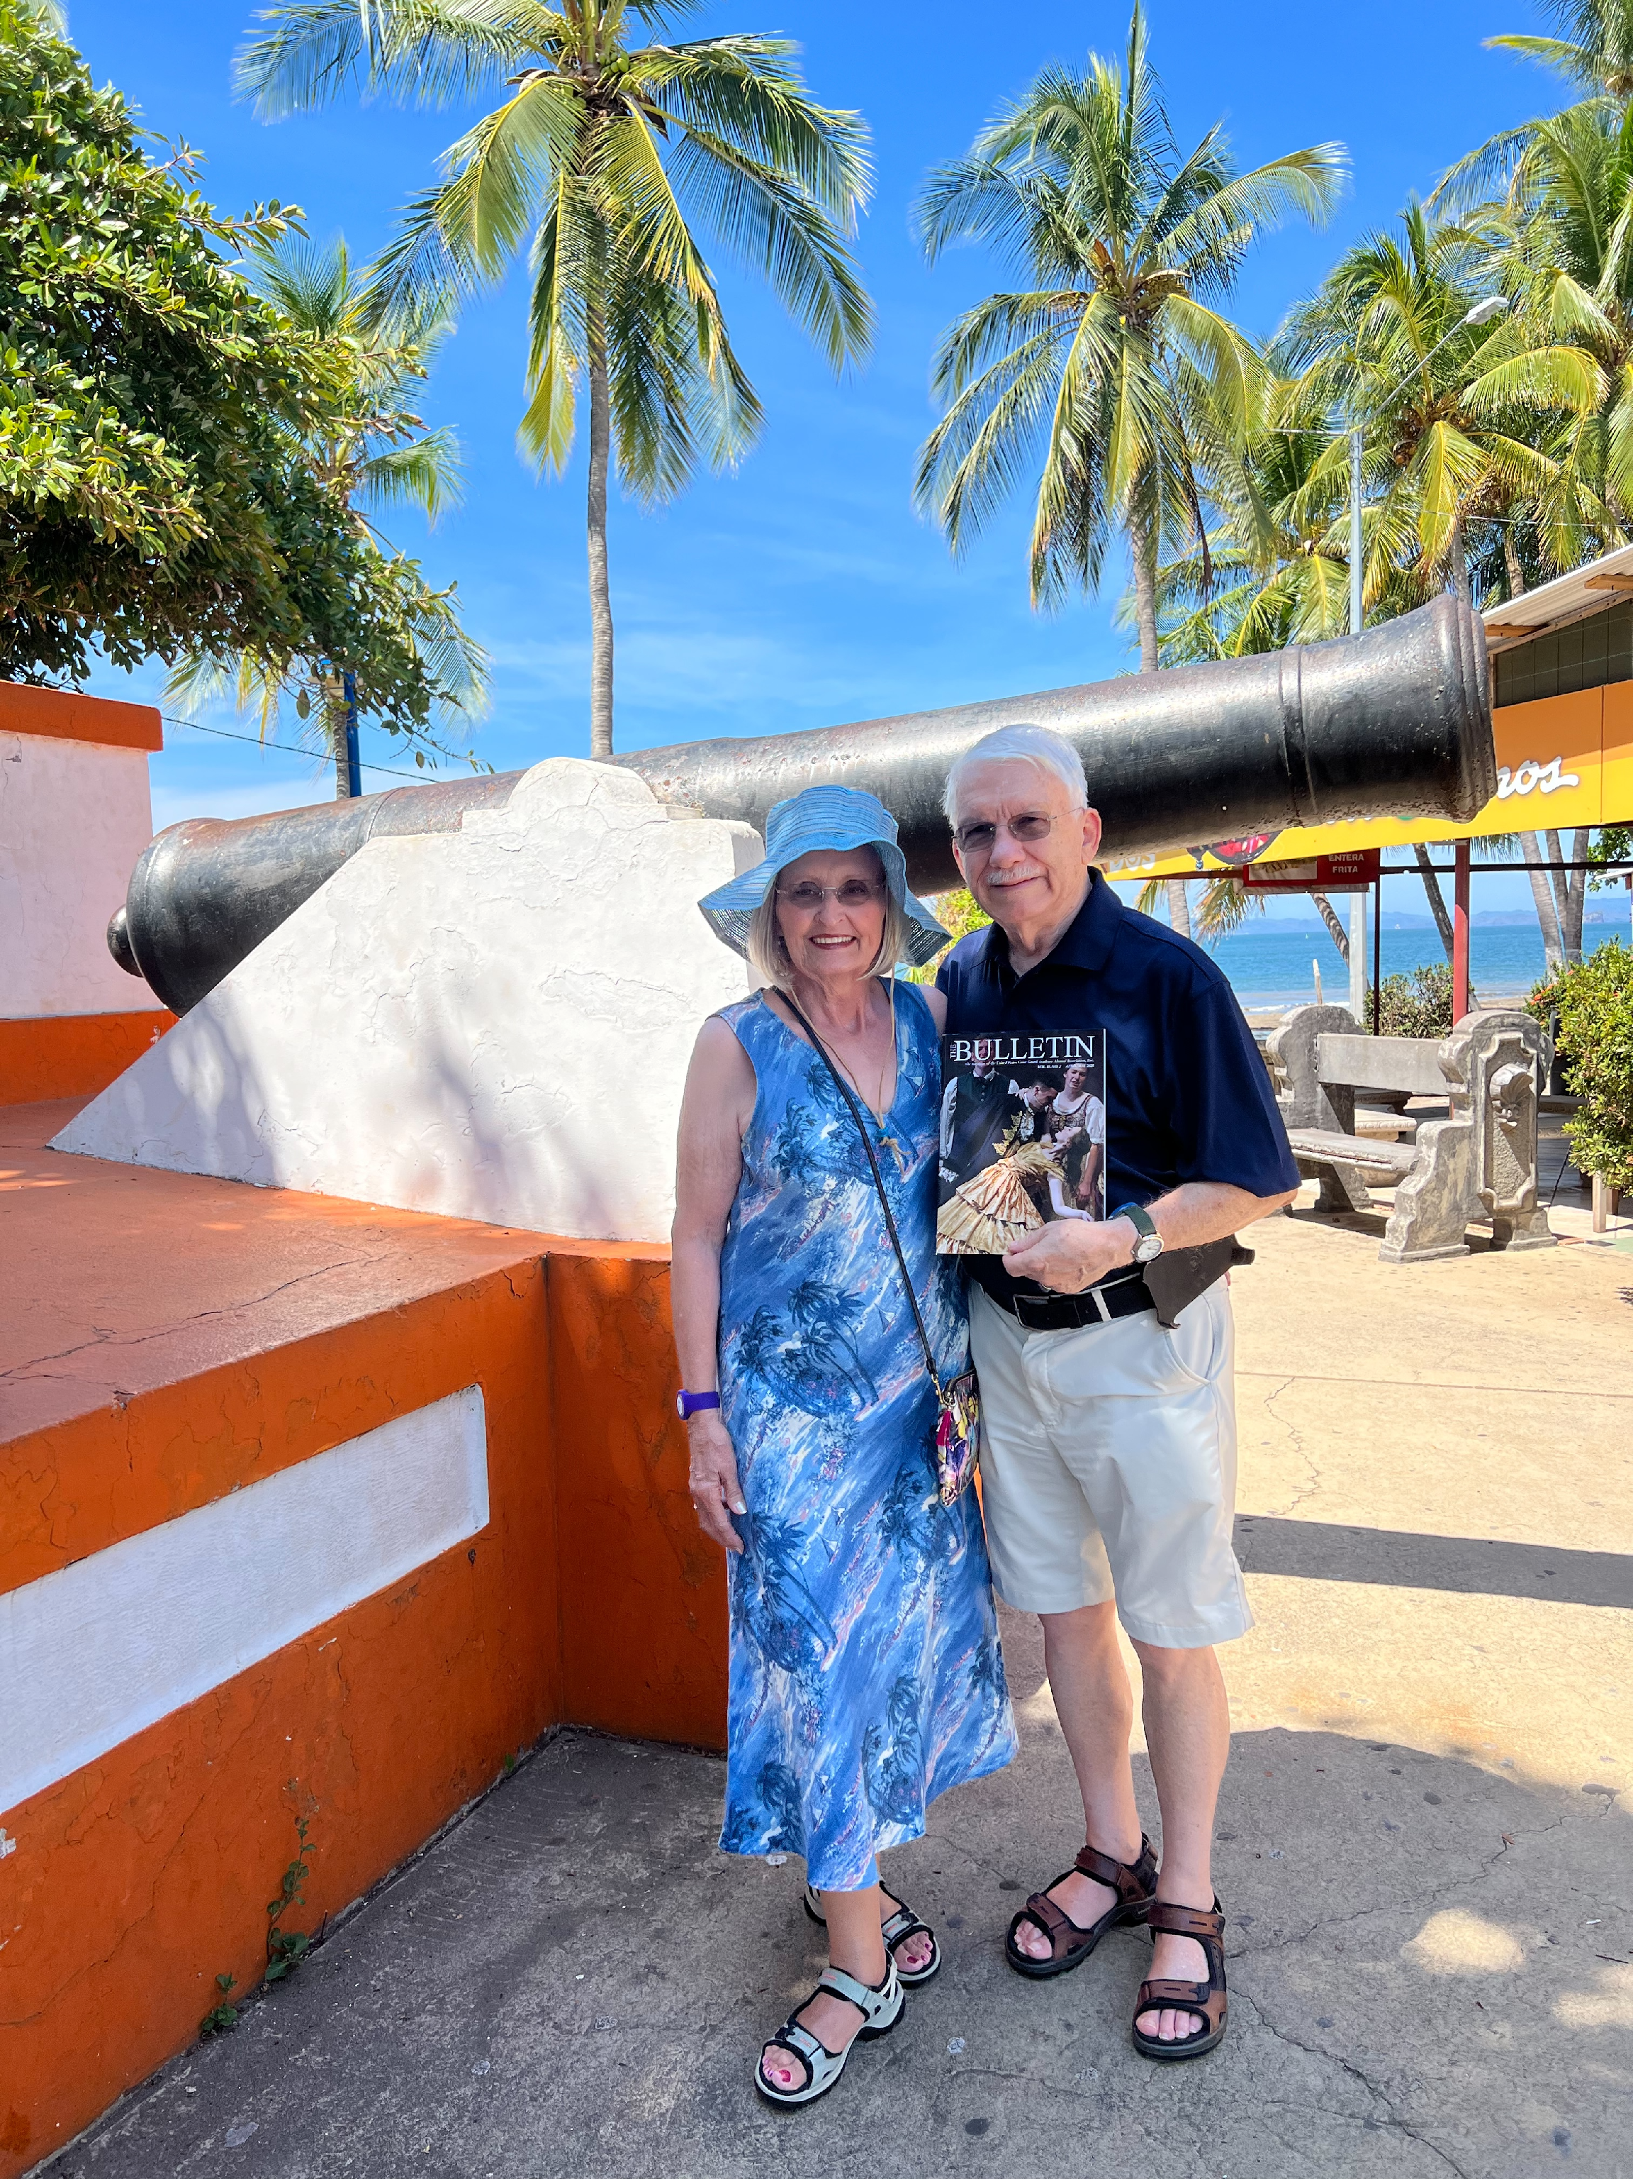

Chris & Judy Kreiler '69 ashore in Puntarenas, Costa Rico, on their cruise from Los Angeles to Fort Lauderdale via the Panama Canal

Jerry and Kris Hale flew to Fort Myers in May to visit a rental property and took some time to view the storm damage at Fort Myers Beach. The Coast Guard station at Fort Myers Beach was new when Jerry arrived at Group St Petersburg in 1983 but was totally destroyed by Hurricane Ian in September of last year. Construction on the replacement station is well underway. Jerry and Kris spent two nights visiting high school friends in Southwest Florida and then two nights with good friends Walt and Mary Ann Miller ‘75 in St Petersburg before joining son Ben’s family for three nights in Orlando.

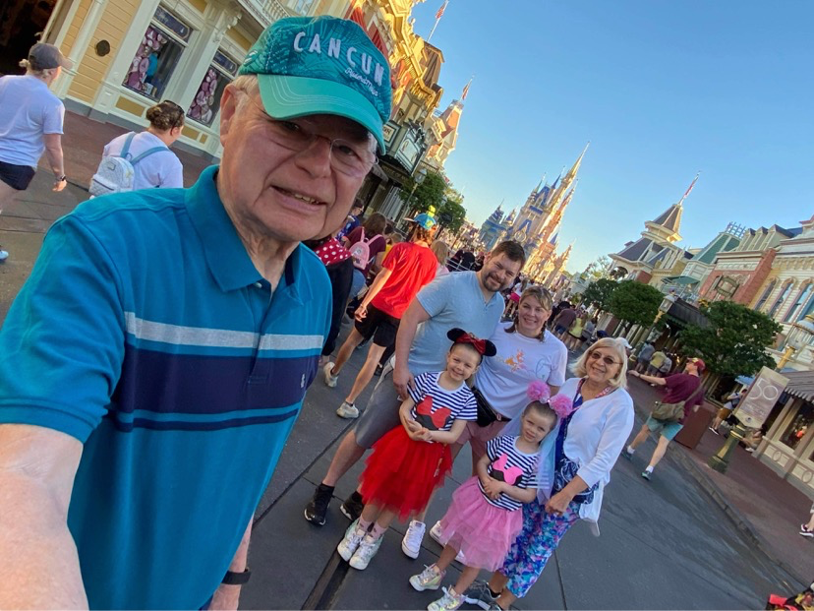

69: Jerry & Kris Hale with son Ben and his family in Orlando

An attractive photo of Ted and Kathleen White and Bob and Lois Acker was posted on Ted’s Facebook page with the caption ‘Happy 54th Anniversary to the four of us’. An e-mail outreach to Kathleen came back with the comment “Bob and Lois Acker recently moved to our community so we are having a lot of fun reconnecting!” Facebook also revealed that Ted’s birthday was on June 4th, a date we can all remember fondly.

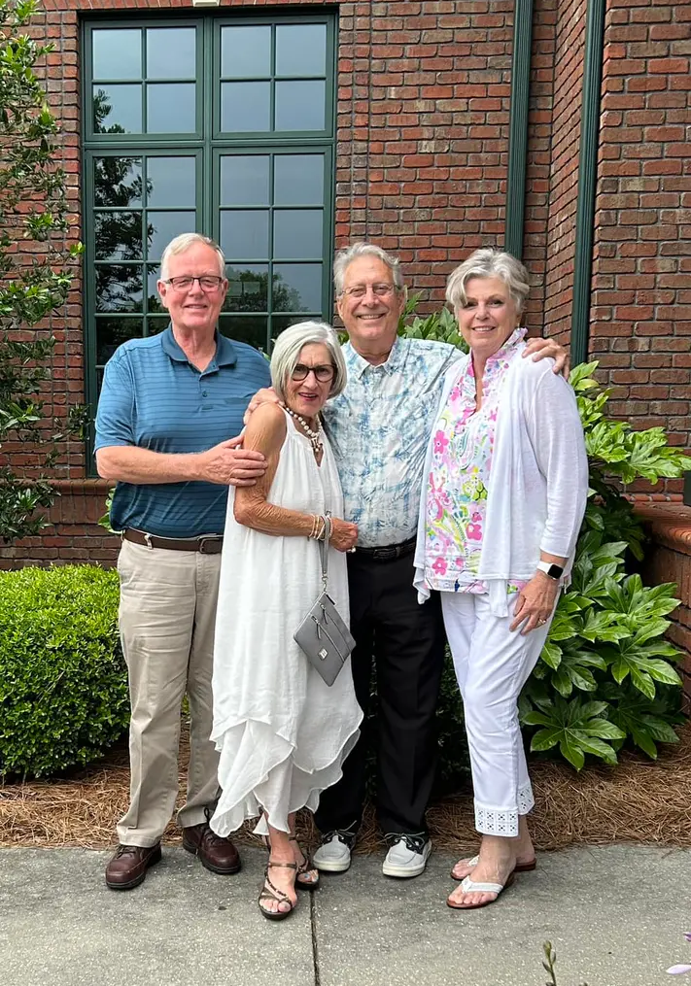

69: Ted & Kathleen White and Bob & Lois Acker celebrating their 54th Anniversaries

Wayne Six ’68 sent me a note to keep the record straight on icebreaker assignments of Academy graduates in the late 1960’s. In the February/March 2023 Bulletin, I incorrectly identified one of the CGC Staten Island crewmembers in the photo from the 1970 Arctic West deployment. “The Dave Potter on the Staten Island was an Officer Candidate School (OCS) graduate who I am still in contact with, and not my classmate Dave Potter. I suspect that the unknown junior officer is Harvey Hudson, an ETC that went through OCS and reported aboard the Staten Island as an Ensign at the same time John Vitt, Jim Soland and I after graduation in 1968. Anything Fred Schmitt or Jim Pennington ever said about the Staten Island and our time in Seattle was true; there was not much that anyone could have made up about that ship and that period of time!” Thanks, Wayne, your feedback is appreciated.
I end this column with a sad note from Chuck Hill. “July 3, 2023: Our bright, stubborn, thoughtful, perpetually happy, quadriplegic, transgender daughter, Charlotte, passed as a result of cardiac arrest. Despite all the difficulties, we were lucky to have her live with us for 51 years.”

