December 2012

’69 CLASS CORRESPONDENT

CAPT Bob Gravino
2 Summer Street
Ipswich, MA 01938
(978) 356-0825 (H)
E-mail: rcgravino@aol.com
Web: http://www.uscga69.org

JOHN ZEIGLER continues his interest in competitive swimming that began in Winter Garden, Florida, where he earned four letters at Lakeview High and was the Orange Belt Conference 100 yard breaststroke champion for two years and third at the state high school meet his senior year, before swimming as a four year varsity letterman and team captain at the Academy. Attached is a photo of Roddy Gaines, 1984 gold medalist and 2012 London Olympic swimming TV analyst, presenting JOHN the 65-69 age group high point award at the Fourth Roddy Gaines Classic Masters Swimming Short Course Meters Meet in Orlando. JOHN won eight gold medals, two silver, and two bronze medals in three days of the Dixie Zone Championships, winning the 1500 meter freestyle, 400 meter individual medley, 200 meter individual medley, 200 meter butterfly, 200 meter breaststroke, 200 meter backstroke, 100 meter backstroke, and 50 meter breaststroke. JOHN swims on the Georgia Masters Team which won the 2010 Atlanta Short Course Large Team National Championship and the 2011 Long Course U.S. Masters National Championship at Auburn University. Georgia was third in the large team race at the 2012 Short Course Championship in Greensboro, North Carolina, in April. JOHN has swum for the Georgia Masters for 35 years and the Gold Coast Masters in South Florida for five years.

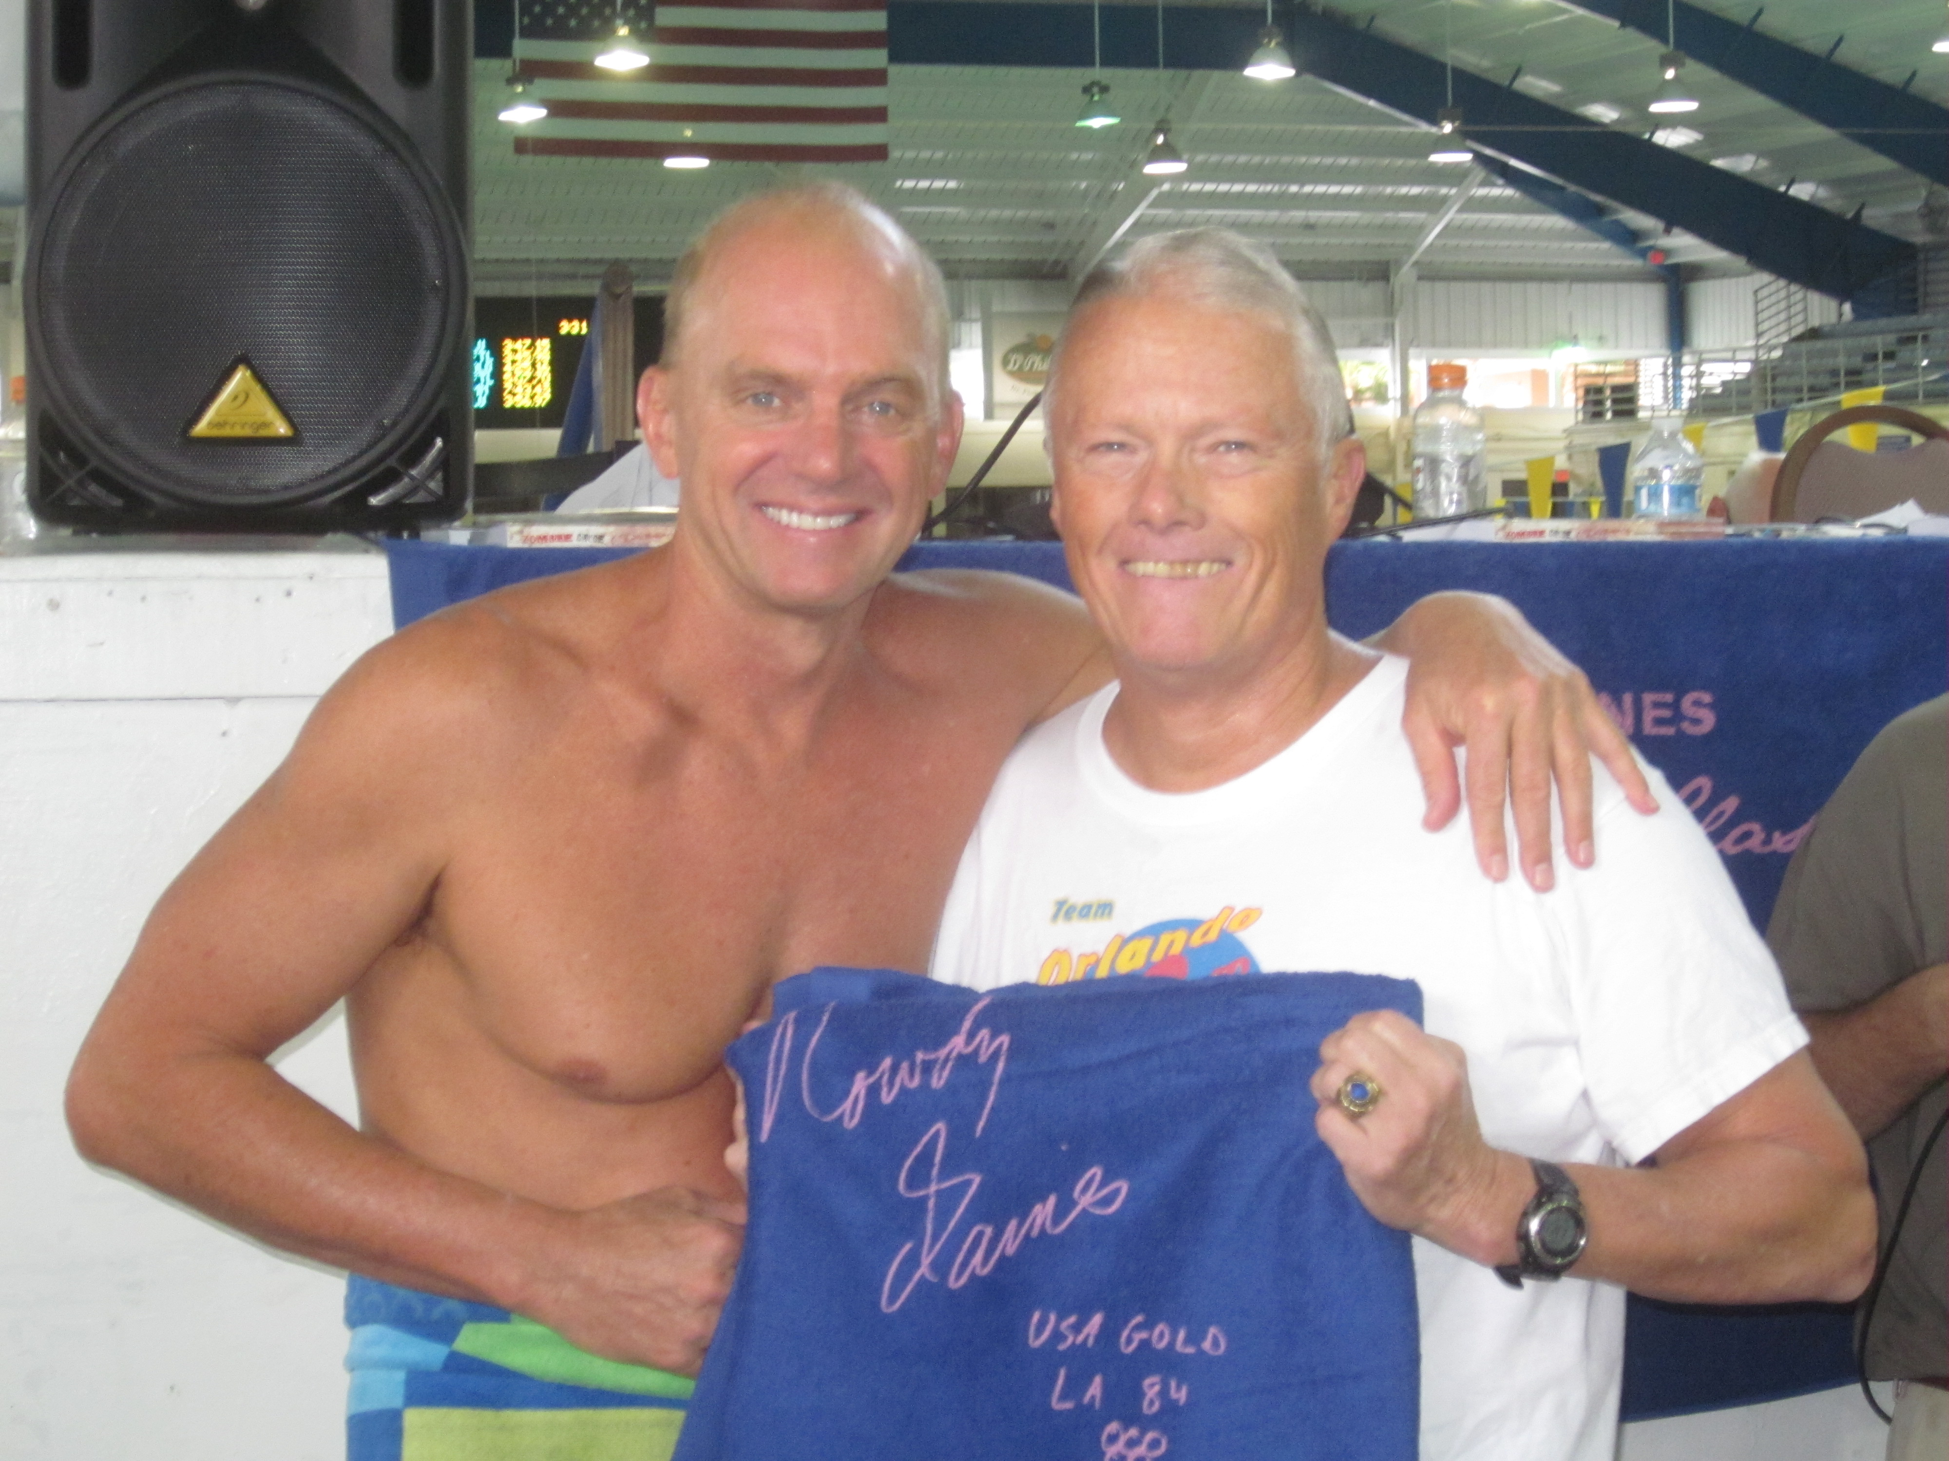

1969: JOHN ZEIGLER & Roddy Gaines

JIM BURK reports that the Western Carolina “Senior Sensitive” Golf outing took place again this year in the Shelby area from September 5-7. Those in attendance included STU WHITE, BARRY KANE, WALT MCDOUGALL, JOHN MINER, Ron Hindman, RON GRETO, JIM BURK and FRED SCHMITT. The photo shows the group at Mount Mitchell Golf Club in the North Carolina mountains. JIM comments: “Attendees brought such things as crabs and shrimp, brownies, sand bagged handicaps and strange political leanings. But as always, it was a great time.”

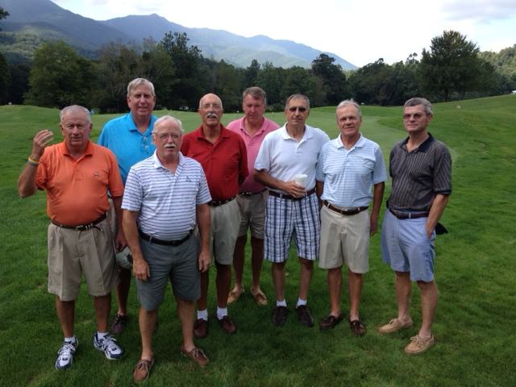

1969: The Western Carolina "Senior Sensitive" Golf Outing

A video was circulating on the Internet featuring The Ventures and their original 17 year old drummer who left after eight months, went into the Air Force, became a four star general, and came back to play with them again, in uniform. I forwarded the website to our very own drummer, JIM SMITH, and received the following from JIM: “I remember The Ventures well. I loved them, all instrumentals. ‘Walk Don’t Run’ was their big hit, but they did several other cover-albums that I still have (no turntable, though). Later they did the theme song for ‘Hawaii 5-0’. Their guitar players used Mosrite guitars; never heard of them since! One of The Gents (Jim Townley CGA ’67), sent this clip around to the rest of us. The drummer who played later while The Ventures were famous has since died. So, there’s the stark contrast; drummers can go on to be 4 star generals, or dead. A LOT more of them are dead than four star generals! Speaking of The Gents, we played in September at CGA for ‘67’s 45th Reunion. ’68 also wants us to play next year. MARILYN and I had dinner with BOB and BARBARA THORNE during Homecoming weekend, and as the resident class reunion coordinators, they are the authority, and …we’re baaaaaacccccckkkk for ‘69’s 45th Reunion, too! Hot dog☺. We’ve got some new songs, but still adhering to our “genre”, 1960’s rock-n-roll. Or, close anyway. ‘Walk Don’t Run’ is not on the playlist yet, but I’m pushing for it!”

BARRY and BETTYMARIE KANE spent three weeks in Portugal, Spain and Ireland in October. “Guinness Beer and Tullamore D.E.W. Irish Whiskey—both pub favorites.”

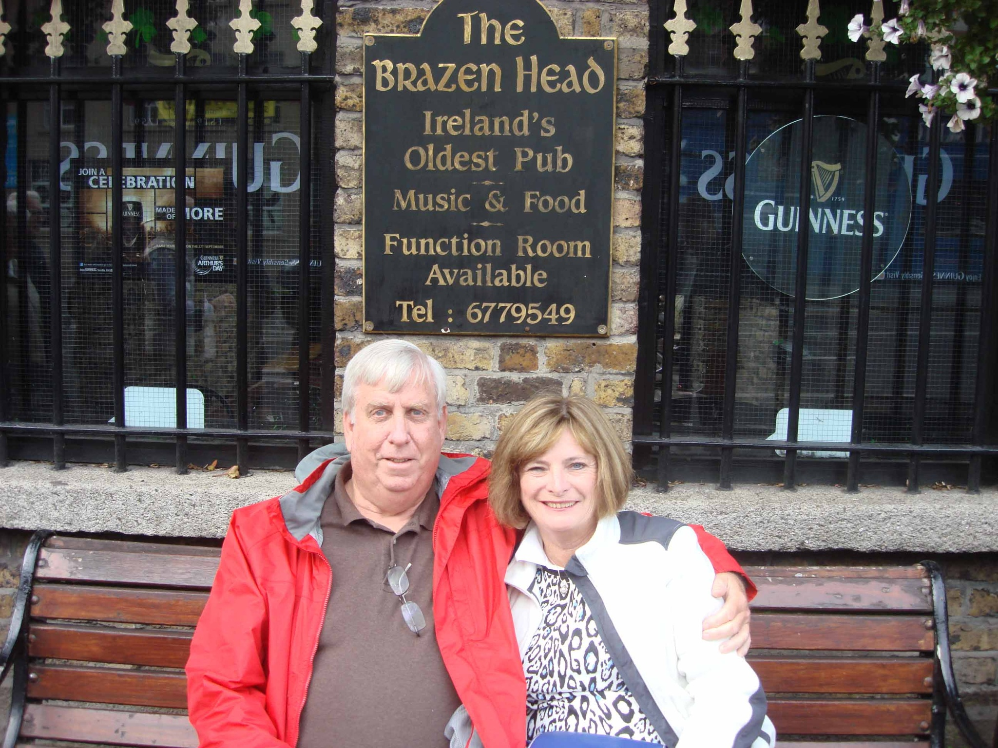

1969: BARRY & BETTYMARIE KANE in Ireland

BRUCE GRIFFITHS was in Hawaii in September where his outrigger club raced two crews in the world’s largest and longest iron man outrigger race. He explains: “I’m sitting in seat three (from the bow) as we cross the finish line after our 18 mile race down the coast of the big island from Honaunau (Refuge). We got to be tourists again as GAIL and I returned to Volcanoes National Park to see how Kilauea was doing; still active as the picture attests. It would be fun to find out if there are any other outrigger paddling Academy alumni. The sport has been an amazing find for me; a competitive team sport (we placed 6th in the 55 and older category) full of interesting Hawaiian culture and aloha spirit. This coming season will be my 5th. If anyone visits San Diego, I’ll arrange a paddle.”

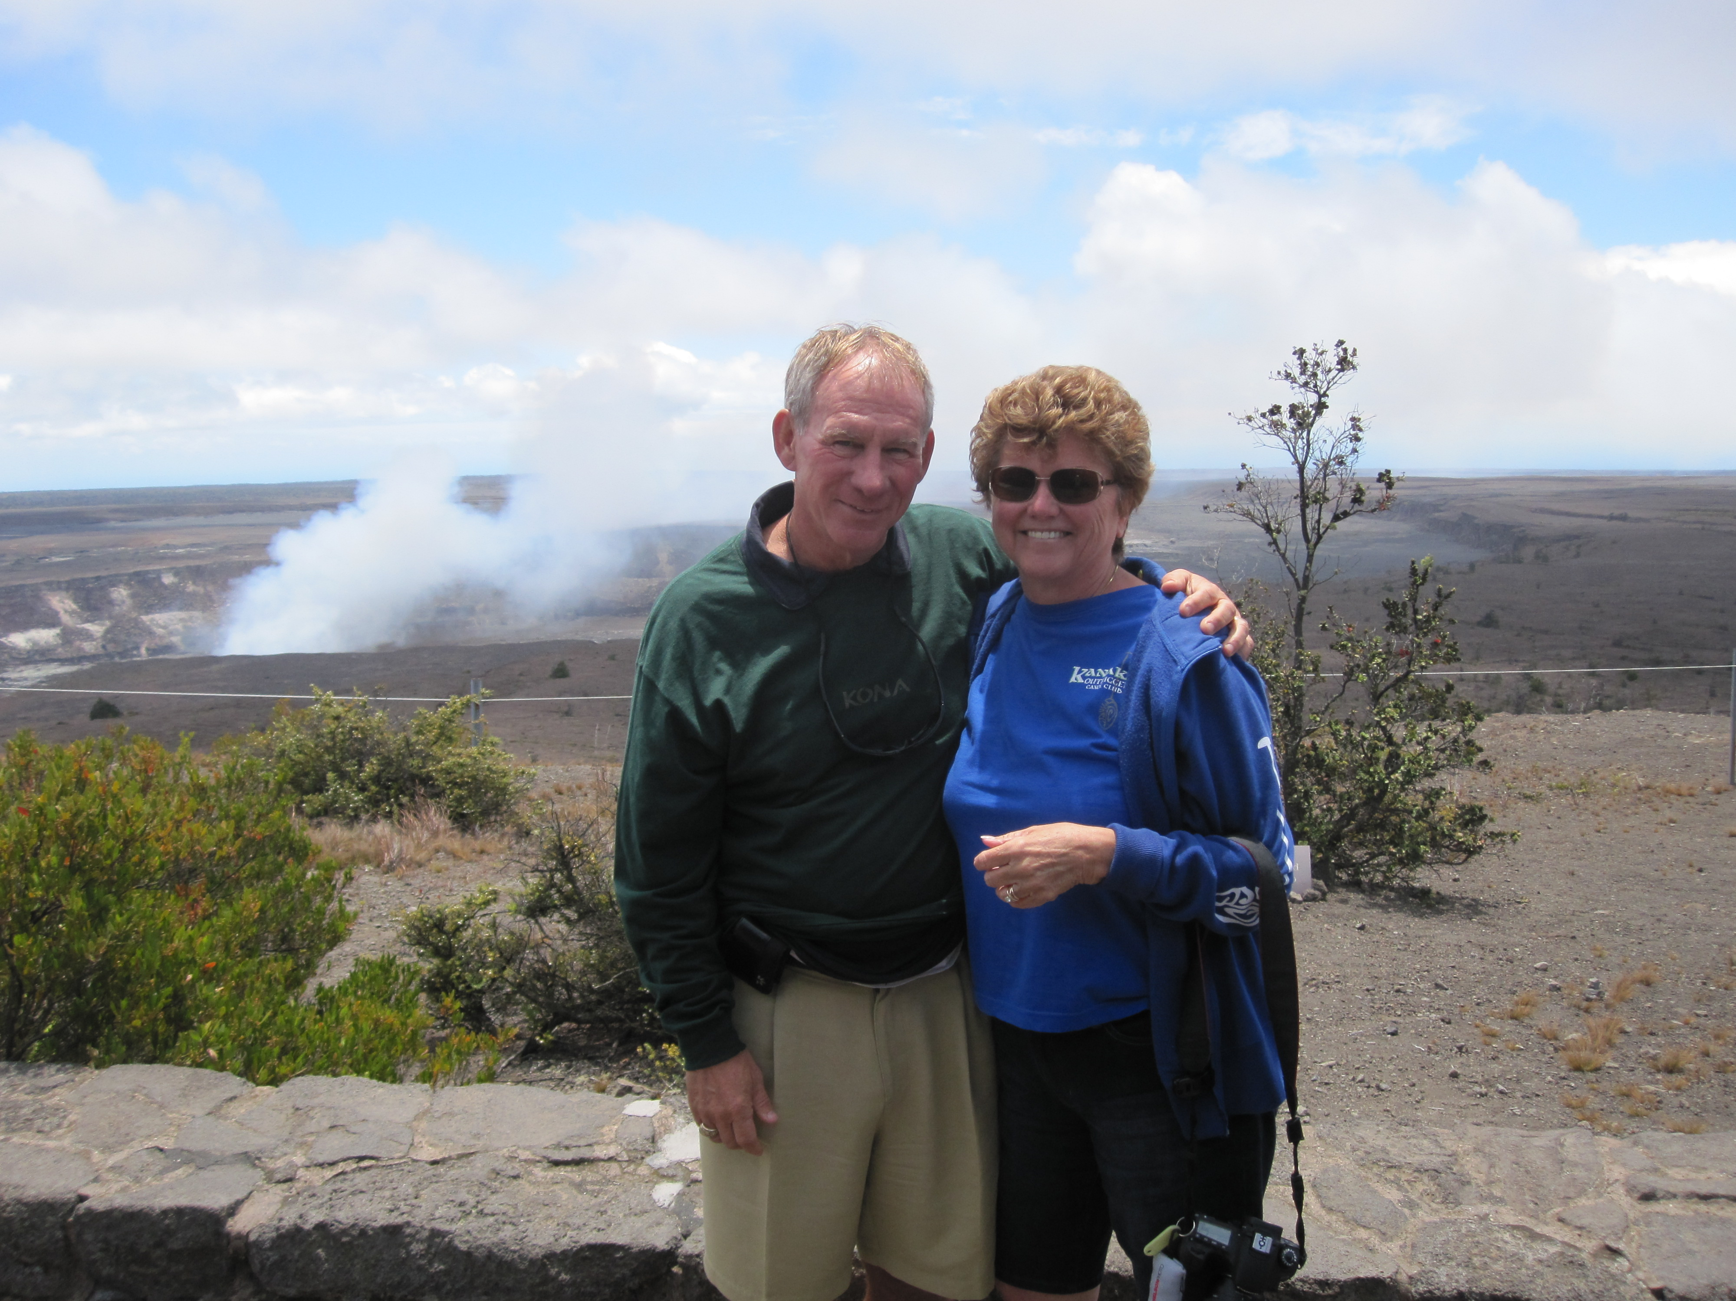

1969: BRUCE & GAIL GRIFFITHS at Volcanoes National Park, Hawaii

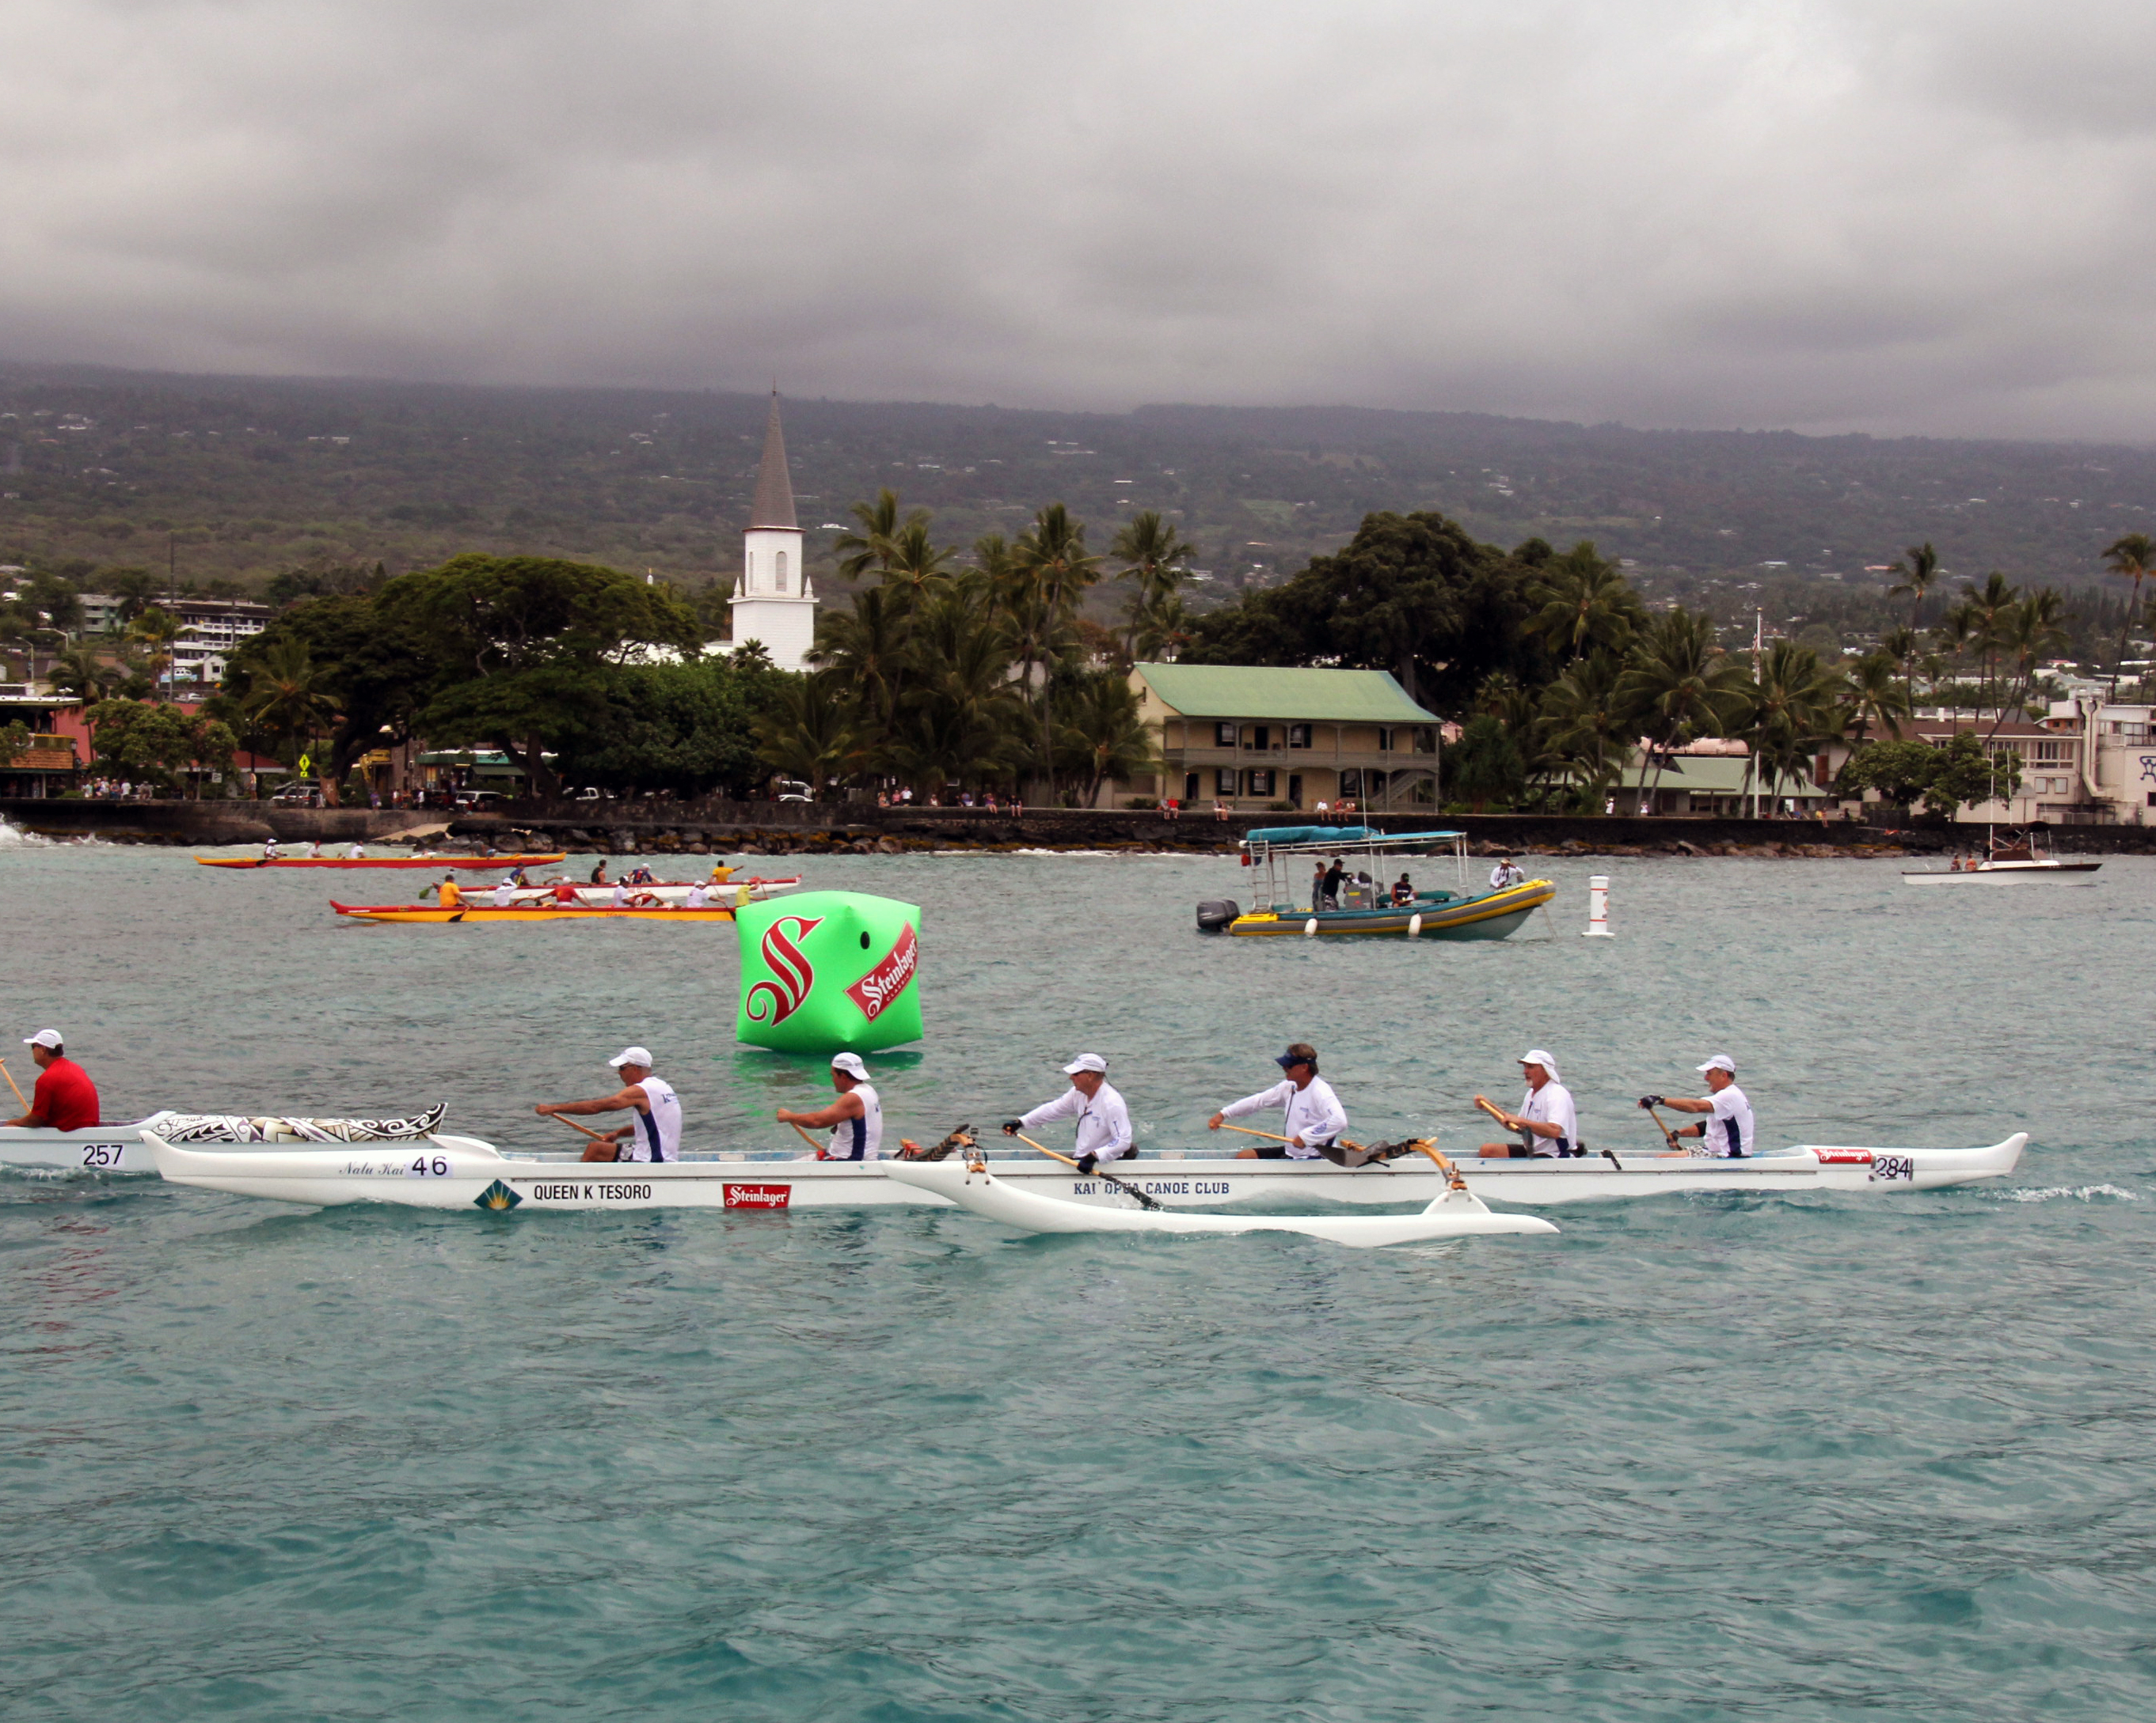

1969: BRUCE GRIFFITHS paddles his way to victory in Hawaiian outrigger race

In the April 2012 Bulletin, I reported that MIKE and JUDY BILLINGSLEY had sailed in May 2011 on a Hurtigruten cruise along the west coast of Norway from Bergen to Kirkenes, visiting Norwegian fiords and coastal ports. In September, KATHY and I took the same trip with some Ipswich friends, which included crossing the Arctic Circle and the traditional baptism with ice water by King Neptune. We also made a four hour port call in Tromso, where BOB GLYNN, RICK GUPMAN and I spent three days in September 1970 while serving our first tour out of the Academy on the USCGC Southwind, a Wind Class Icebreaker homeported in Baltimore. Much had changed since my last visit 42 years previously, including the difference in accommodations between the two vessels. One of the highlights of our time in Norway was the delicious seafood and beer that Norway had to offer. I especially enjoyed a beer that we tasted in Bergen, named FRYDENLUND. Now I understand what DAVE meant when I quoted him in the October 2012 Bulletin as saying “Having been raised with an old Norwegian ethic…” Unfortunately, I have not been able to find FRYDENLUND beer here in the States.

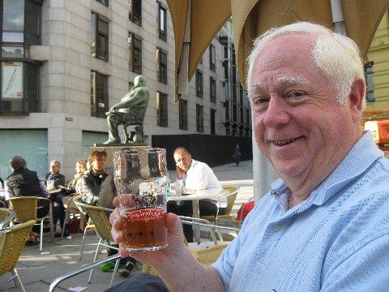

1969: BOB GRAVINO enjoying a FRYDENLUND beer in Bergen, Norway

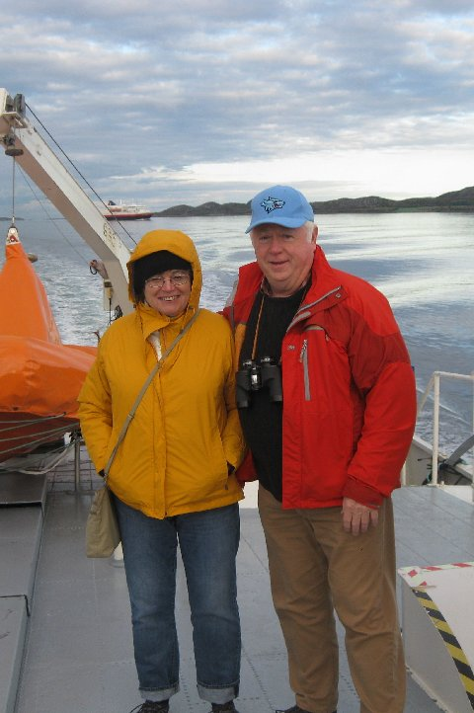

1969: KATHY & BOB GRAVINO on the Norwegian M/S Kong Harald

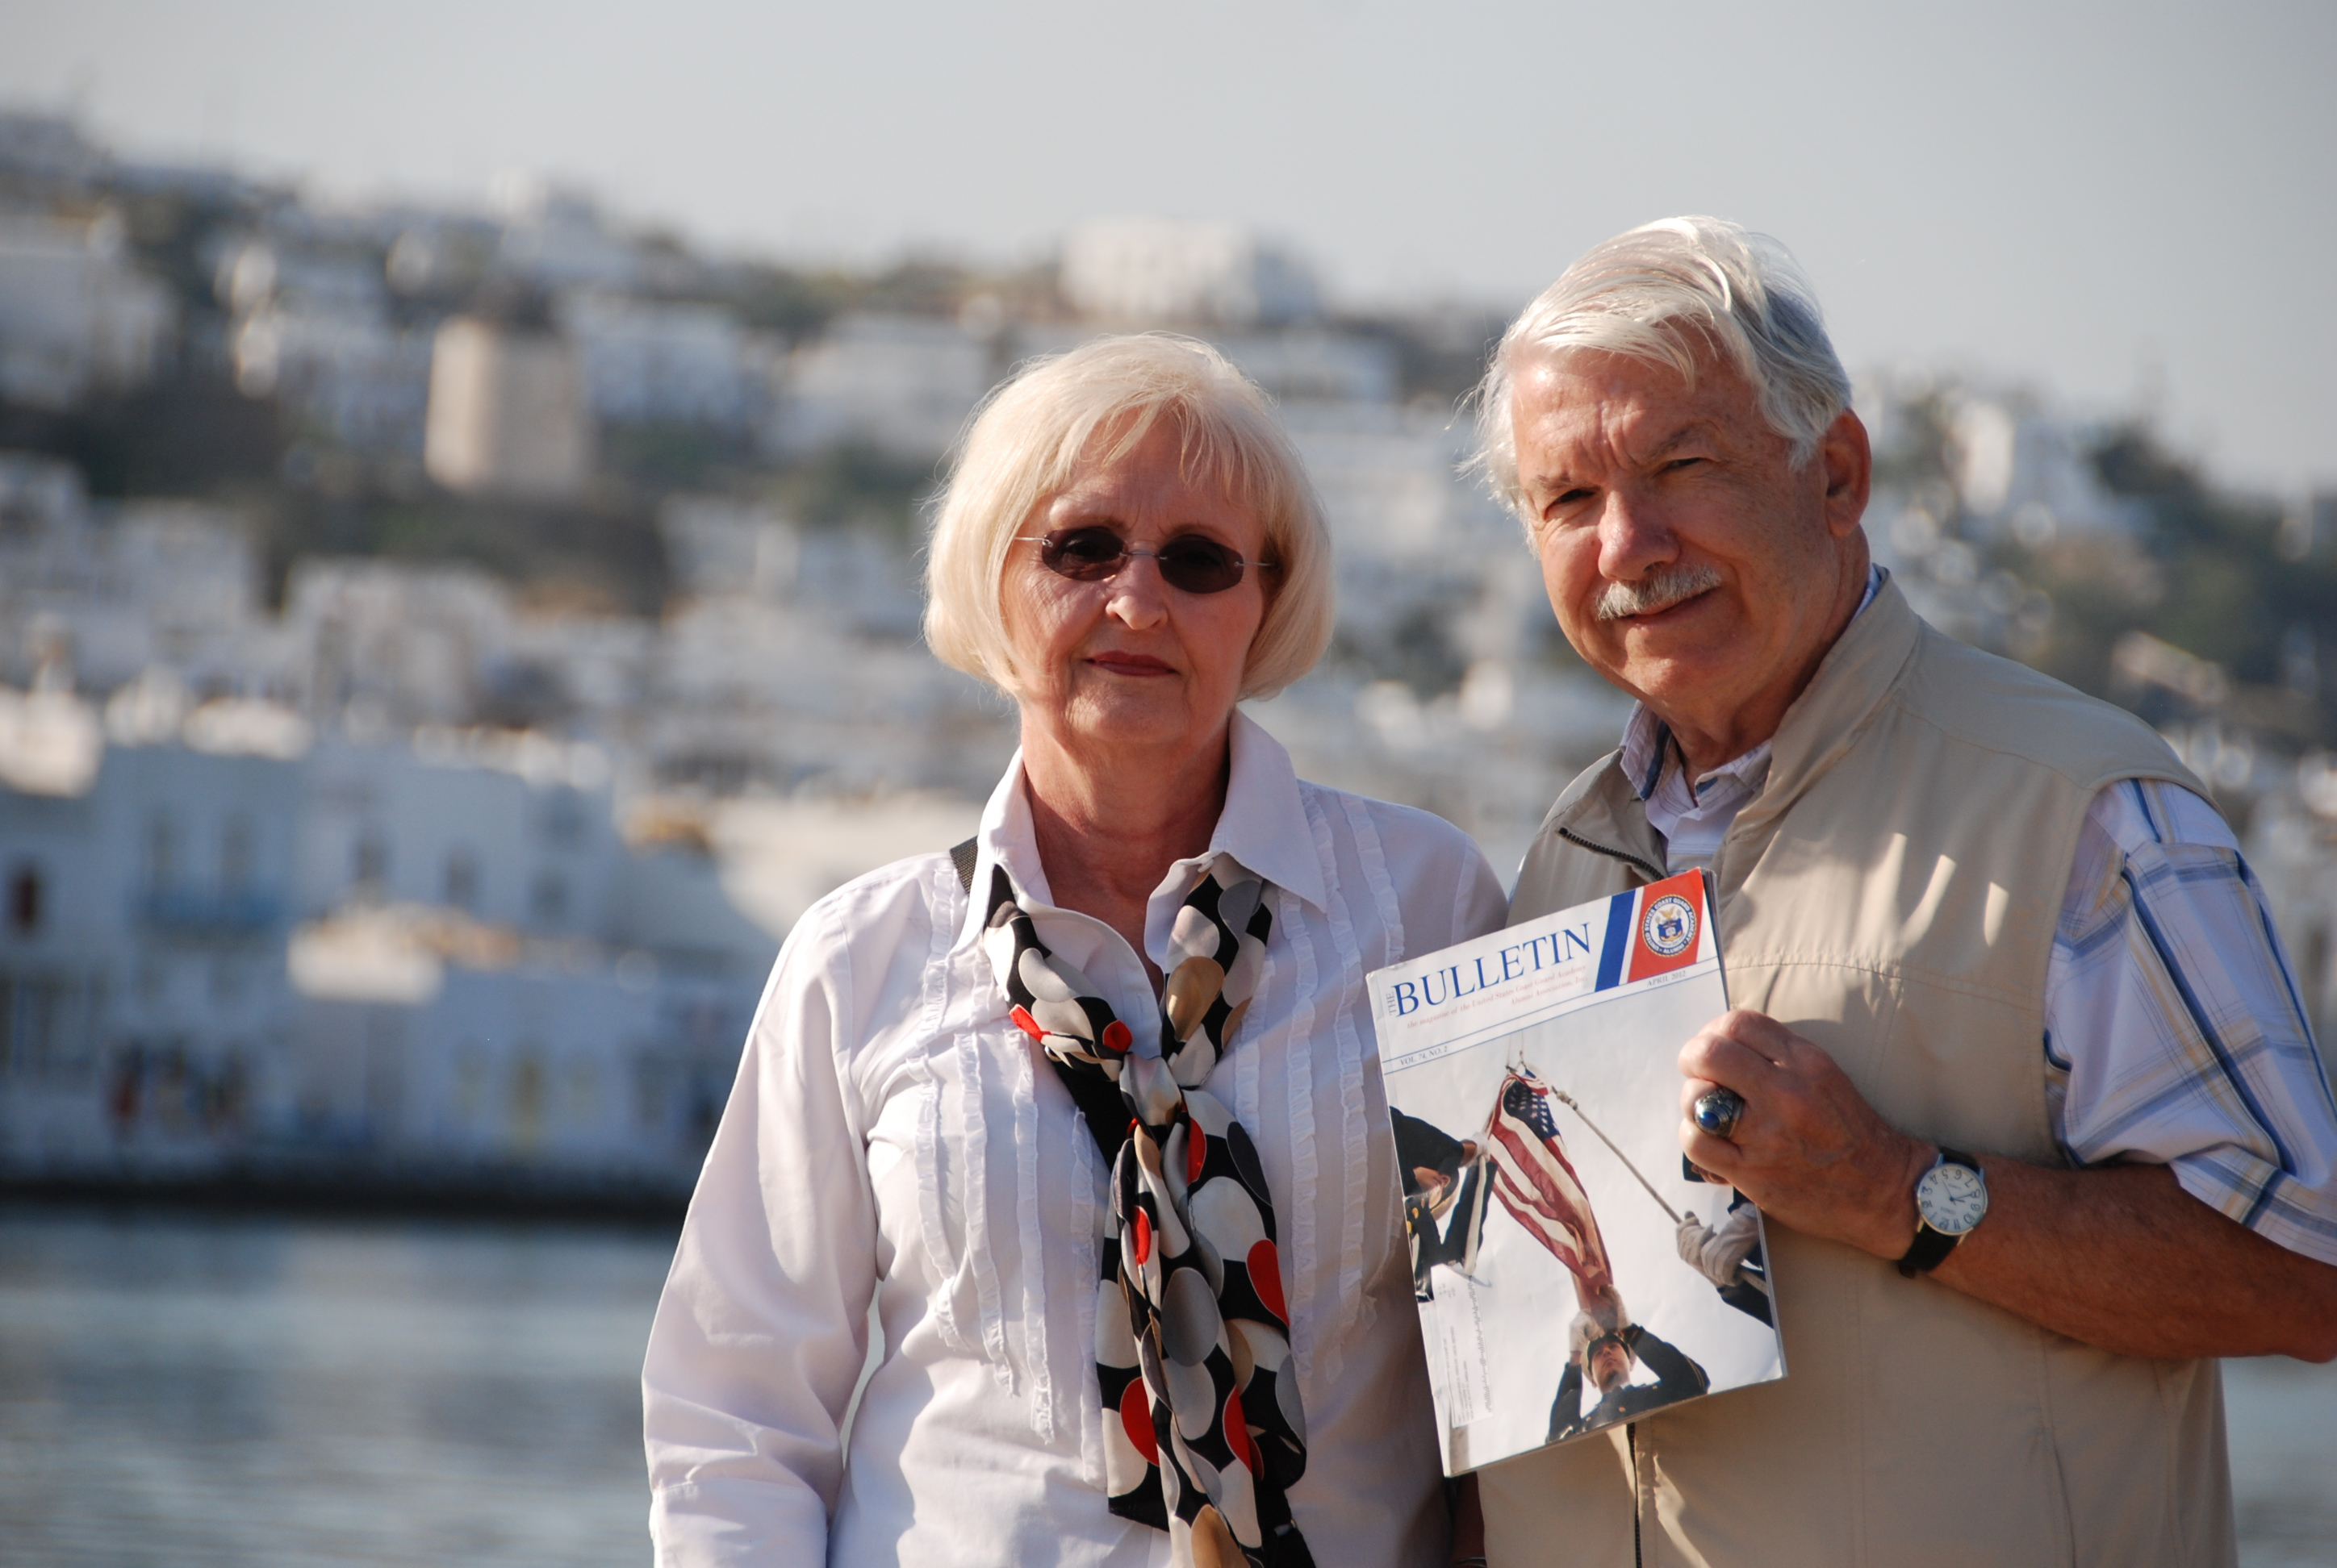

1969: CHRIS & JUDY KREILER in Mykonos, Greece, with Ancient Literature

