December 2018
’69 CLASS CORRESPONDENT
CAPT Bob Gravino
2 Summer Street
Ipswich, MA 01938
(978) 356-0825 (H)
E-mail: rcgravino@aol.com
Website: http://www.uscga69.org

Why the photo of Jim Smith? He’s getting ready for The Gents gig at our 50th Reunion at Homecoming on October 5, 2019, which we are told will be the last performance of their 54 year career. This is a good time to mark your 2019 calendar to set aside the weekend of October 4-6 for the 50th. The unveiling and dedication of our 50th Reunion class gift of the George Washington statue is going to be on the morning of Friday, October 4th, so classmates will need to arrive on Thursday to attend the class gift presentation ceremony on Friday morning. Jim Smith, Wayne Gronlund, Bob Thorne and Kathy and I were present for the dedication of the Class of ’63 statue of Alexander Hamilton on the Friday morning of this year’s Academy Homecoming. The Hamilton statue is impressive and is located adjacent to Hamilton Hall, looking to the Washington Parade ground toward where our gift of the George Washington statue will be located. The evening before, classmates and spouses had dinner in Mystic and discussed ideas for the 50th Reunion.



1969: Jim Smith, Drummer for The Gents

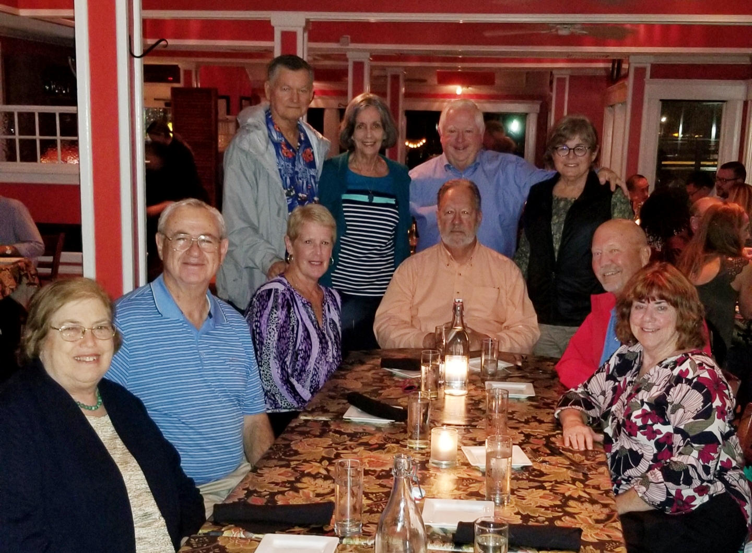

1969: Barbara & Bob Thorne, Debbie & Wayne Gronlund, Paul & Candace Bodenhofer, Jim & Marilyn Smith, and Bob & Kathy Gravino

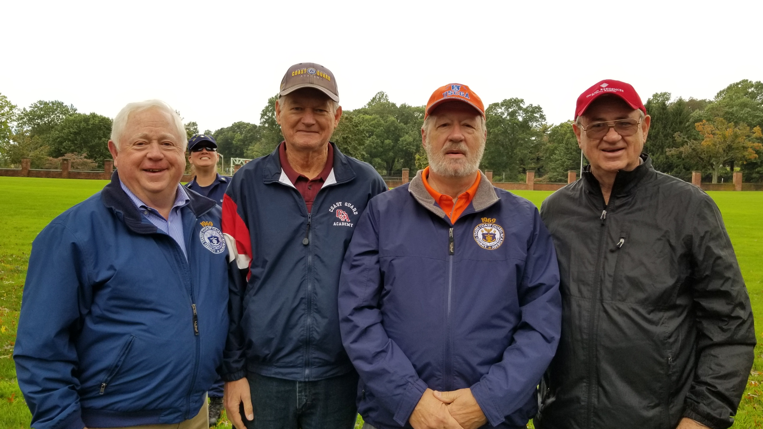

1969: Classmates at the unveiling ceremony of the Alexander Hamilton statue

The last column in The Bulletin reported that Hurricane Florence produced only wind and rain as it passed through the regions of North Caroline where John Miner and Stu White lived, and that the Kanes and McDougalls had evacuated from Wallace, North Caroline, to get out of harm’s way. Barry sent a photo of the area of River Landing where he and Walt lived, showing flooding up to the windows of the one story homes. Barry’s comments: “This was about a half mile from Walt’s house. He has a one story house and there was almost 3 feet of water in the house. He is living in an apartment in Wilmington - probably for the next 6-9 months. Of the 480 homes in our community, about half are uninhabitable. We were lucky - the guy across the street had his crawlspace flooded - had to replace ducting and air conditioner - but our home stayed dry.” The following was received from Walt McDougall shortly thereafter: “Alive and well in Asheville. Kathy, Heather, the three dogs and I evacuated Wednesday night. Due to flooding, I probably can't get home to assess damage for at least a week. No power. River exceeded historic high flood level by 5 feet. Plus a few more inconveniences.” Four days later: “Still in Asheville. River Landing remains flooded. Ted White said that I probably have 2-3 feet of water in my house. We do not have flood insurance because we’re in a 500-year flood plain. Ted’s house made out okay. He also said that Barry’s home escaped any flooding. Flood waters are receding, and I may be able to get back this weekend to assess damage and start restoration. No power in River Landing since substation went underwater. Good opportunity to start decluttering.”
John Zeigler shared his Hurricane Florence experience and added some family notes. “After a week of above normal warm temps, the landfall of the hurricane gave North Georgia hot air, no rain, and cloudy weather. It was over 90 degrees for over a week after passage of the storm. I swam in the Pan American Games Masters swim meet in Orlando in early August, and on Coast Guard Day, Carol and I celebrated her mother's 90th birthday with two Coast Guard Academy graduates attending, her grandson George Borlase (Carol’s nephew and a 1990s era graduate) and myself. I was born in Boston at the Chelsea Naval Hospital and saw my first Boston Red Sox game in Atlanta when the Red Sox swept the series in Atlanta, so maybe my favorite American League team will win another World Series. My best to everyone until October 2019, for our 50th Reunion.”
Jerry Hale started a sequence of seagoing reminisces by sharing that he attended the Coast Guard’s 228th Birthday Celebration at the Philadelphia Union League on Coast Guard Day. “Thad Allen gave a compelling speech on the past and future of the Coast Guard, and in his remarks he spoke about ice breaking and told the audience the Coast Guard was getting a new ice breaker. Great day, great talk!” CGC Staten Island sailor John Curtis then chimed in that when the first breaker is delivered, the Coast Guard needed a tiger cruise to Point Barrow for all the old Wind Class sailors, and to get an authentic feel for the trip someone needed to provide a bunch of WWII movies from the Navy Motion Picture Exchange. CGC Southwind sailors Rick Gupman and Bob Glynn recommended that the old Navy movies not be brought onboard; “they were bad in '69, and I'm sure they haven't gotten better with age!” Dan Carney ended the conversation with another of his personal tales. “I had a crazy experience with those movies. A crusty warrant officer on the CGC Bibb told the executive officer he wanted to be the Motion Picture Officer. Since no officer wanted that job because you got nothing but grief from the crew - including the wardroom - the XO gladly gave him the job. The Bibb was stationed in Boston and the movie locker was in the Navy Shipyard in Charlestown. The WO asked me if I would give him a ride over to the Yard to pick up movies, and we went into the movie locker and this guy behind the counter asked what he could do for us. Without a moment of hesitation the WO asked ‘Can you be bribed?’ I almost passed out. However, the guy didn’t call NCIS; he just said ‘I like scotch.’ The WO said okay, and we were off to the Liquor Locker. The WO bought a bottle of Chivas Regal, and we went back to the movie locker. The guy gave us movies from the Sub Locker; first run movies. We returned to the ship, and as soon as the WO stepped on the Quarterdeck he went over to the 1 MC and piped ‘All hands muster on the fantail.’ The XO and CO both buzzed the Quarterback and asked what that was all about. The OD told them the WO made the pipe. When the crew was assembled, the WO told the crew that each of them owed him fifty cents (to cover the cost of the scotch) and that he would collect the same amount before each patrol to get great movies.”
Historical fact. The Coast Guard had seven polar ice breakers when we were commissioned in 1969: Burton Island (Bob Belote, Bob Henry, Jim Robinson); Edisto (Russ Askey, Dave Blomberg, Jim Gynther); Glacier (John Cwiek, Dave Frydenlund, Howie Waters); Northwind (Jim Cain, Jerry Kemp, Jay Snyder); Southwind (Bob Glynn, Bob Gravino, Rick Gupman); Staten Island (John Curtis, Jim Pennington, Fred Schmitt); and Westwind (Bill Jurgens, Eric Miller, Fred Pryor). The Eastwind was decommissioned shortly before we graduated, and the first Mackinaw (Jerry Hale) was restricted to the Great Lakes and the Storis (Gary Pavlik) to Alaskan waters.
Little known fact: Pete Lenes and Bob Donnee share the same birthday, October 3rd.
Drew Gerfin has been in contact with Jack Bergman and is encouraging him to attend our 50th Reunion in 2019 and become a member of the Coast Guard Ancient Order of Pterodactyls. Jack retired from the United States Marine Corps as a Lt. General, trained and served as a Naval Aviator with the Marines, and was reelected in November to a second term to the Michigan Congressional District that represents Traverse City.
Bob Pokress tells me that his ‘69 Firebird is ready for the 50th Reunion. “The restoration took nine years and is just about done. I took it out for its first highway test drive in early November after not having driven it for 29 years; two decades of sitting idle in my garage followed by the nine years of restoration. I had forgotten how quickly you can accelerate to 60 mph with a 350 cubic inch V-8 with lots of low RPM torque under the hood.”

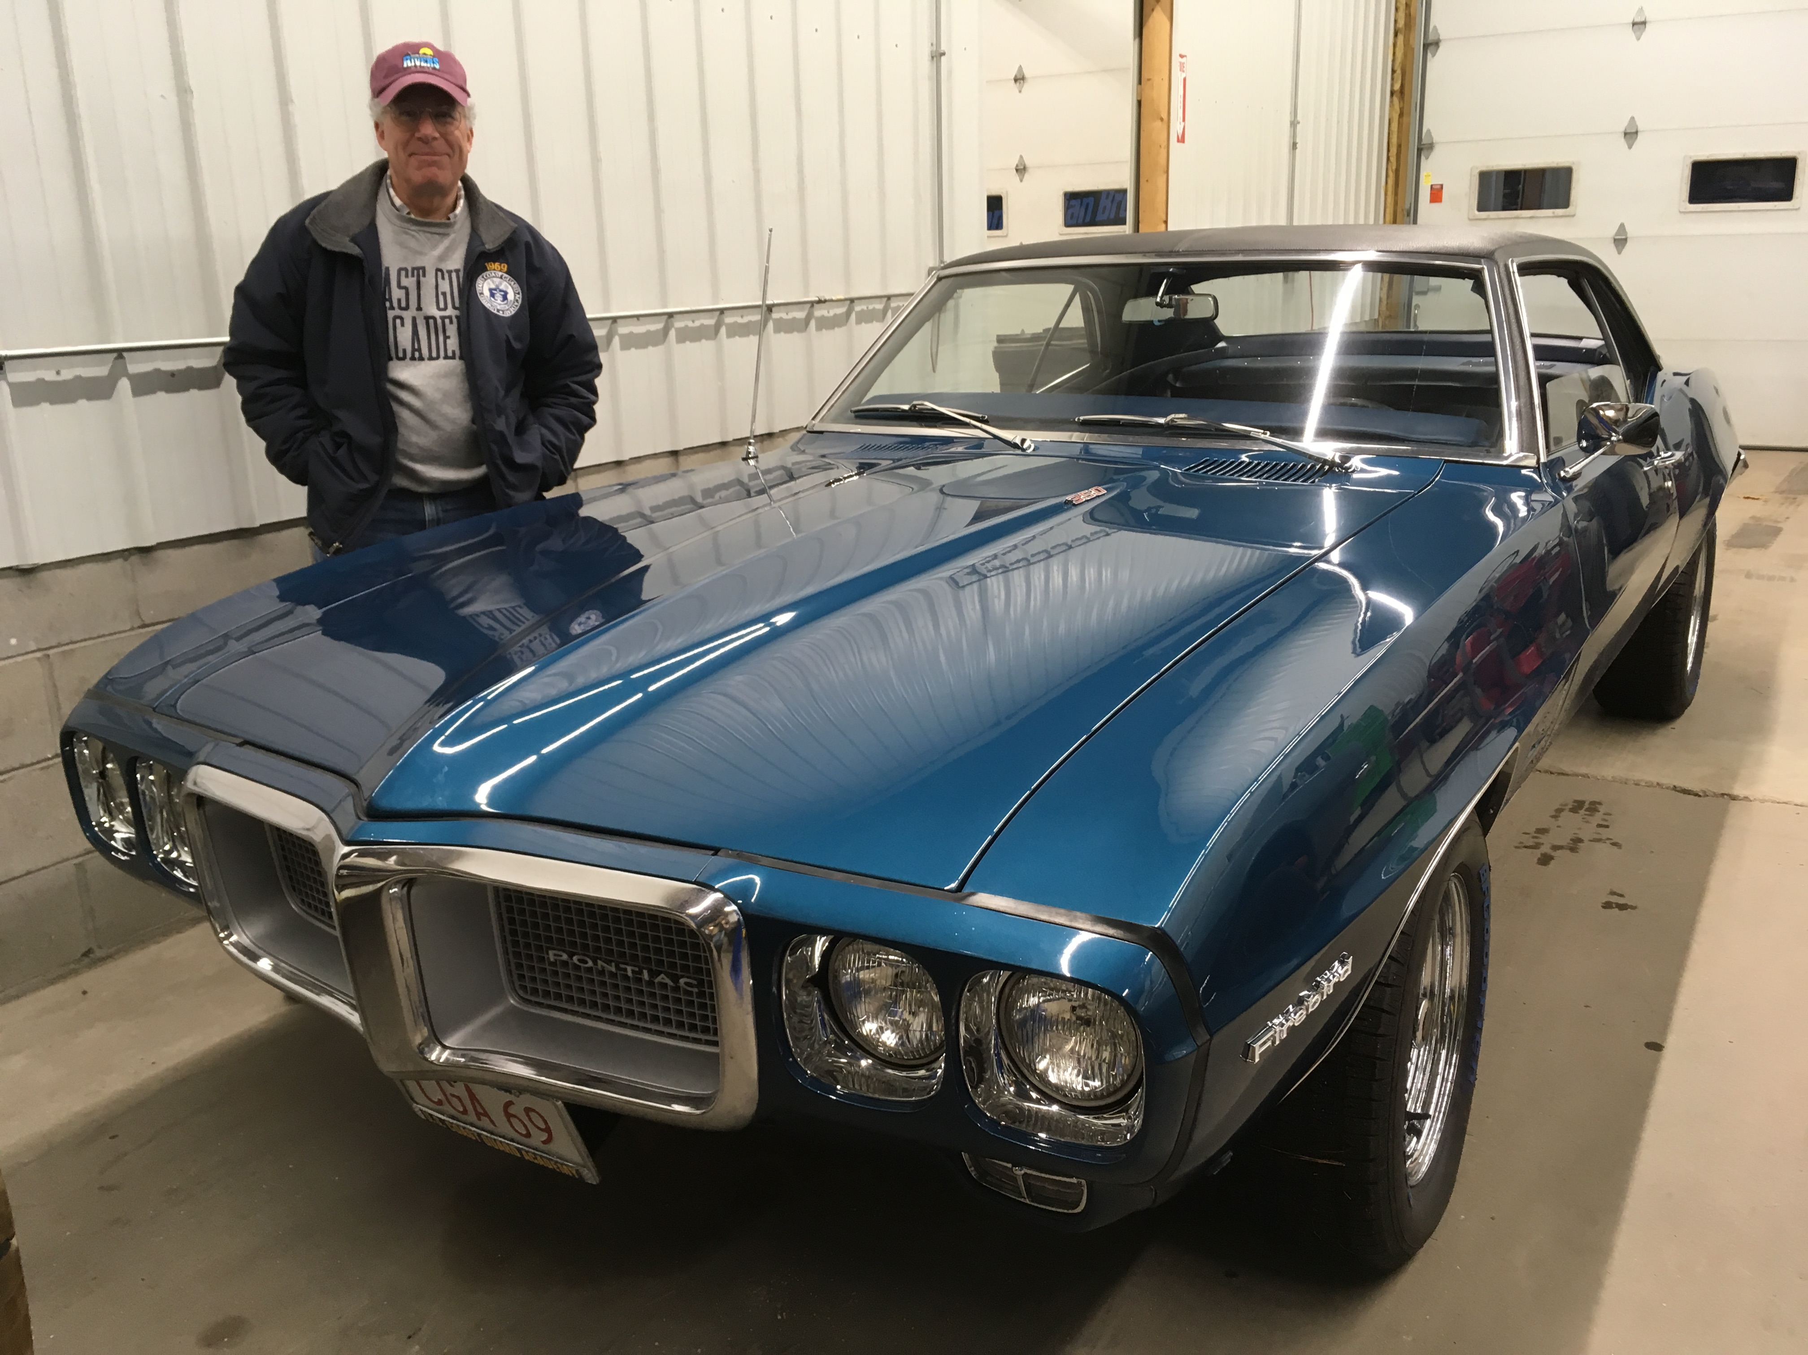

1969: Bob Pokress and his 1969 Firebird

Stu White went on another barge trip with four friends in the Aquitaine region of France on the Canal de Garonne in September. Being the sailor that he is, he did almost all the driving. He visited Jim and Linda Robinson in October to play in the Sun City Member Guest Golf Tournament and took fourth place in their flight, just missing second by two shots. Jim and Stu took a road trip to Oklahoma and Arkansas to add two more states to Stu’s list of states visited; only five more to make all fifty. The Paul Garrity Memorial Senior Sensitive Western Carolina Golf Experience was held in November in Pinehurst with golfers Tim Josiah, Stu, Fred Schmitt, Jim Burk, Ron Hindman, Ron Greto and Barry Kane. Missing from Stu’s photo is Ron's brother Tom, John Miner and Ron's son Michael.

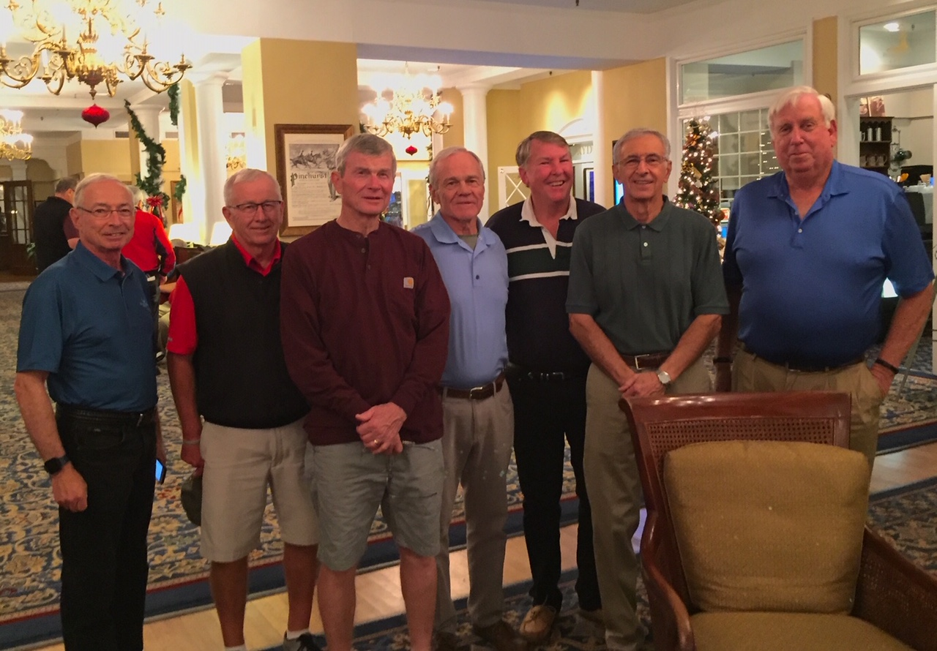

1969: Golfers at the Paul Garrity Memorial Senior Sensitive Western Carolina Golf Experience

Jerry Hale participated in the Veterans Day Commemoration at Valley Forge National Historic Park on November 11th. He was honored and excited to be involved because both of his grandfathers were in France on that day 100 years before. His Hale grandfather was the commander of Battery E, 119th Field Artillery (a Michigan National Guard Cavalry unit that was converted to artillery and federalized for WWI) as a part of the 32nd Division. The unit spent several months training at the French Artillery School before entering battle and was in the first wave of Americans to arrive in theater. They served in combat continuously for five months. November 1st was their last day of fighting as their horses had all died and they didn’t have the ability to pull the guns to pursue the enemy. Jerry’s mother’s father was a machine gunner for another National Guard unit in the 32nd Division. He arrived in France in August and was severely wounded (gassed) during his first day in combat on September 12th. His mother received a telegram from the United States Army letting her know of his injuries on October 25th. Her next communication was a letter from the Army on April 4, 1919, saying he was on a ship heading home. He arrived home on March 31, 1919. He lived another 26 years before complications from the gas attack took his life at age 48. Jerry didn’t have a photo of the Veterans Day Commemoration, but he did send one of 14 Valley Forge Military High School cadets who joined 200 others at a local church and produced and packed 30,000 meals for hungry families in the third world.

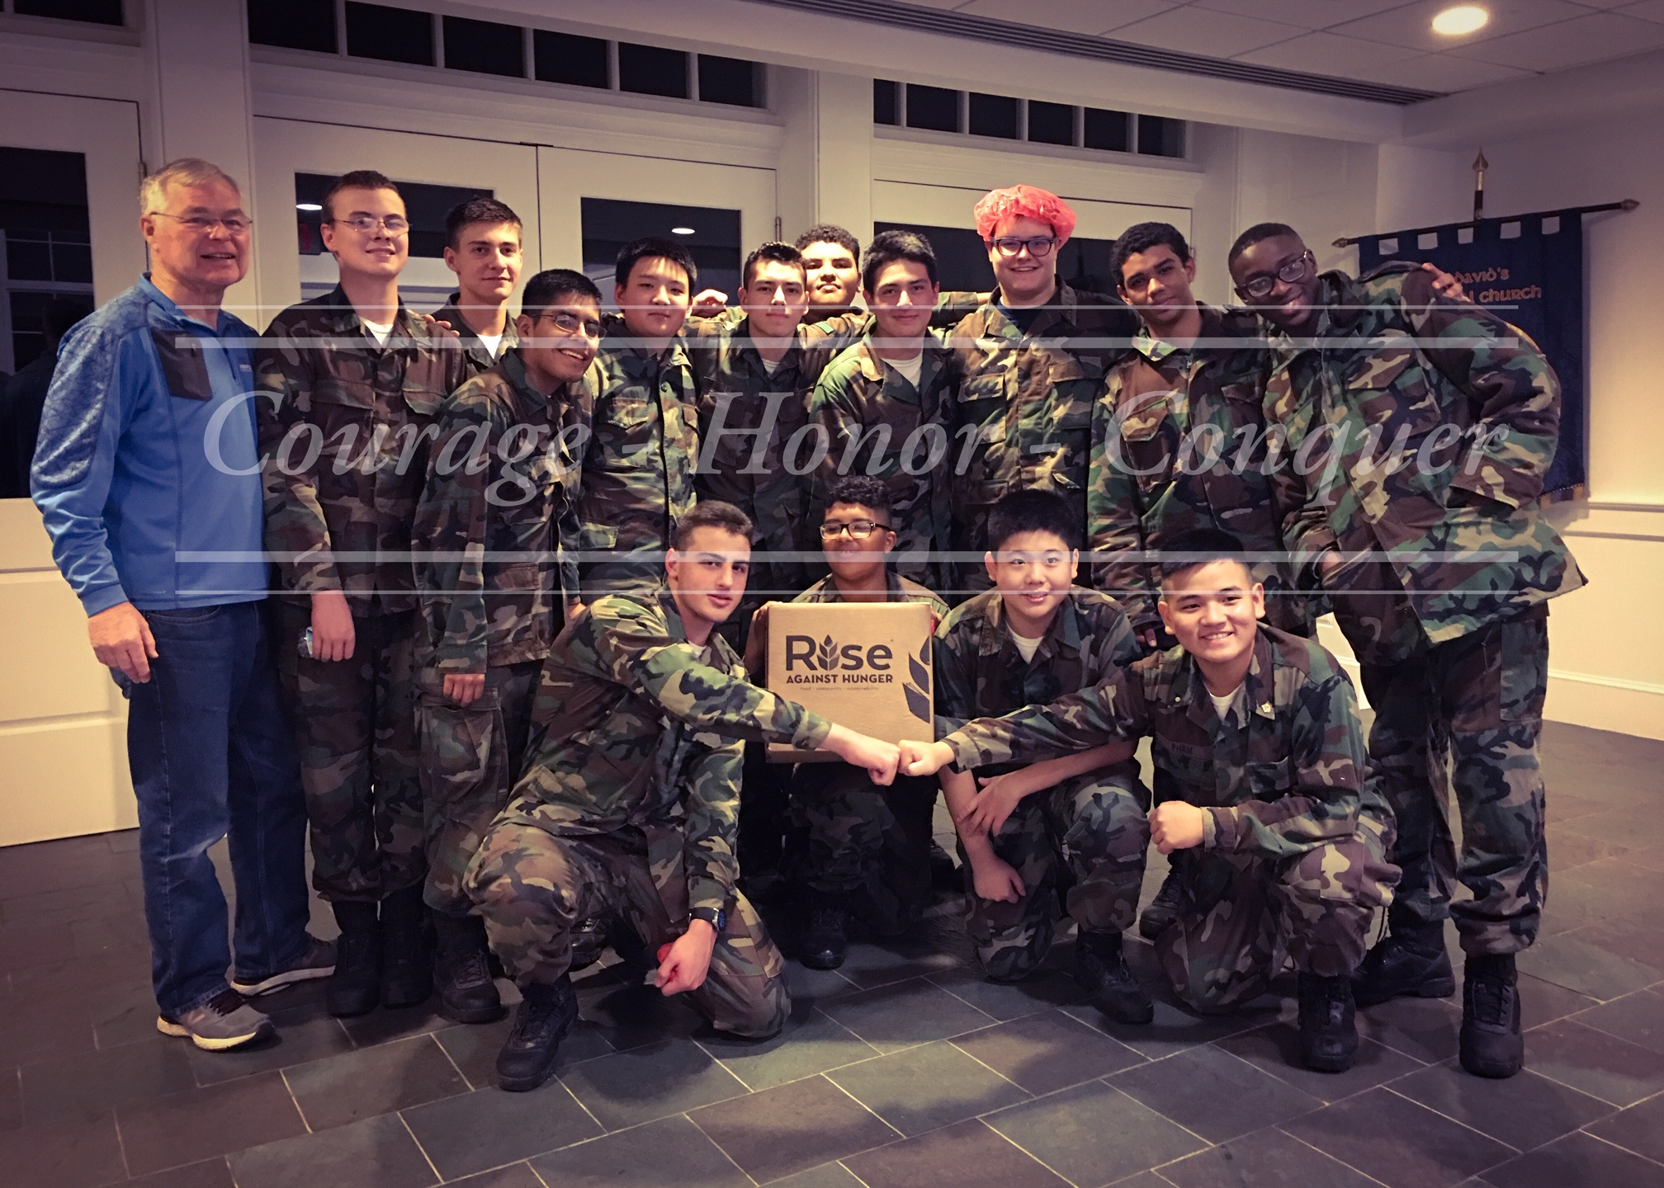

1969: Jerry Hale and Valley Forge Military High School cadets at food packing event

