February 2013

CAPT Bob Gravino
2 Summer Street
Ipswich, MA 01938
(978) 356-0825 (H)
E-mail: rcgravino@aol.com

Mike and Judy Billingsley attended Mike's 20 year reunion from Virginia Theological Seminary in October and then took a trip to Australia and New Zealand in November. In July they visited the Grand Canyon with daughter Tammy, son-in-law Rick, and grandchildren Kaitlyn and Michael. In August, Judy retired from her job in the pharmaceutical industry.

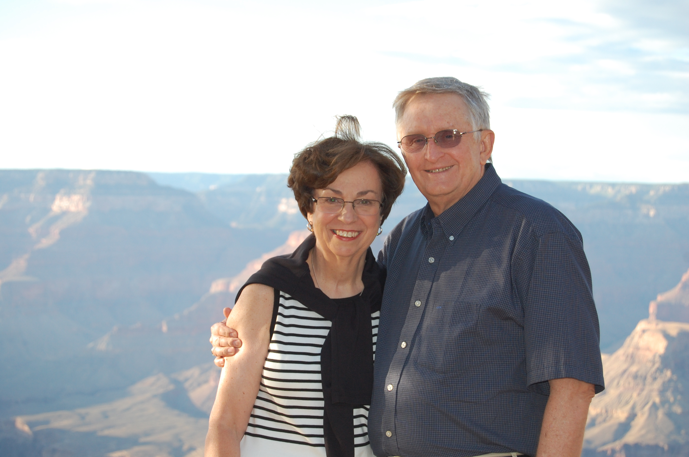

1969: Mike & Judy Billingsley at the Grand Canyon

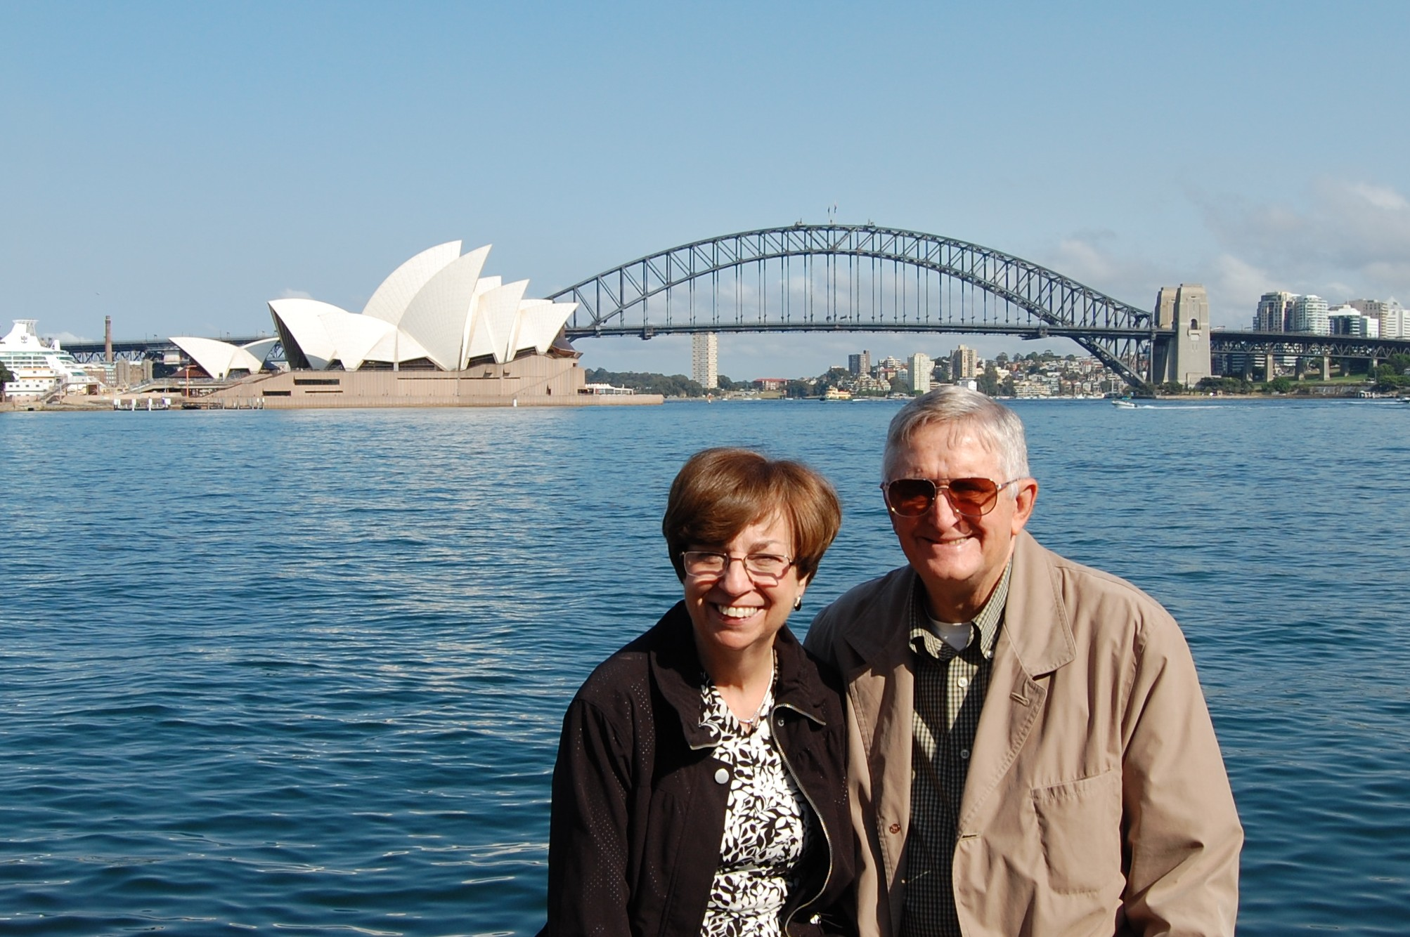

1969: Mike & Judy Billingsley in Sydney, Australia

Tim Cenna married Jennifer on June 8, 2012 and they spent their honeymoon in Charleston, South Carolina. Tim commented: "Jenny inherits three of the cutest grandchildren in the world."

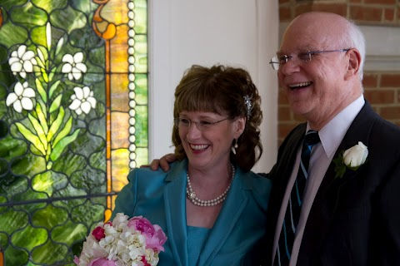

1969: Tim & Jennifer Cenna on their wedding day

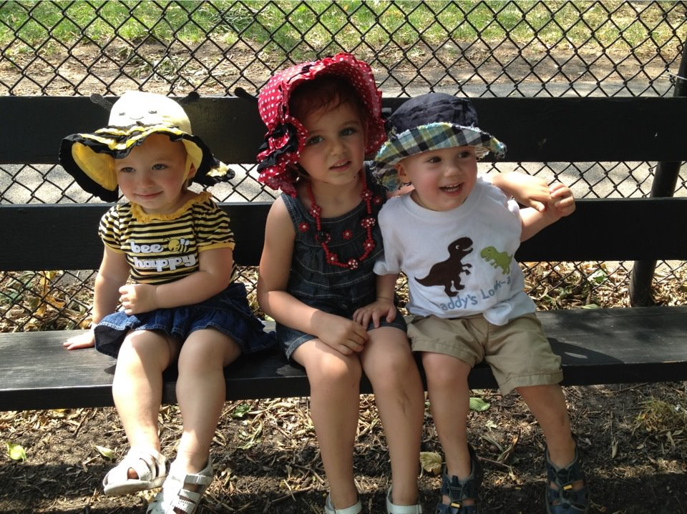

1969: Tim Cenna's grandchildren

While Jim and Cindy Burk were visiting a son in Los Angeles in October and John and Lesley Miner were in San Diego visiting Lesley's aunts, they took time to meet up with Bruce and Gail Griffiths for brunch at a seaside restaurant in San Diego, the restaurant aptly named World Famous. Discussion got around to the next Class Adventure, possibly Australia and New Zealand.

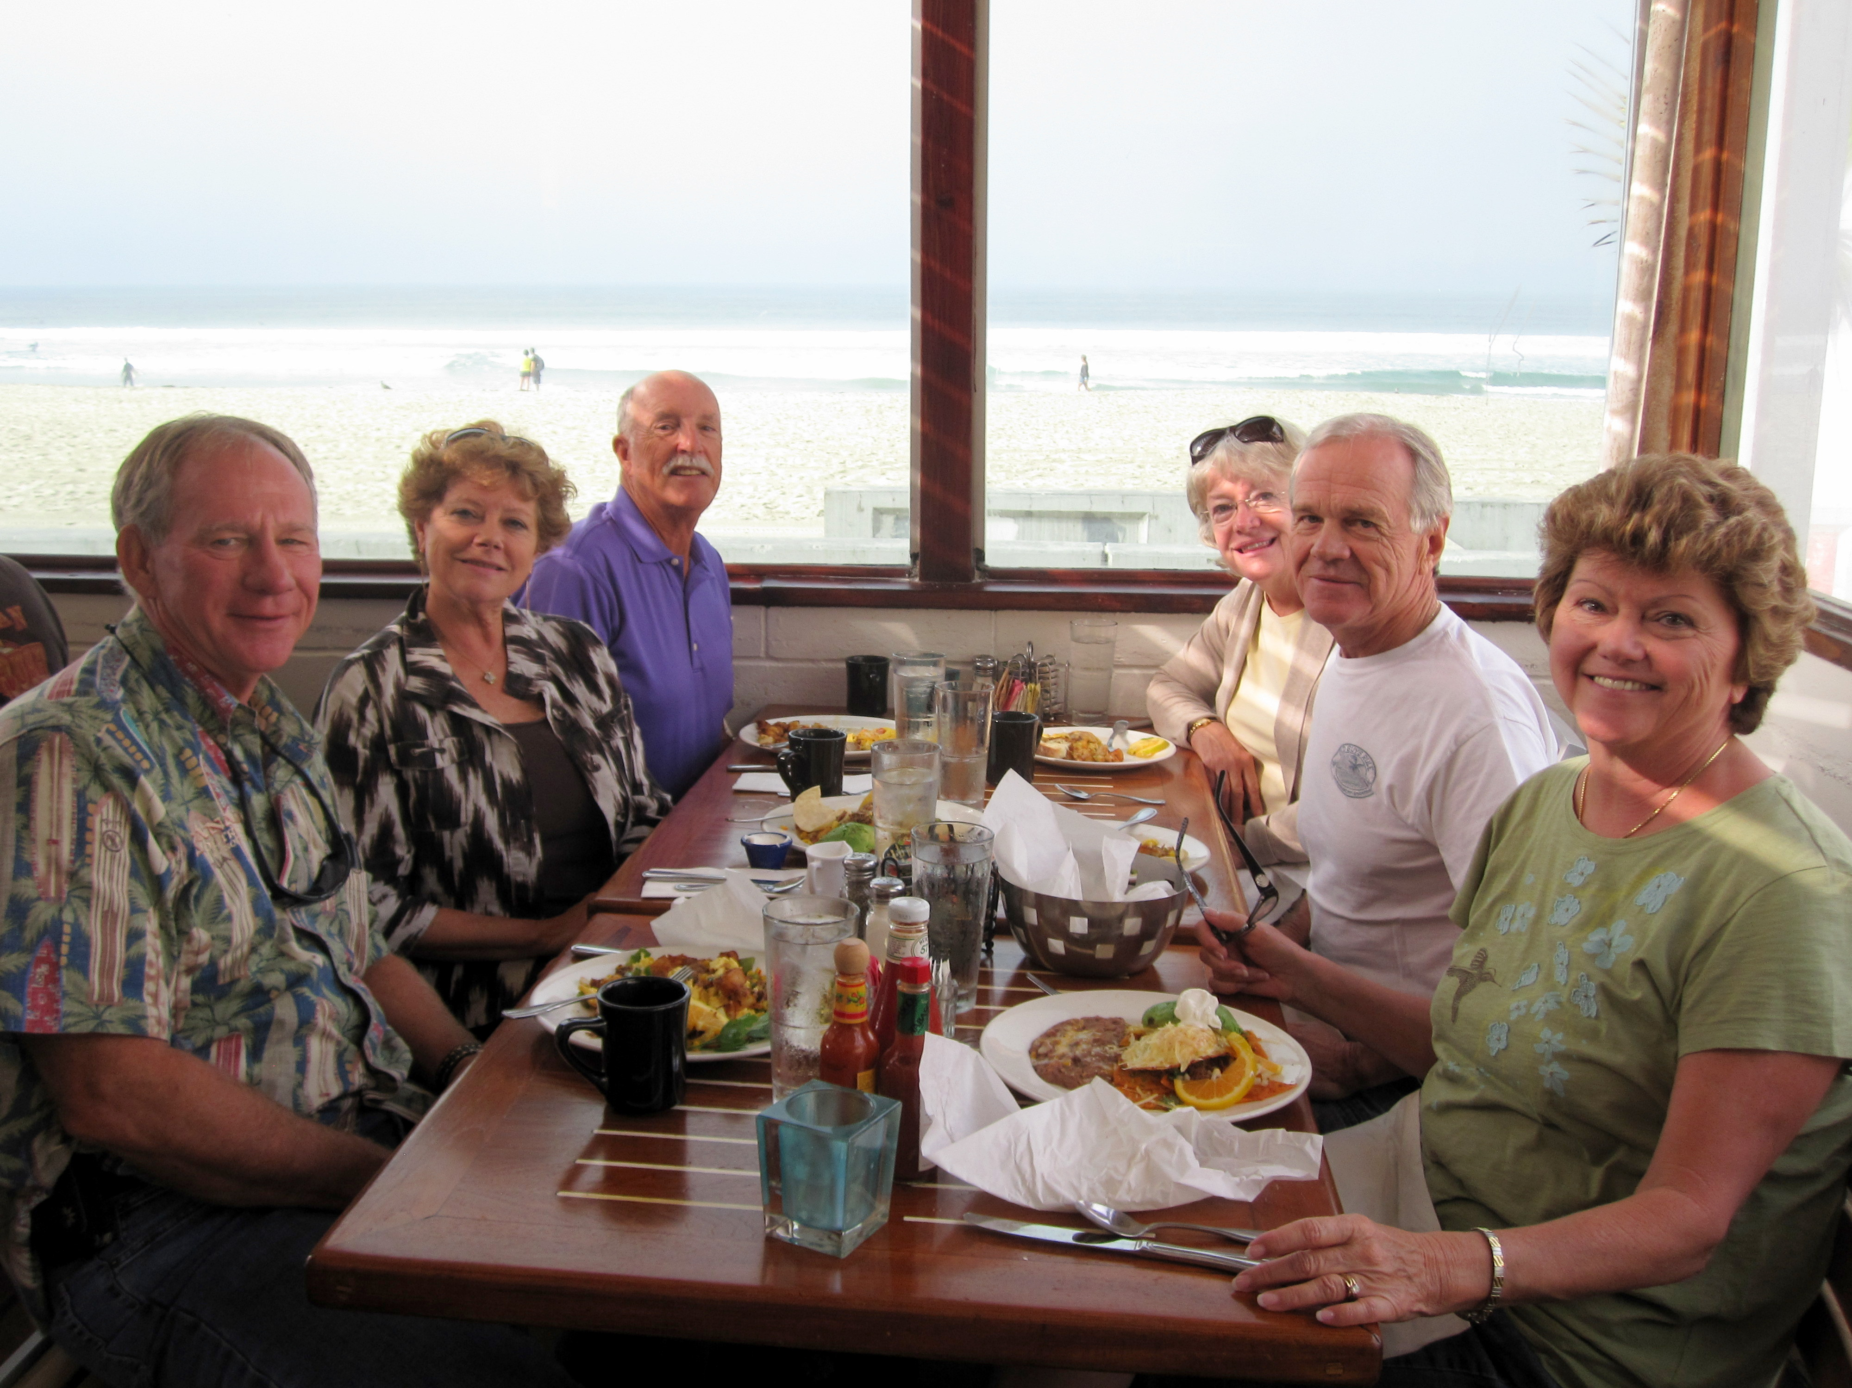

1969: Griffiths, Burks & Miners at the World Famous

Dick Burke retired from his second career after 15 years with AT&T. "In August I added 5 days to my weekend. I spent the last 8 years at AT&T Labs where the work was interesting and challenging and my co-workers and bosses were a great pleasure to work with. I'm enjoying my retirement since I get to spend my time the way I want; with Bekki, kids, grandkids, church activities and watching football. I often repeat the classic line 'I don't know how I found enough time to have a job'". I've not heard this said before, but I think the Burk(e) brothers of the Class of '69 are in a race for most grandchildren. Dick reports that he now has twelve, six girls and six boys. Accompanying is a family photo of son Adam's wedding in August. The wedding party includes daughters Debbi, Carrie, Tricia and Heather; bride Shalome and groom-son Adam; Bekki, Dick, daughter Jennifer, and son Rick.

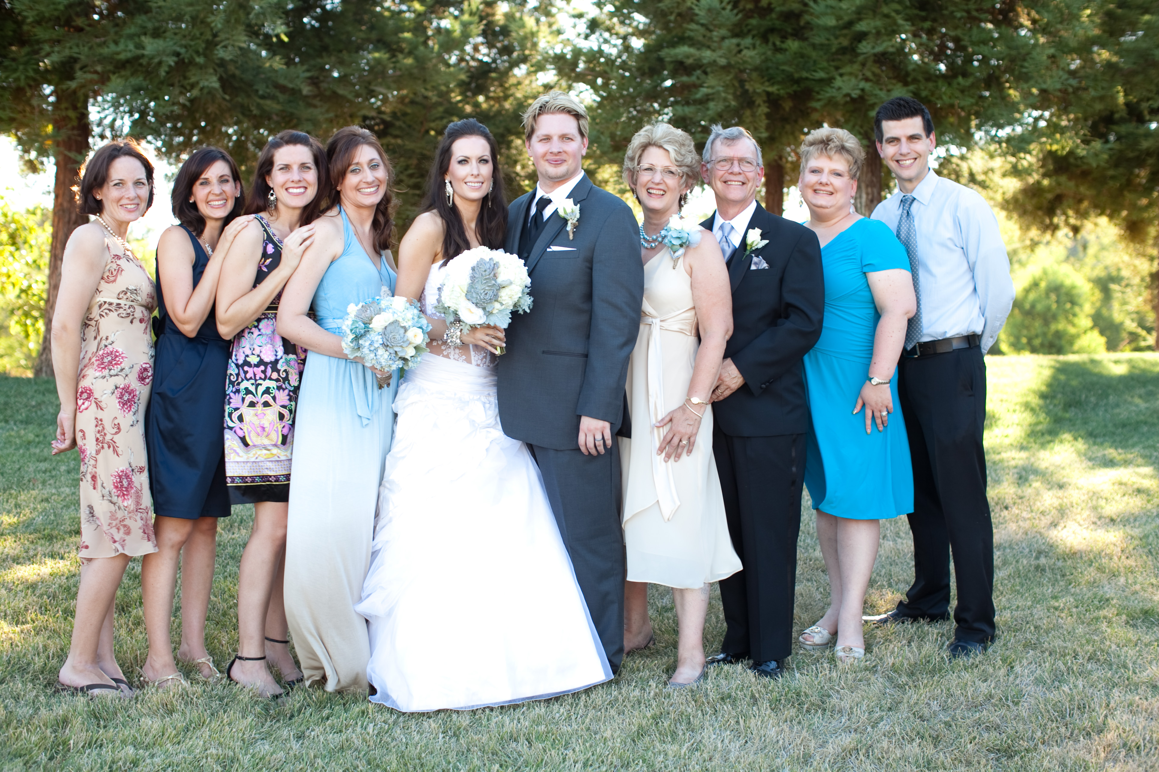

1969: Dick & Bekki Burke and family at son Adam's wedding

Fred Adamchak's Christmas card included a note saying that the Williamsburg Chapter of the Class of '69 continues to get together on a regular basis, and that Woody Stoeger has moved into the area (the November 2012 Alumni Membership Directory confirms same).
Short e-mail from Pete Aalberg: "Happy new year...been off the grid like forever. Just retired from teaching, got much more time...this is my address." Pete's new e-mail address is p.aalberg@aol.com.
Vince Kinal has retired from commercial aviation and moved from Orlando to Treasure Island, a beach community north of St. Petersburg Beach. Vince also bought a more hurricane proof home in Ruskin, on the eastern shore of Tampa Bay, about 20 miles from our son Tim in Lithia.
George Flanigan sent a photo of son Dave and his two daughters. Dave is completing a Ph.D. program at George Mason University in systems engineering and operations research and works at the Johns Hopkins Applied Science Lab. Son Sam is Deputy Director of Data Research at US News and World Report. George continues to work for a defense contractor in the DC area and participates in ultra-distance cycling (125+ miles). "I'm busy as all out. Not fully ready to retire; I think this will be it and then something stimulating pops up and I'm ready to keep going. I could retire in 2013 or 2014, but we don't know where we want to go."

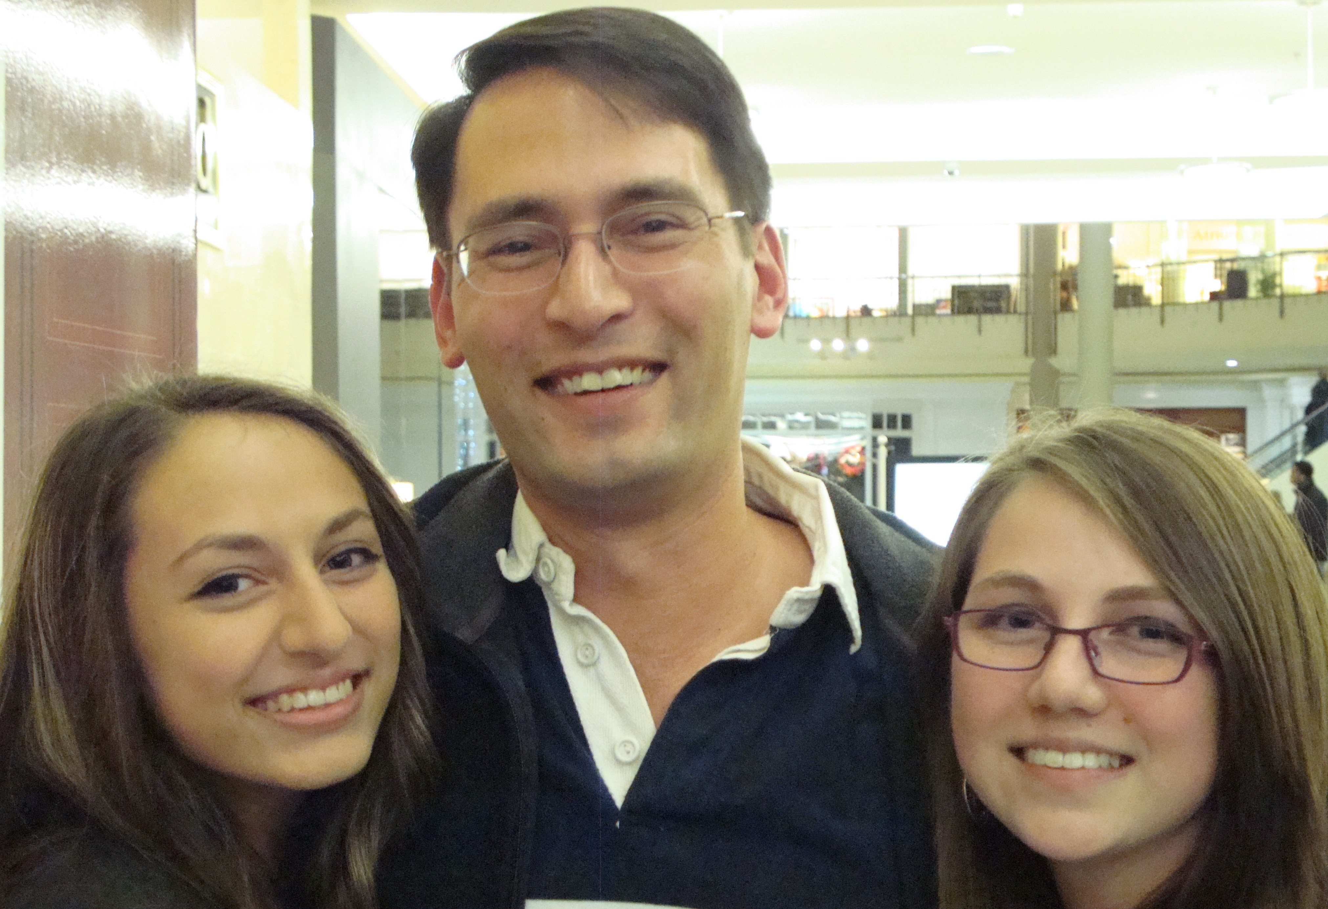

1969: George Flanigan's son Dave & his two daughters

Stu White noted in his Christmas card that he had been on a barge trip to France and had only been on the race track once this year. "Should visit the track again; I don't think I'm getting too old."
For Paul and Molly Prokop, 2012 was a year of travel. In June, they flew to Reno, visiting Carson City, Virginia City, Lake Tahoe, and Yosemite, where they attended a mini-reunion of the Connecticut College Class of 1970. July found them traveling through Ohio to Birmingham, Michigan, site of their 1970 wedding, before heading north to a rented cabin on Suttons Bay on Michigan's Leelanau Peninsula for a family reunion. Rumors about a vessel running aground under the command of a retired Coast Guard Captain remain unconfirmed. September found them in Charleston, South Carolina, for the annual Thunderbird International convention and tours of historic sites. Back home in New Orleans, life was somewhat slower, with noteworthy events including Hurricane Isaac taking down one of their large live oaks, a poor Saints season, and Medicare eligibility for Paul (join the Class, mate!).
Pete Lenes sent a photo of his two year old granddaughter, Saylor, who lives close by. His sons, Chad and Sean, attend the local community college as sophomores, majoring in music and business, with a goal of getting into the business side of the music industry. Susan is in network marketing. Her company took them to Maui in September and on a cruise in October. Pete continues: "My mom passed away in June so we have one less reason to visit Minnesota. I still have one sister left up there and some nieces and nephews so we won't totally quit visiting. I used to see Tom Hamblin at the Workboat Show but I did not make it this year. Tom retired to Colorado in September so I don't know if he attended the show or not. Likewise, I would see Bob Donnee at the Workboat Show every year. I saw Fred Wilder at a November ASNE/SNAME dinner in New Orleans where the guest speaker told us about the Coast Guard Offshore Patrol Cutter (OPC) acquisition. They want that ship to do a lot. I've been consulting as a proposal writer for the past year and staying fairly busy. Waiting to see what happens with the budget to see whether I continue at the same pace or not. I think about the word retire, but I don't know what I would do if I did retire."

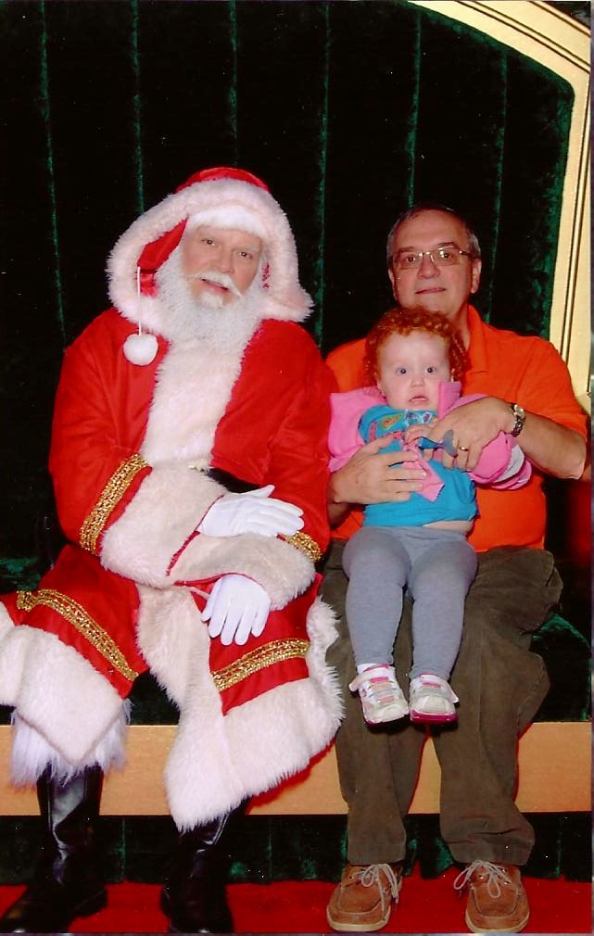

1969: Pete Lenes & granddaughter Saylor

