February 2022
’69 CLASS CORRESPONDENT

CAPT Bob Gravino
P.O. Box 158
Georgetown, ME 04548
(207) 371-2765 (H)
E-mail: rcgravino@aol.com
Website: http://www.uscga69.org

Holiday cards and notes provided updates and greetings from many classmates, including an on-going competition as to the number of grandchildren accumulated over the years. Dick and Bekki Burke, John and Anne Curtis, and Pat Garrity are at the top of this year’s family photos, but I expect that Jim and Cindy Burk will send in a photo for the next column after seeing the included submittals.
Dick Burke: “The attached photo is from our daughter Heather’s wedding this past July. The reception was held in our back yard, so you can imagine what I was doing in May, June, and early July. I lost about 10 pounds. Heather’s re-marriage means we inherited two additional grandchildren, so our grandkid tribe now numbers eighteen. Turns out that we kept things even: nine boys and nine girls. Bekki and I went through mild COVID although both of us were double vaccinated. For good measure, we took the monoclonal antibody treatment soon after COVID was detected, and all is well now. I play racquetball three times a week with my racquetball buddies at the Travis AFB gym and co-lead a weekly bible study group that meets at our home and a Baby Boomer-age church group that meets once a month, also at our house. Our best to all.”

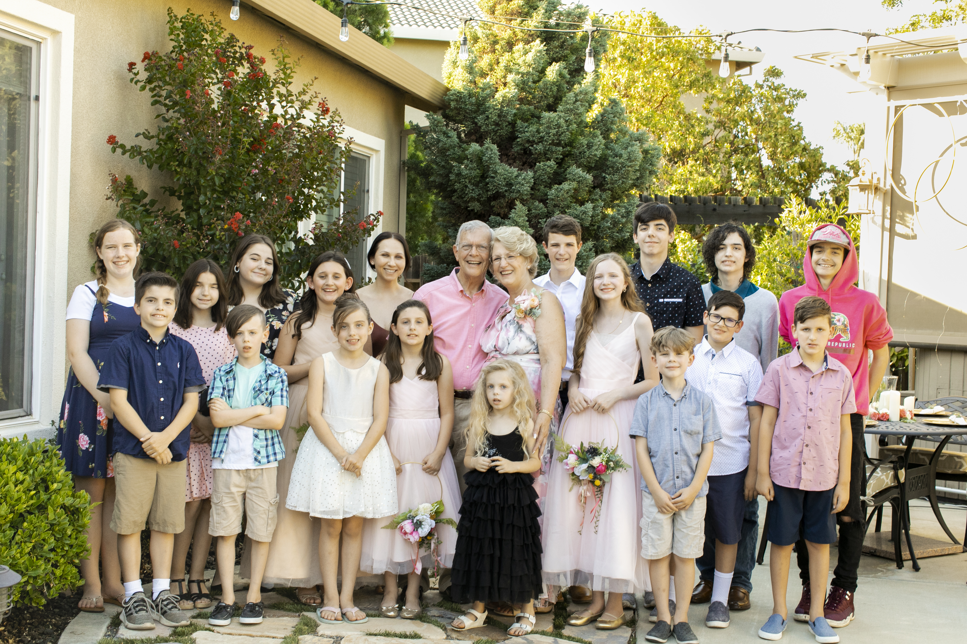

69: Dick & Bekki Burke and Family

Anne Curtis: “We are not in competition - it’s not like we have any say! We are lucky all are close by to spend time with us. The grandkids are my inspiration to stay healthy and in shape! Our oldest daughter has eight kids ages 2 to16, homeschools them, and lives in Port Townsend about two hours away. It’s an excursion for them to visit with a ferry crossing as part of the trip! We see them often; lots of birthdays and events! Oldest went to state in swimming, fourth granddaughter danced in the Nutcracker in Port Townsend over the holidays. Second daughter lives in Kirkland, about twenty minutes away, so we see them often. She has two kids, ages 4 and 7, and is a nurse at the University of Washington Hospital. Our son lives closest, a few minutes away, working for Microsoft as a software engineer in Minecraft. He loves his job, works hard, no time for relationships now.”

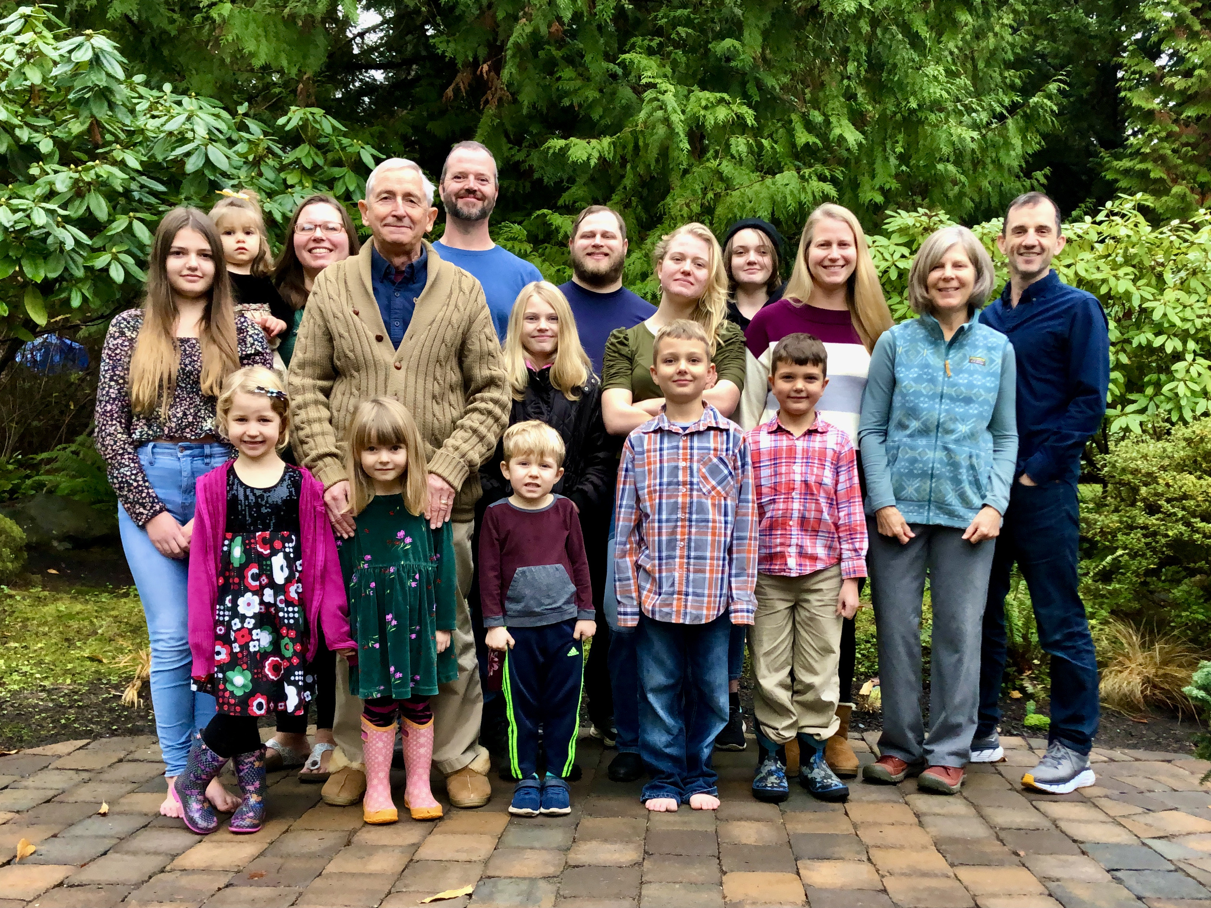

69: John & Anne Curtis and Family

Pat Garrity: “Staying busy with family, friends on Cape Cod, and volunteering at the Coast Guard Heritage Museum in Barnstable on the Cape. No rest for the weary!” Pat is one of the driving forces behind the success of the Heritage Museum on the Cape, along with Greg Ketchen ’70, Jim Sylvester ’71, Buck Baley ’72, and George Howe ’77. The museum reopens for the 2022 season in early May, and further information can be found at www.CGHERITAGE.ORG.

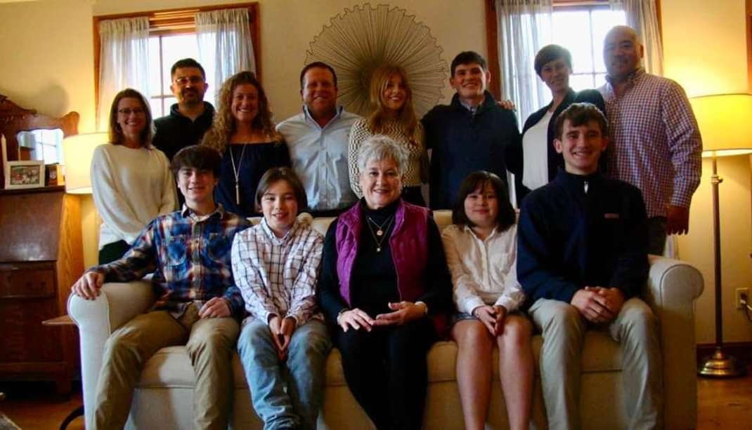

69: Pat Garrity and Family

Barry Kane sent a family photo taken at a special celebration at Thanksgiving. “Our three children, two spouses, four grandchildren, one dog and one cat joined us for Thanksgiving at our home in Wallace, North Caroline. To have as many people in comfortable beds as possible, Bettymarie and I snuck off to a motel late in the evenings and came back the next mornings. Family activities included golf, fishing, and marathon Rummikub games. This was also a belated family celebration of our 50th wedding anniversary (delayed 15 months due to COVID), so on one of the nights, the kids rented a party bus and took us into Wilmington for bar hopping and dinner. Bus was complete with adult refreshments and a 1970's playlist. One of our best Thanksgiving weekends ever.”

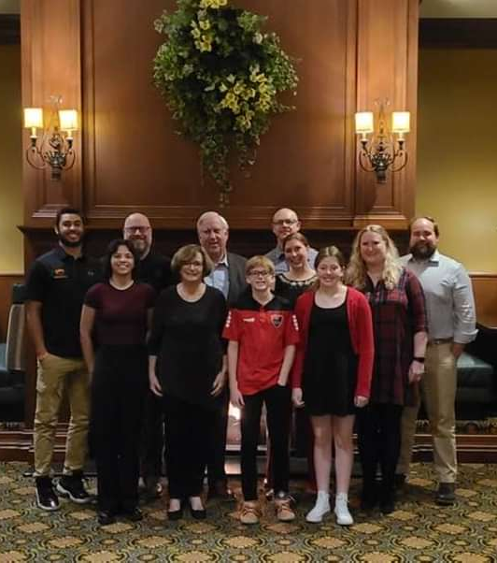

69: Barry & Bettymarie Kane and Family

Janet Brown sent new year greetings in January. “Doug and I were happy to see family and friends in Rhode Island this past summer after not being able to travel north from South Carolina in 2020 for the first time in forty years because of COVID. The sloped floors in our old house were a challenge for Doug, but overall, it was a good summer. And we finally had a new septic system installed that was long overdue. In November we went out to Port Angeles, Washington, to spend Thanksgiving with son Zach, Julie, and family. Doug and I did a VRBO rental within walking distance of their house, and son Dave, Ethel and girls joined us too. It was the first time we had all been together in two years, and it was especially enjoyable to see the four-year-old twins interacting with their six- and ten-year-old cousins. During our Port Angeles visit, Doug had a fall and had to go to the emergency room for stitches. While chatting with the doctor, we learned that he attended a small college in New England, which turned out to be the Coast Guard Academy! Josiah Hill was from Kansas and graduated in 2005 as a deck officer. He told us that he thinks that he is one of only a few Academy graduates to become a doctor. We decided to stay home in Bluffton for Christmas, which worked out well given the wild spreading Omicron virus and all the cancelled flights because of it. Although Doug and I do not keep in touch with all of you, we want you to know that we think of you often. We are so grateful for all the support you have given us, especially during the past few years.”
Stu White sent a photo of classmates gathered at The Salt Lick BBQ in Driftwood, Texas, including Jim Robinson, Pablo Rodriguez and Jim Burk. Jim was heading on to San Antonio, and Stu was in town to play in Jim’s Member/Guest golf tournament. Stu commented in his Christmas card that he tried Pickleball on Thanksgiving Day: “It is a dangerous sport if wearing the wrong shoes; I’m recovering.”

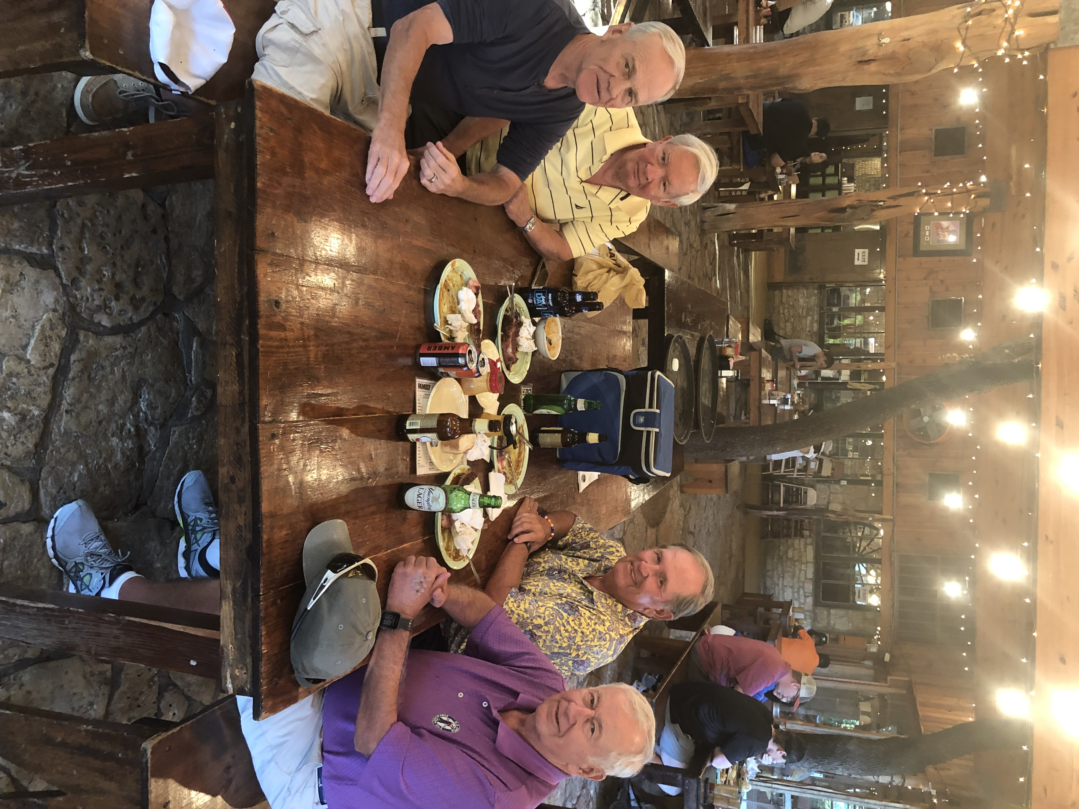

69: Jim Burk, Pablo Rodriguez, Jim Robinson & Stu White
at The Salt Lick BBQ in Driftwood, Texas

I spoke with Gary Pavlik in late January, and he is enjoying the warmth of the sunny Florida weather and the golf courses that he spends much time on. Gary was able to visit with Jim and Judy Hull, who were in Florida in January to visit a relative.
It was reported in the last Bulletin that Fred Schmitt correctly answered the question as to who was the famous golfer from the Class of ’69 included in the October/November Class Notes column. Fred was the only respondent with the correct reply and writes that his prize of a one-way ticket to Harrisburg, Pennsylvania, has not yet arrived. Fred has been assured that the ticket is in the U.S. Postal Service system and should arrive shortly. (Correspondent’s Note: Trust me, Fred, it’s in the mail!). In late November, I received an e-mail from Wayne Shade ’68, who asked why someone would be offered a one-way ticket to Harrisburg as a prize to a contest. I responded to Wayne, copying the reply to Fred, who then responded to Wayne as follows. “Wayne: Bob Gravino forwarded your e-mails regarding Harrisburg and the photo in the Bulletin. I gave Bob that picture when we were gathering stuff for our 50th Reunion a few years ago. He said I might see it again at some point, hence the riddle in the Bulletin. I still have family in the Harrisburg area but have not lived there since I left for the Academy in 1965. I graduated from Bishop McDevitt High School that year and have many fond memories of that experience. Coincidentally a high school classmate and friend of mine graduated from your post graduate university, Dickinson Law School, as well. Same last name but spelled differently. Charles Schmidt practiced in the Harrisburg area for many years. I'm not sure if he is still active or retired. Jessie and I relocated to a small mountain community (Banner Elk) in western North Carolina after my final retirement from a second career in public education. In any event, thanks for reaching out. Maybe we can connect during one of my trips back to the ‘burg. Fred.” Thanks, Wayne, for noticing the riddle; you and Fred were the only readers I heard from. Is anyone in the Class reading the Class Notes column, or was there no interest in a one-way ticket to Harrisburg?
As mentioned in the December 2121/January 2022 Class Notes column, Kathy and I attended the 50th Reunion of the Class of ’71 at the Academy. As part of the weekend, Bob and Barbara Thorne invited Candace and Paul Bodenhofer and Kathy and me to their East Lyme home for a delicious lunch of lobster rolls and all the fixings. It was a wonderful time with special people, celebrating a spectacular autumn afternoon in Connecticut. Knowing couples that you can spend time with after long absences is a cherished commodity, not to be taken for granted.

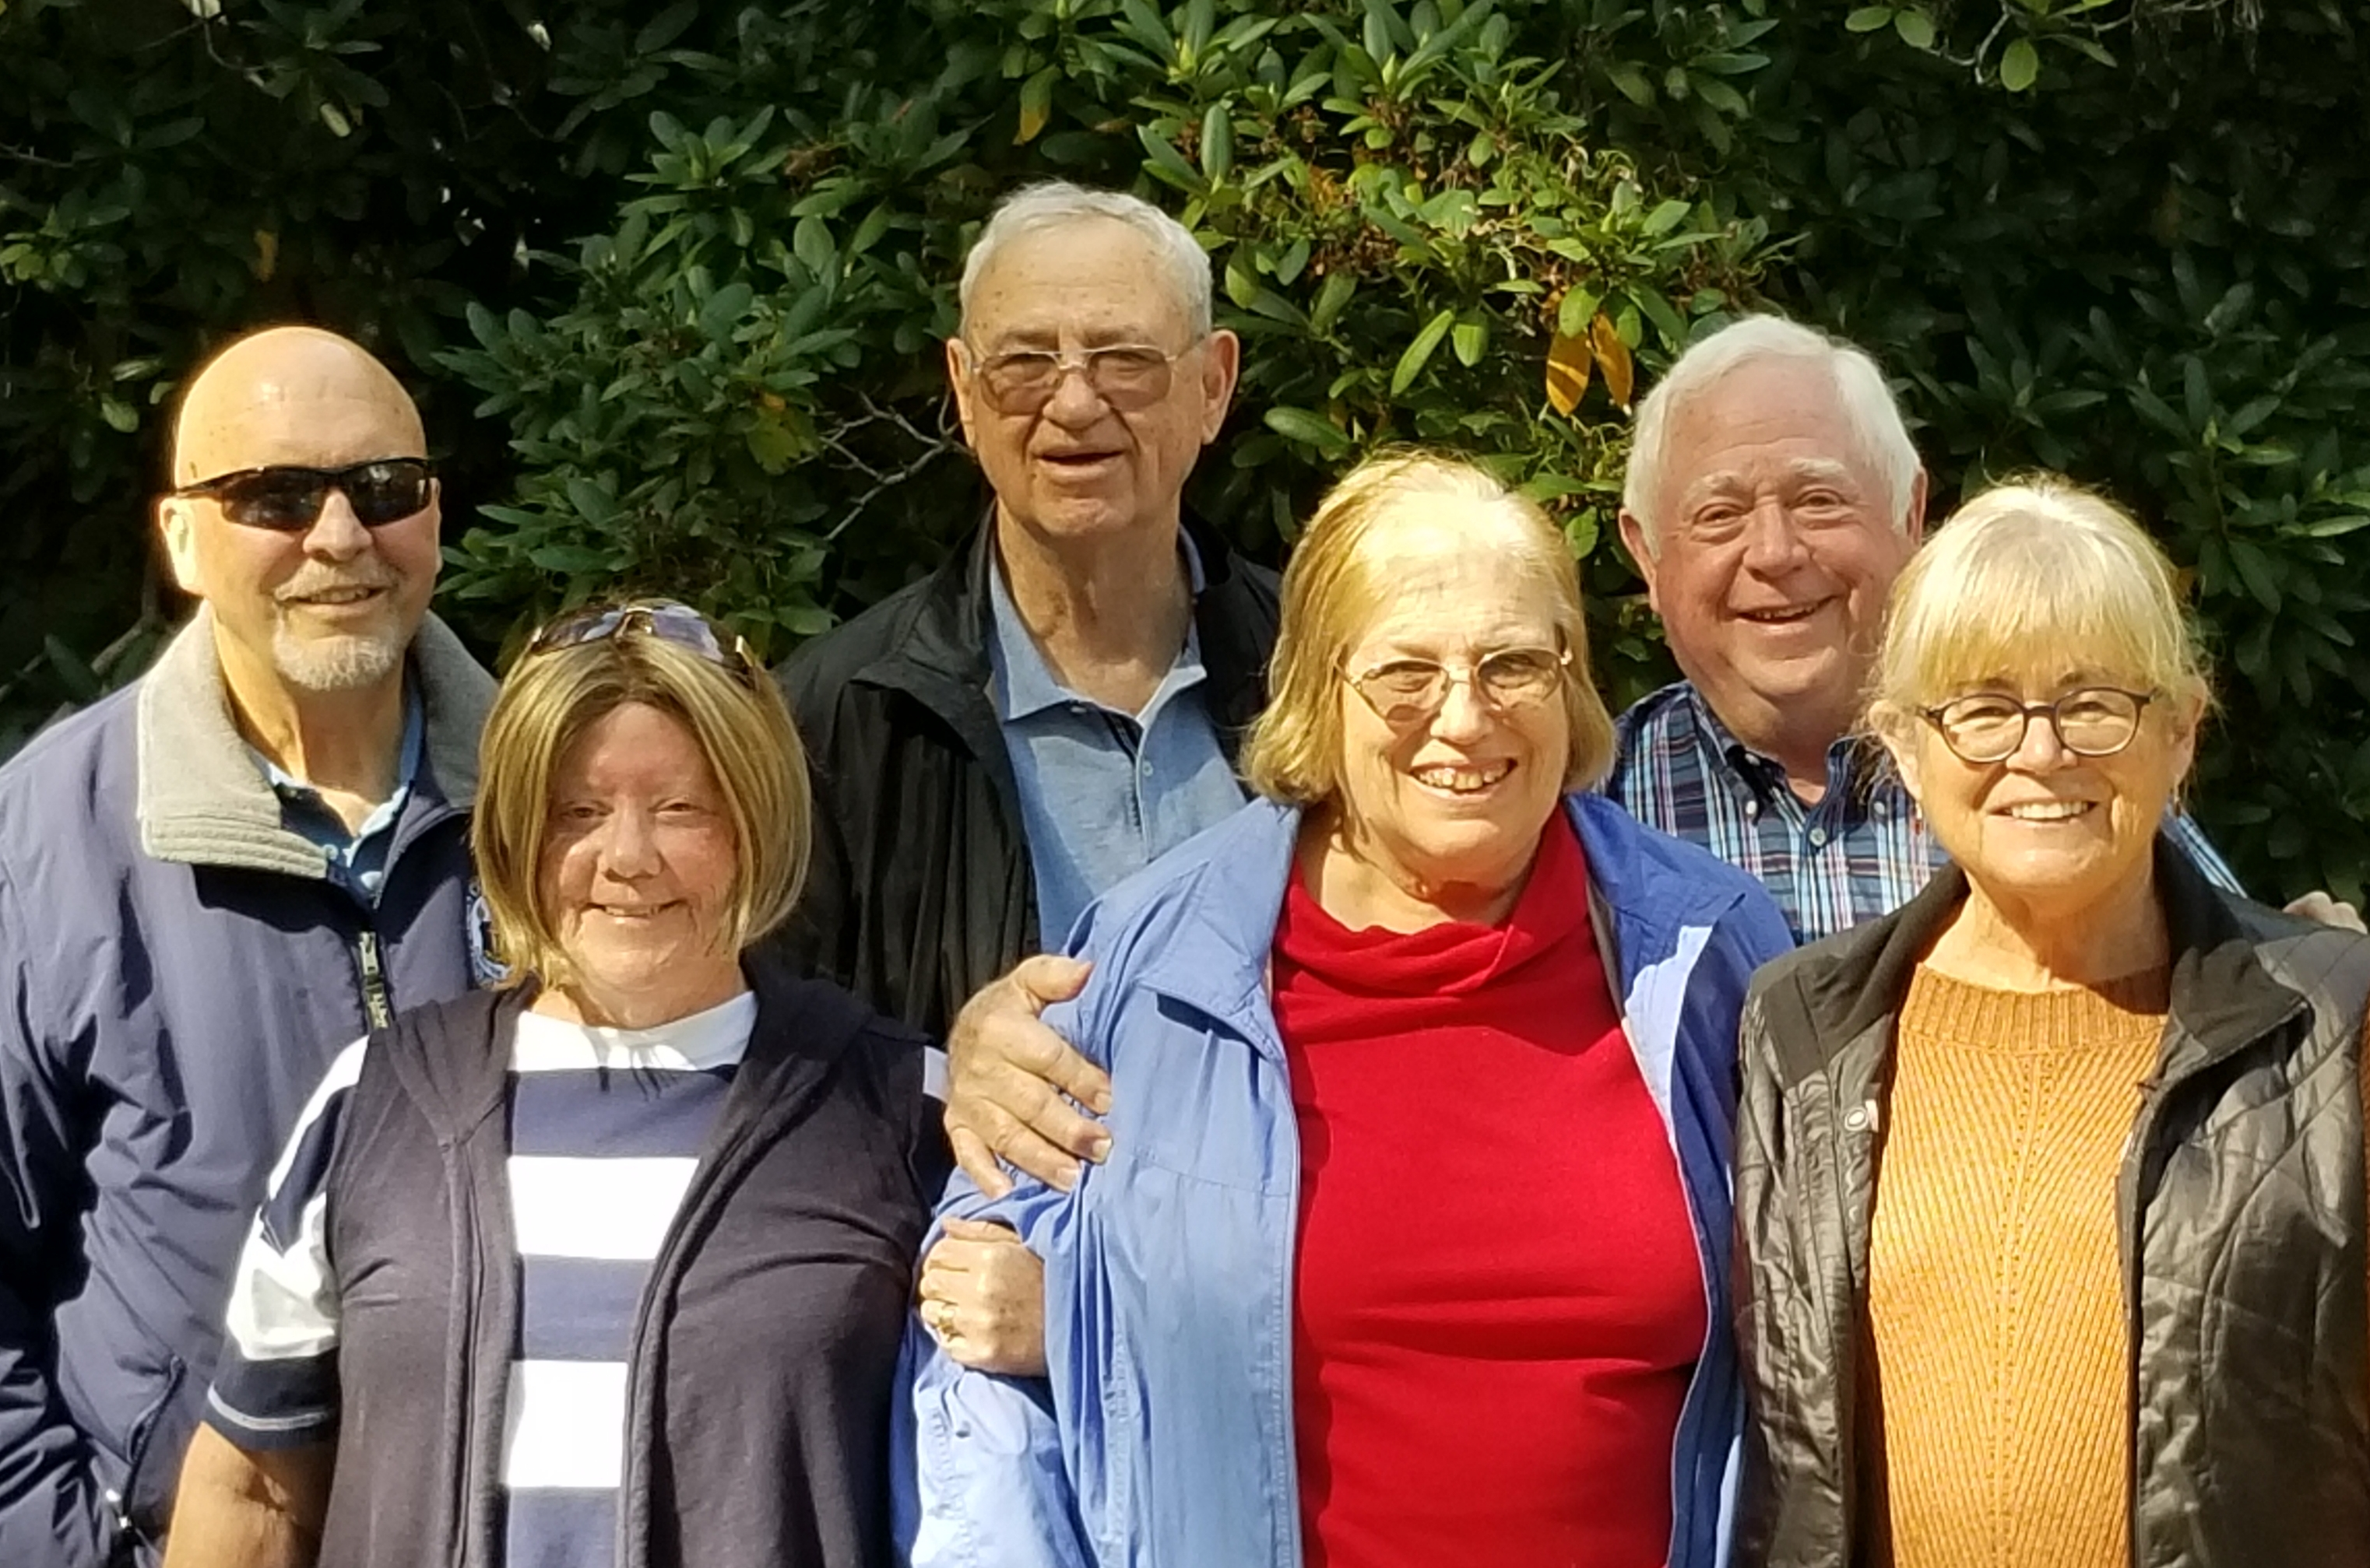

69: Paul & Candace Bodenhofer, Bob & Barbara Thorne, and Bob & Kathy Gravino
in East Lyme

Kathy and I were diagnosed with breakthrough COVID in early January and spent the first part of the month in isolation. We were both fully vaccinated and had received our booster shots, and our symptoms were mild, not even at the level of flu. All's well now - get your shots!

