June 2009
’69 CLASS CORRESPONDENT

CAPT Bob Gravino
2 Summer Street
Ipswich, MA 01938
(978) 356-0825 (H)
E-mail: rcgravino@aol.com
Class Website: http://mywebpages.comcast.net/ckreiler/index.htm

GREG SHAW has once again documented the end of winter and the arrival of spring. The Thirteenth Annual Spring Training Baseball Trip was to the Southwest this year. Shown in Phoenix, Arizona are Jack Harrald (CGA ’64), GREG, Steve Froehlich (CGA ’73), John Bastek (CGA ’68), Paul Pluta (CGA ’67) and Rudy Peschel (CGA ’63). GREG and Paul are plank owners of the annual event, having attended all thirteen years since 1997.

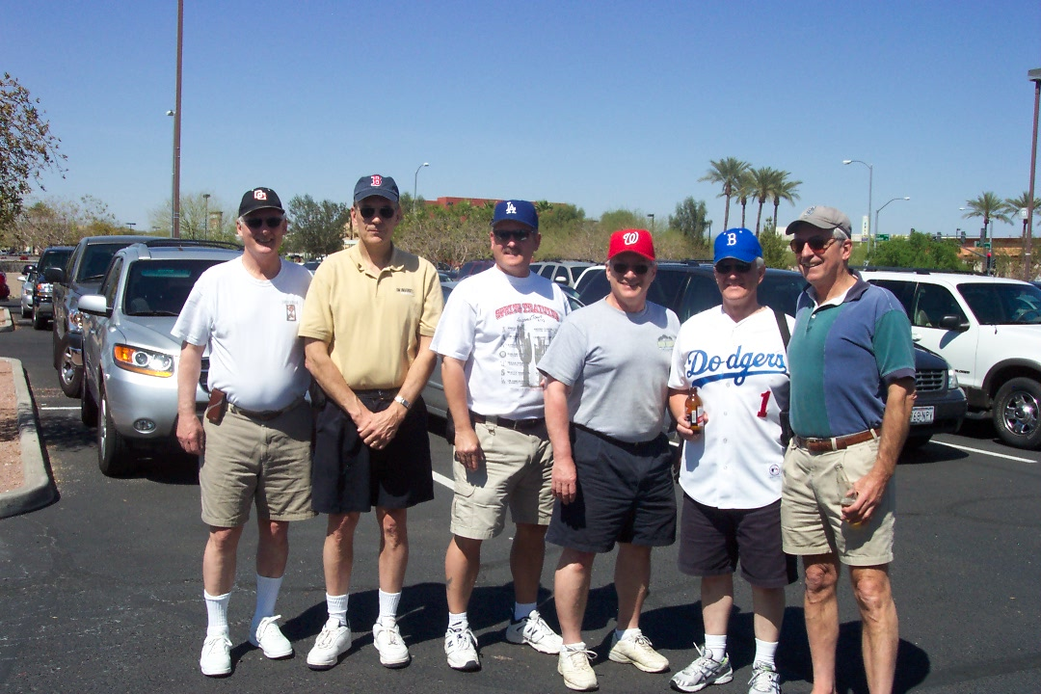

Coast Guard Academy Boys of Summer in Phoenix

For those who did not hear the details on the second attempt by Somali pirates to target a U.S. flagged vessel in April, I’m including the information sent by BOB THORNE on the actions of DON GROSSE on the M/V Liberty Sun. “I was listening to the ABC Evening News on April 14th and a story popped up about the U.S. flag ship M/V Liberty Sun being a target of Somali pirates. ABC listed the master of the vessel as Captain DON GROSSE and then played a radio transmission of the Captain’s voice. I immediately recognized DON’s voice. I spoke to a couple of classmates the next day and followed later with a call to his home. I spoke to DOTTIE’s sister who confirmed that in fact it was DON on the M/V Liberty Sun. She said that DOTTIE had spoken to him and that he was safe. DON attributed their escape to the fact that he and his crew had regularly trained and practiced for this kind of event. From other reports, the ship was bombarded with small arms fire and rocket propelled grenades. DON placed his crew in the engine room and secured the space, and took evasive maneuvers to escape the attack. The bridge was badly damaged during the attack. At the time of the attack, the ship was off the coast of Somalia en route to Kenya to deliver international humanitarian relief cargo.” It sounds like DON’s professionalism, leadership and quick thinking saved his ship and crew from a bad situation. The Class expects a full report from DON at the 40th Reunion in October.

I received two updates from Classmates with daughters who serve our country as doctors in the United States Armed Forces. From GARY PAVLIK: “Oldest daughter Emily returned to U.S. soil permanently in late April. She is an Air Force MD, O-3, now assigned to the hospital at Lackland Air Force Base in Texas as an attending/teaching doctor. While serving in Iraq she was a CCATT (Critical Care Air Transport Team) Leader responsible for in air care of the most seriously wounded, flying between Balad, Iraq and Germany. She doesn’t talk about her patients from the Balad to Ramstein AFB transport missions, but has told a couple of interesting stories. On one short hop on a C-130 to a secondary base in Iraq, the aircrew thought they saw a missile flash so they took evasive action and popped off flares and chaff. She said it was like an amusement park ride. The attached photo shows Emily in the body armor and helmet that the CCATT wore during take-off and landing. I asked her why she didn’t have her shoulder holster on. She said it was under the armor. I asked her how she could quickly get to the pistol if she needed it. Her reply was ‘Quickly! What difference would that make? If we crash, we all are going to die anyway.’ Emily was ‘rear echelon’, but it’s not a happy thing to have a kid walking around on a base in Iraq. By Air Force rotation rules, she should not have to deploy again before her active duty commitment expires in July 2010. THANK GOD.”

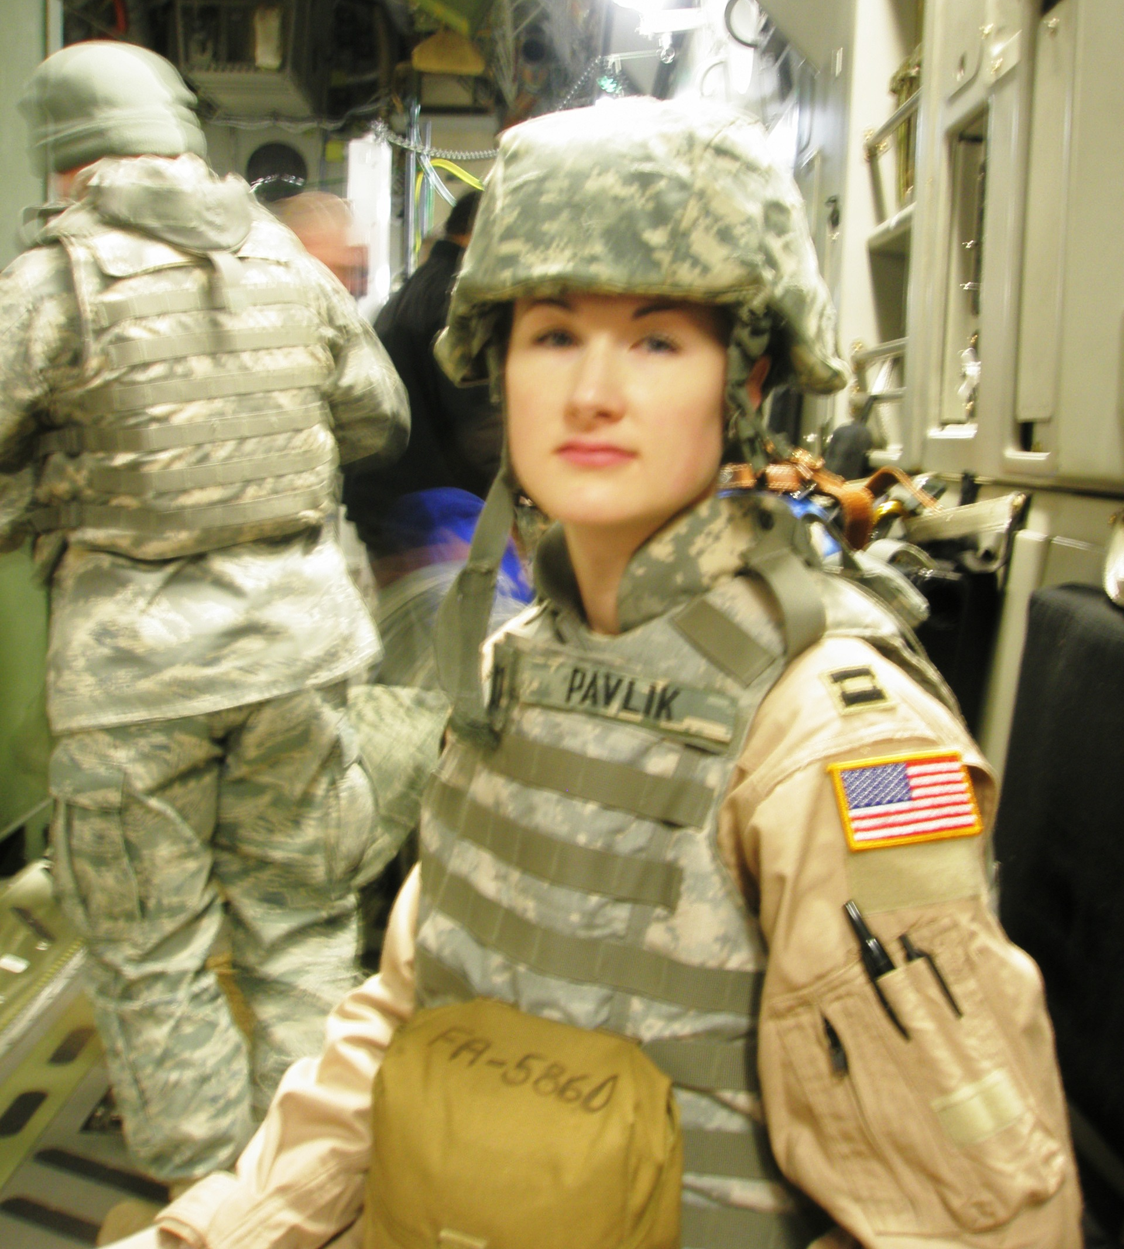

Emily Pavlik, USAF, in flight

GEORGE and GAYLE BOND drove to Camp Lejeune in March to welcome their daughter home from an extended deployment in support of military operations in Iraq. “Kate was on the USS Iwo Jima for eight months as the U.S. Navy MD assigned to MEU 26 out of Camp Lejeune. Her husband Jon is presently assigned to Iraq as a Marine Corps aviator on his fifth deployment flying Cobras. In June they both head to USMC Air Station Yuma for three year tours. This will be the first time in their eight years of marriage that they will be living in the same location. Between his deployments and her medical school, they have had no time together in one location. As to deploying again—Kate will have to see what the Navy decides and how long she remains on active duty.”

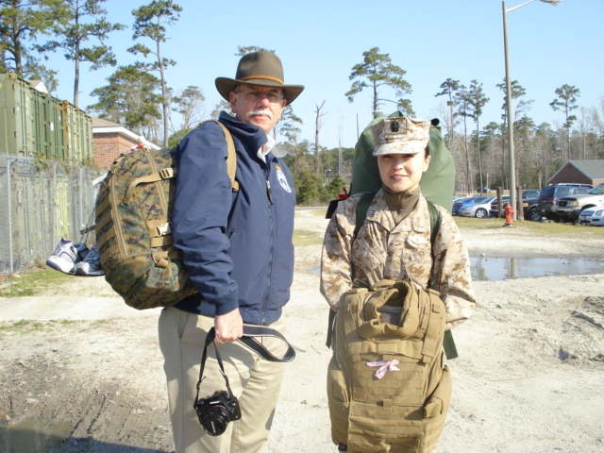

GEORGE BOND & daughter Kate at Camp Lejeune

RICH FORD retired on April 1st from Aramco Services Company in Houston, Texas. His new e-mail address is reford.texas@att.net.

JIM HULL sent along an update on two former classmates whom he has remained in contact with. “JOHN BERGMAN is a LT General in the U.S. Marine Corps presently serving as the Head of the Marine Corps Reserve. He left the Academy Swab Year and eventually became a Marine and airline pilot. I met him again while I served as the Commander of the Ninth District in Cleveland and he lived in the Detroit area. JOHN was in New Orleans during Hurricane Katrina. I am also in touch with DOUG EVAUL, who was my first roommate during Swab Summer. DOUG retired from the Internal Revenue Service and is living in Seattle but hoping to move to Florida.” TIM JOSIAH and TOM HAMBLIN have written in the past that they have had contact with JOHN BERGMAN. I recently corresponded with JOHN via e-mail, and he said that he looks forward to getting involved with the Class after he retires from the Marine Corps.

Short note from JIM ROBINSON: “LINDA and I were hoping that the 40th Reunion would fall on an away Texas football game weekend. Unfortunately, we will have to celebrate the 40th from Austin since Colorado visits here that weekend. However, we can celebrate early with BARRY KANE and golfing classmates during the golf outing that he has organized for May.” JIM and BARRY—please send photos!

JOHN and LESLEY MINER sent a photo of a family visit to Disney World. Son Steve, daughter-in-law Jennifer, and their two sons JP (the oldest) and Logan spent five days in Orlando during the boys’ Easter school vacation. JOHN said that this is a great year to visit Shades of Green at Disney World and/or Walt Disney World because of the super discounts they are offering. He recommends that classmates check out the details at http://www.shadesofgreen.org/home.html and http://disneyworld.disney.go.com/.

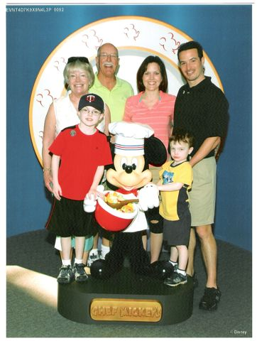

JOHN & LESLEY MINER and family at Disney World

KATHY and I escaped the New England winter to celebrate a “significant birthday”, accompanied by our daughter Kelly, son Tim, son-in-law Scott, daughter-in-law Tara, and grandsons Dominic, Joseph, Liam and Finn. Our adventure included a Carnival Cruise sailing out of Tampa into Caribbean and Gulf of Mexico waters. For those who have sailed on a cruise ship, you know that the experience of a cruise is nothing like a tour of duty on a Coast Guard cutter.

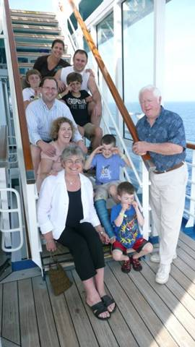

BOB & KATHY GRAVINO and family at sea—“It’s not your Daddy’s Coast Guard”.

BOB THORNE has arranged to have the Mystic Hilton Hotel (with 40 rooms reserved) as our 40th Reunion Headquarters. He will be setting up a special Hilton website so classmates can make reservations online. He will also send out a SitRep to cover details, including the evening dinner events at the hotel. Entertainment will include a DJ and a special appearance by The Gents, featuring our own JIM SMITH! BOB is organizing a local class committee to plan for meals, events, walk-on attire, etc. To help plan the weekend, contact him at thorne@ct.metrocast.net. WAYNE GRONLUND is working on a special presentation for Reunion, details to follow.

Many of my recent Class e-mailings have not been delivered to many of the e-mail addresses that I have on record, and I do not have correct e-mail addresses for the following classmates: BOB ILLMAN, BOB GAINES, ALAN BERRY, RICK BARLOW, BILL JURGENS, JOHN ZEIGLER, BOB WENZEL, FRED SCHMITT, TOM HOWARD, MIKE WILLIAMS, DAN CARNEY and DAVE DUBOIS. If you see your name above or have a current address for one of the listed individuals, please send me a current e-mail address at rcgravino@aol.com. While you’re doing this, include an update and photo for the next column.

