October 2016

CAPT Bob Gravino
2 Summer Street
Ipswich, MA 01938
(978) 356-0825 (H)
E-mail: rcgravino@aol.com
Website: http://www.uscga69.org

Pete Aalberg is a multi-media artist living in Florida and spends summer months on the mid-coast of Maine. This summer he was in Maine working on a mural. The accompanying photo of Pete (p.aalberg@aol.com) is with son Jesse, and there are three more Aalberg children living in Minnesota.

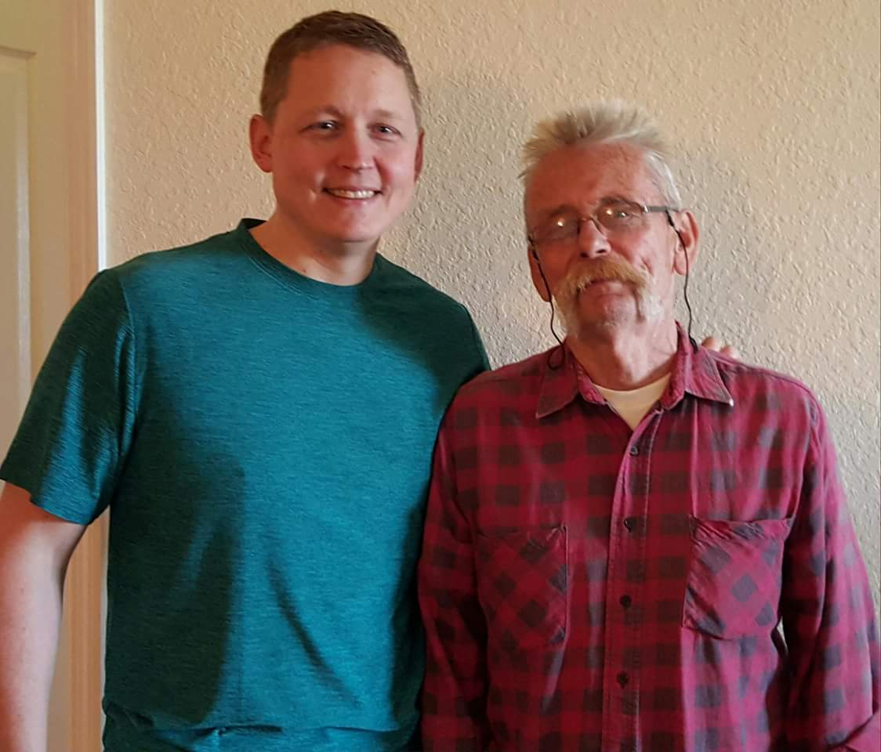

1969: Pete Aalberg and son Jesse

George and Linda Naccara, Dave and Trish Dubois, and Bob and Barbara Thorne vacationed in Maine over Labor Day Weekend. Highlights included seeing the Windjammers Festival in Camden and making short trips into Booth Bay Harbor with repeat visits to the great Lobster Dock Restaurant. Linda provided the photo of Dave, Bob and George.

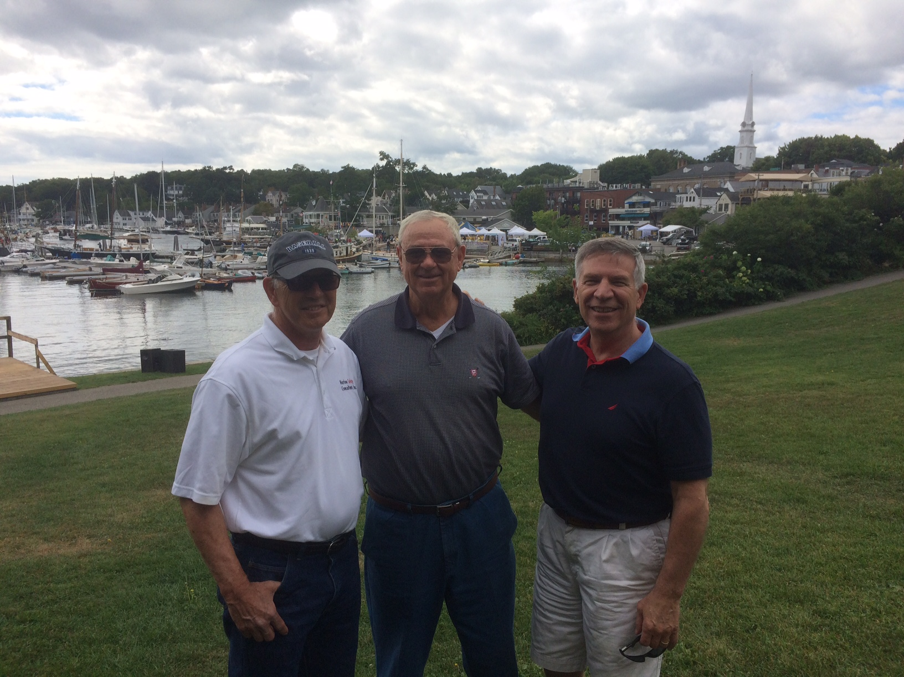

1969: Dave Dubois, Bob Thorne and George Naccara on the Maine Coast

For those who may not read The Bulletin cover to cover, this edition has a photo of Chris Kreiler taken during the 2016 Women’s Softball spring break trip to Florida that was included in the April 2016 Bulletin titled “Class of 2019 Softball Team players with their Link in the Chain connection CAPT Chris Kreiler ‘69”. We expect a similar photo next spring from Chris with the Class of 2019 Softball Team players during their 2017 spring break trip to Florida.

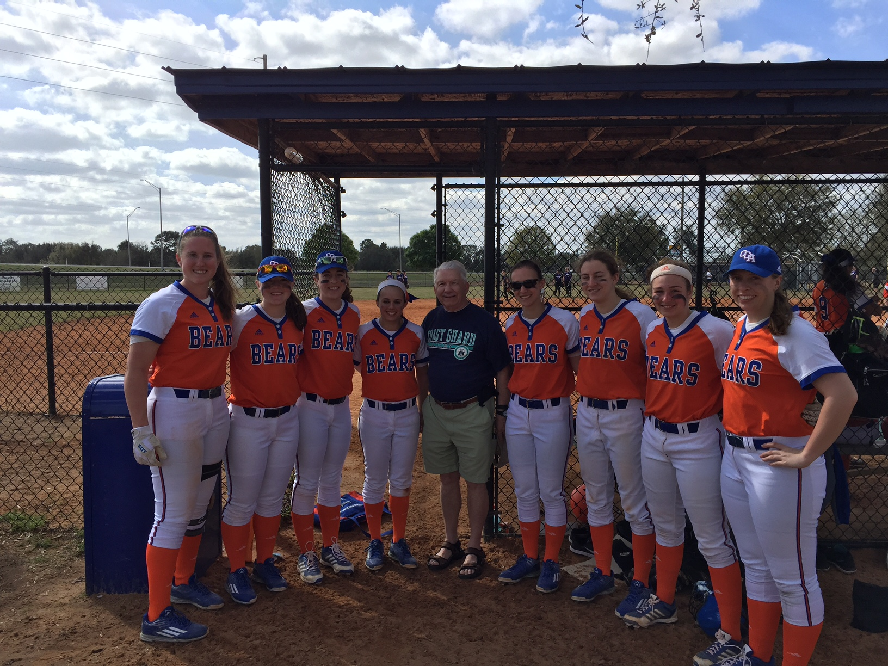
1969: Chris Kreiler and the Class of 2019 members of the Women's Softball Team at spring training

Jerry and Kris Hale were in Brazil for a wedding in May. Jerry officiated at the ceremony and Kris made the bride’s dress.



1969: Jerry & Kris Hale in Brazil

Bob and Carmel Belote were in Ireland in September to celebrate their 43rd wedding anniversary in Kenmare and to visit Carmel’s mom in Listowel. They were there for the Listowel Races, which is a seven day annual event dating back to the nineteenth century, consisting of games, horse racing, and a pre-arranged faction fight which concludes the gathering. They attended the festival and racing on Lady’s Day, where high fashion and fancy hats and attire are the uniform of the day. The Listowel Races tie with the Galway Races as the longest racing festival in Ireland, both running for seven days, and is second in attendance only to that great event.

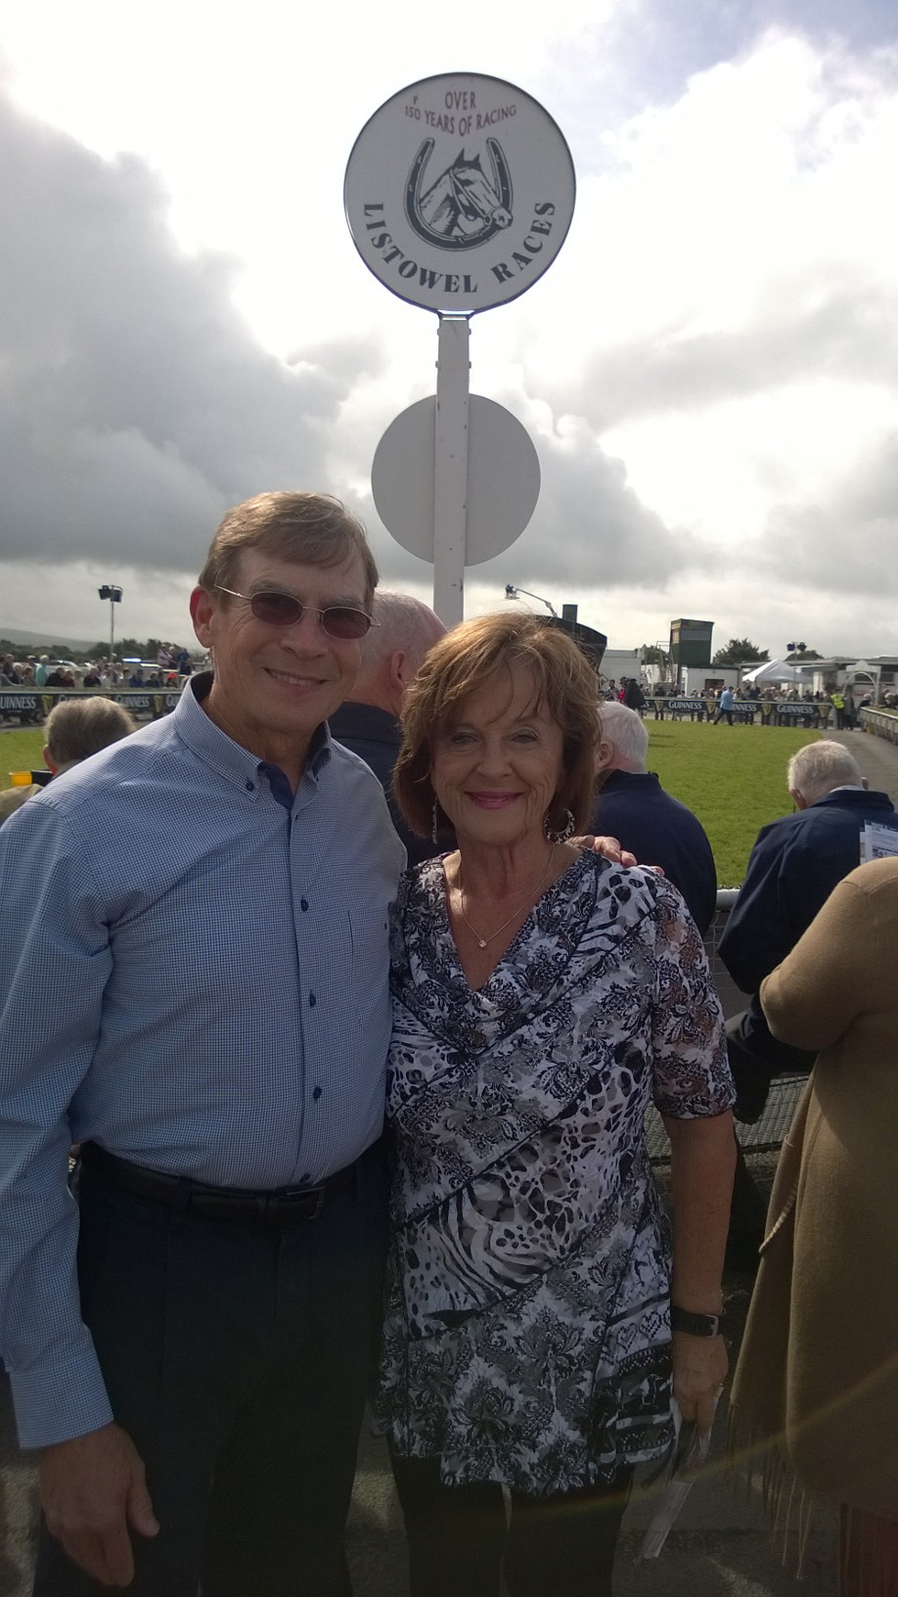

1969: Bob & Carmel Belote at the Listowel Races in Ireland

Bob and Carmel’s time in Ireland overlapped a tour of Scotland and Ireland that Kathy and I were escorting. We missed by three days being with them in Kenmare, where they celebrated their anniversary three days before our arrival. On the way from Kenmare to Doolin, we passed through Listowel, missing Bob and Carmel by two hours while they were in Tralee for the afternoon. The photo of them at the River Front Monument in Listowel in this Bulletin’s Where have you been with your Bulletin was taken the day following the photo of our tour group posed before the Monument. Carmel’s mom’s home in Listowel is 200 yards away from the Monument!

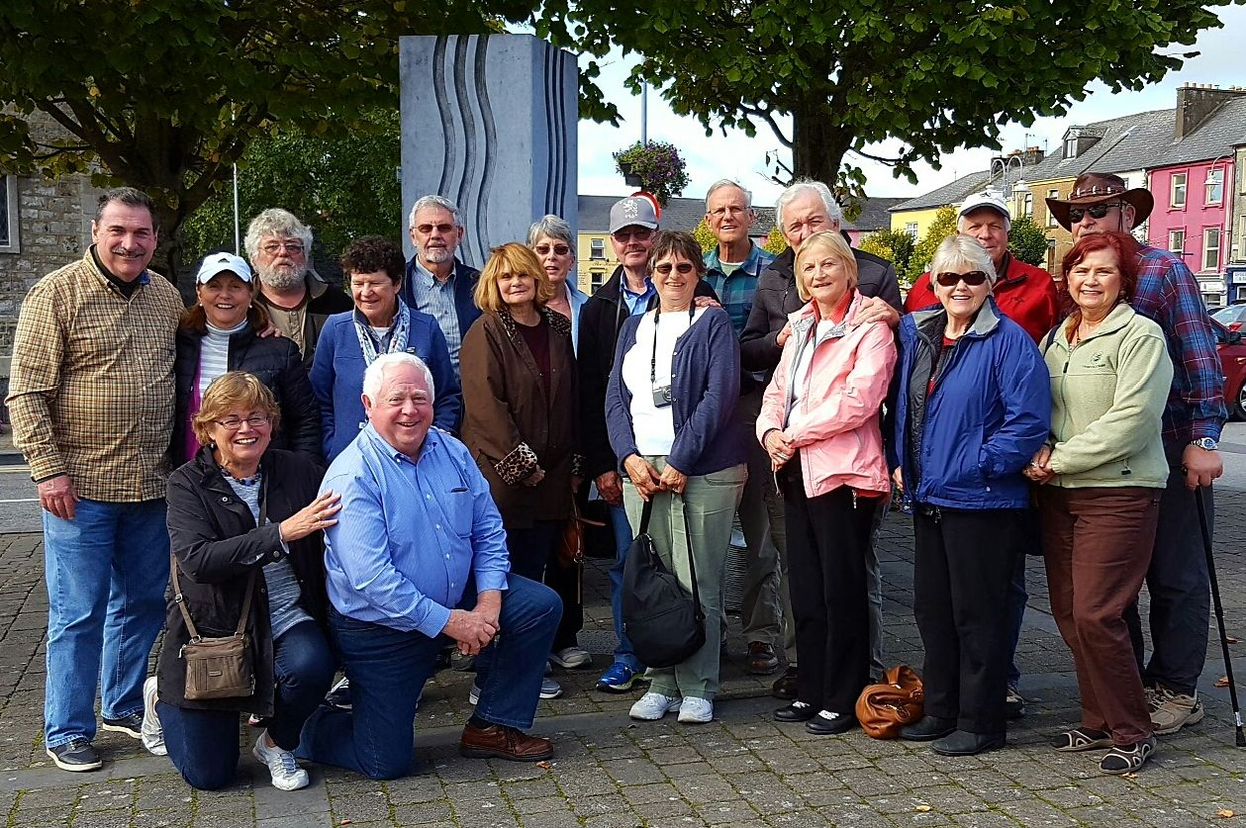
1969: Bob & Kathy Gravino and the Scotland/Ireland Tour Group at the River Front Monument in Listowel

Jerry Hale and Jim Hull recently sent updates on Jack Bergman, who played football and left our class sometime during or after Swab Year. Tim Josiah and Tom Hamblin also ran into Jack over the years at military gatherings and airports. Jack won the Republican primary in Michigan’s 1st Congressional District in August, and will face Democratic and Libertarian nominees in the November 2016 election. The following is a list of his accomplishments, taken from Wikipedia.
John W. "Jack" Bergman is a retired United States Marine Corps Lieutenant General who served as commanding general of Marine Forces Reserve. He was a naval aviator, flying rotary-winged as well as fixed-wing aircraft. Jack received his undergraduate degree from Gustavus Adolphus College in 1969 and earned an MBA from the University of West Florida. His formal military education includes Naval Aviation Flight Training, Amphibious Warfare, Command & Staff, Naval War College Strategy & Policy, Syracuse University National Security Seminar, Combined Forces Air Component Command, and CAPSTONE. He was commissioned a second lieutenant in the Marine Corps Reserve in 1969 under the Platoon Leader School program after his college graduation. He flew CH-46 helicopters with HMM-261 at Marine Corps Air Station, New River, North Carolina and with HHM-164 in Okinawa, Japan and the Republic of Vietnam. Assigned as a flight instructor, he flew the T-28 with VT-6, NAS Whiting Field, Florida. Leaving active duty in 1975, he flew UH-1 helicopters with the Rhode Island National Guard, Quonset Point, Rhode Island. Following a 1978 civilian employment transfer to Chicago, he served in several 4th Marine Aircraft Wing units at NAS Glenview, Illinois, flying the UH-1 in HML-776 and the KC-130 in VMGR-234. Jack stood up the second KC-130 squadron in 4th MAW and in 1988 became the first Commanding Officer of VMGR-452, Stewart ANGB, Newburgh, New York. In 1997 he transferred to 4th Marine Aircraft Wing Headquarters, New Orleans, to serve as Assistant Chief of Staff. Promoted to Brigadier General, Jack became Deputy Commander, 4th Marine Aircraft Wing. Transferred in June 1998 to Headquarters, Marine Forces Europe, Stuttgart, Germany, he served as Deputy Commander. Recalled to active duty from April to July 1999, he was Deputy J-3A, EUCOM, and then commanded II Marine Expeditionary Force Augmentation Command, Camp Lejeune, until assuming command of 4th Marine Aircraft Wing, New Orleans in August 2000. Jack served as Chairman of the Secretary of the Navy’s Marine Corps Reserve Policy Board from 2001 to 2003. Returning to active duty in October 2003, he served as Director, Reserve Affairs, Quantico. Jack began his final assignment, command of Marine Forces Reserve in June 2005, and relinquished that command in October 2009 and retired from active duty in December.
Ron DeMello has been living in Miami for over 20 years, and before moving to Florida spent eleven years in York and Portland, Maine. He still has relatives in his hometown of Waltham, Massachusetts, and visits the Boston area periodically, but has no intentions of leaving Miami. Ron retired two years ago after 34 years on tugboats, operating in or out of New York Harbor, plus nine years on active duty with the Coast Guard. Wife Sara worked as a sales manager for Hyatt Hotels in Washington, D.C., Miami, and Coral Gables.
The Class sends their condolences to Tommy Clarke ’71 and Paul Ljunggren ’71, on the death of Susi Clarke, Tommy’s wife and Paul’s sister, on July 13, 2016. Our thoughts and prayers are with them and their families.

