October 2017

CAPT Bob Gravino
2 Summer Street
Ipswich, MA 01938
(978) 356-0825 (H)
E-mail: rcgravino@aol.com
Website: http://www.uscga69.org

We begin this Class Notes column with historical notes and photos, starting with a picture sent by Bill Bissell of Connecticut classmates taken on July 16, 1965. Most classmates are recognizable, with Chuck Talar having the honor of shaking the hand of Captain Austin C. (Red) Wagner (CGA ’42), Commandant of Cadets. Included in the photo are (left to right) Rube Olsen (New London), Rich Vlaun (Groton), Mike Miller (Hamden), Rich Losea (Old Lyme), Don Parsons (West Suffield), Al Vlach (Old Saybrook), Bill Bissell (East Haven), Chuck Talar (Greenwich), Chuck Lowery (Coventry), Jim Pennington (Groton), Tom Zieziulewicz (New Britain), John McGrath (Newington), Bob Gravino (Guilford), Paul Garrity ( Kensington), and Greg Labas (Kensington). Hidden from view (or AWOL during the photo op) are Bob Callahan (Stamford), Alden Cole (Storrs), Bob Coviello (Danbury), Dave Dubois (Wolcott), Mark Forauer (Bloomfield), Bob Glynn (Hartford), Jim Gynther (Pawcatuck), Al Hindle (Taftville), Jack McGowan (Stamford), Ted Neilson (Milford), Jim Richardson (New Milford), Louis Sehoen (Danbury), Frank Snyder (Milford), and Ed Walsh (Watertown). Stu White sent a map of the Academy from his father's 1943-1944 Running Light when his father attended Coast Guard Officer Candidate School at the Academy. In the blow-up, you can see that the layout of the Academy was much the same as when we reported to New London in July 1965.

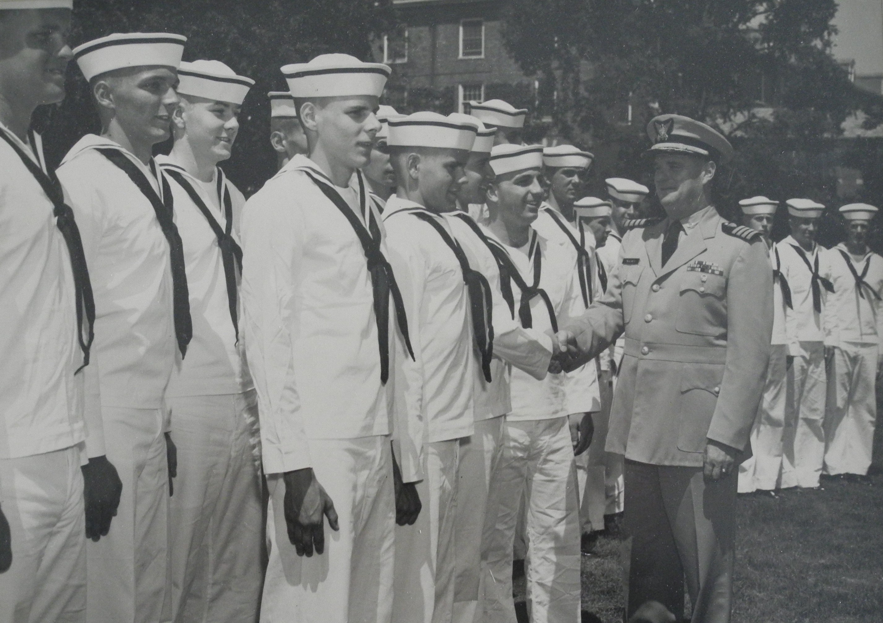

69: Connecticut Classmates, July 16, 1965

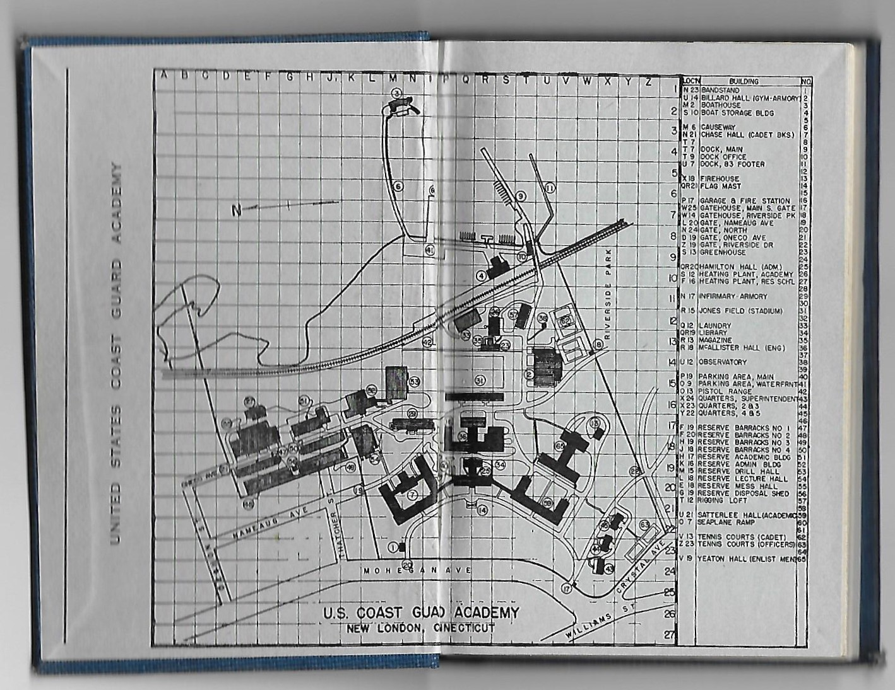

69: 1943 - 1944 Running Light

In January Mike and Judy Billingsley set foot on their 6th continent, Antarctica. They sailed on the Hurtigrutin ship MS Midnatsol from Punta Arenas on January 6, circumnavigated Cape Horn on their way south, and crossed Drake’s Passage in beautiful conditions. “We landed on a number of the South Shetland Islands, meeting penguins of more varieties than I ever imagined. We set foot on the Antarctic Peninsula before the summer weather turned and headed north and the Falkland Islands. We experienced hurricane conditions in the Drake Passage northbound. Still the ride was better than I remember in Hurricane Camille back in ’69 on the CGC Diligence! Antarctica was unexpectedly beautiful and life was abundant. Our shipboard lectures helped us to understand just how fragile the ecosystem of the Antarctic really is, and how important it is to all of us.” Postings on Face Book have Mike and Judy traveling in Africa in August, their 7th continent.

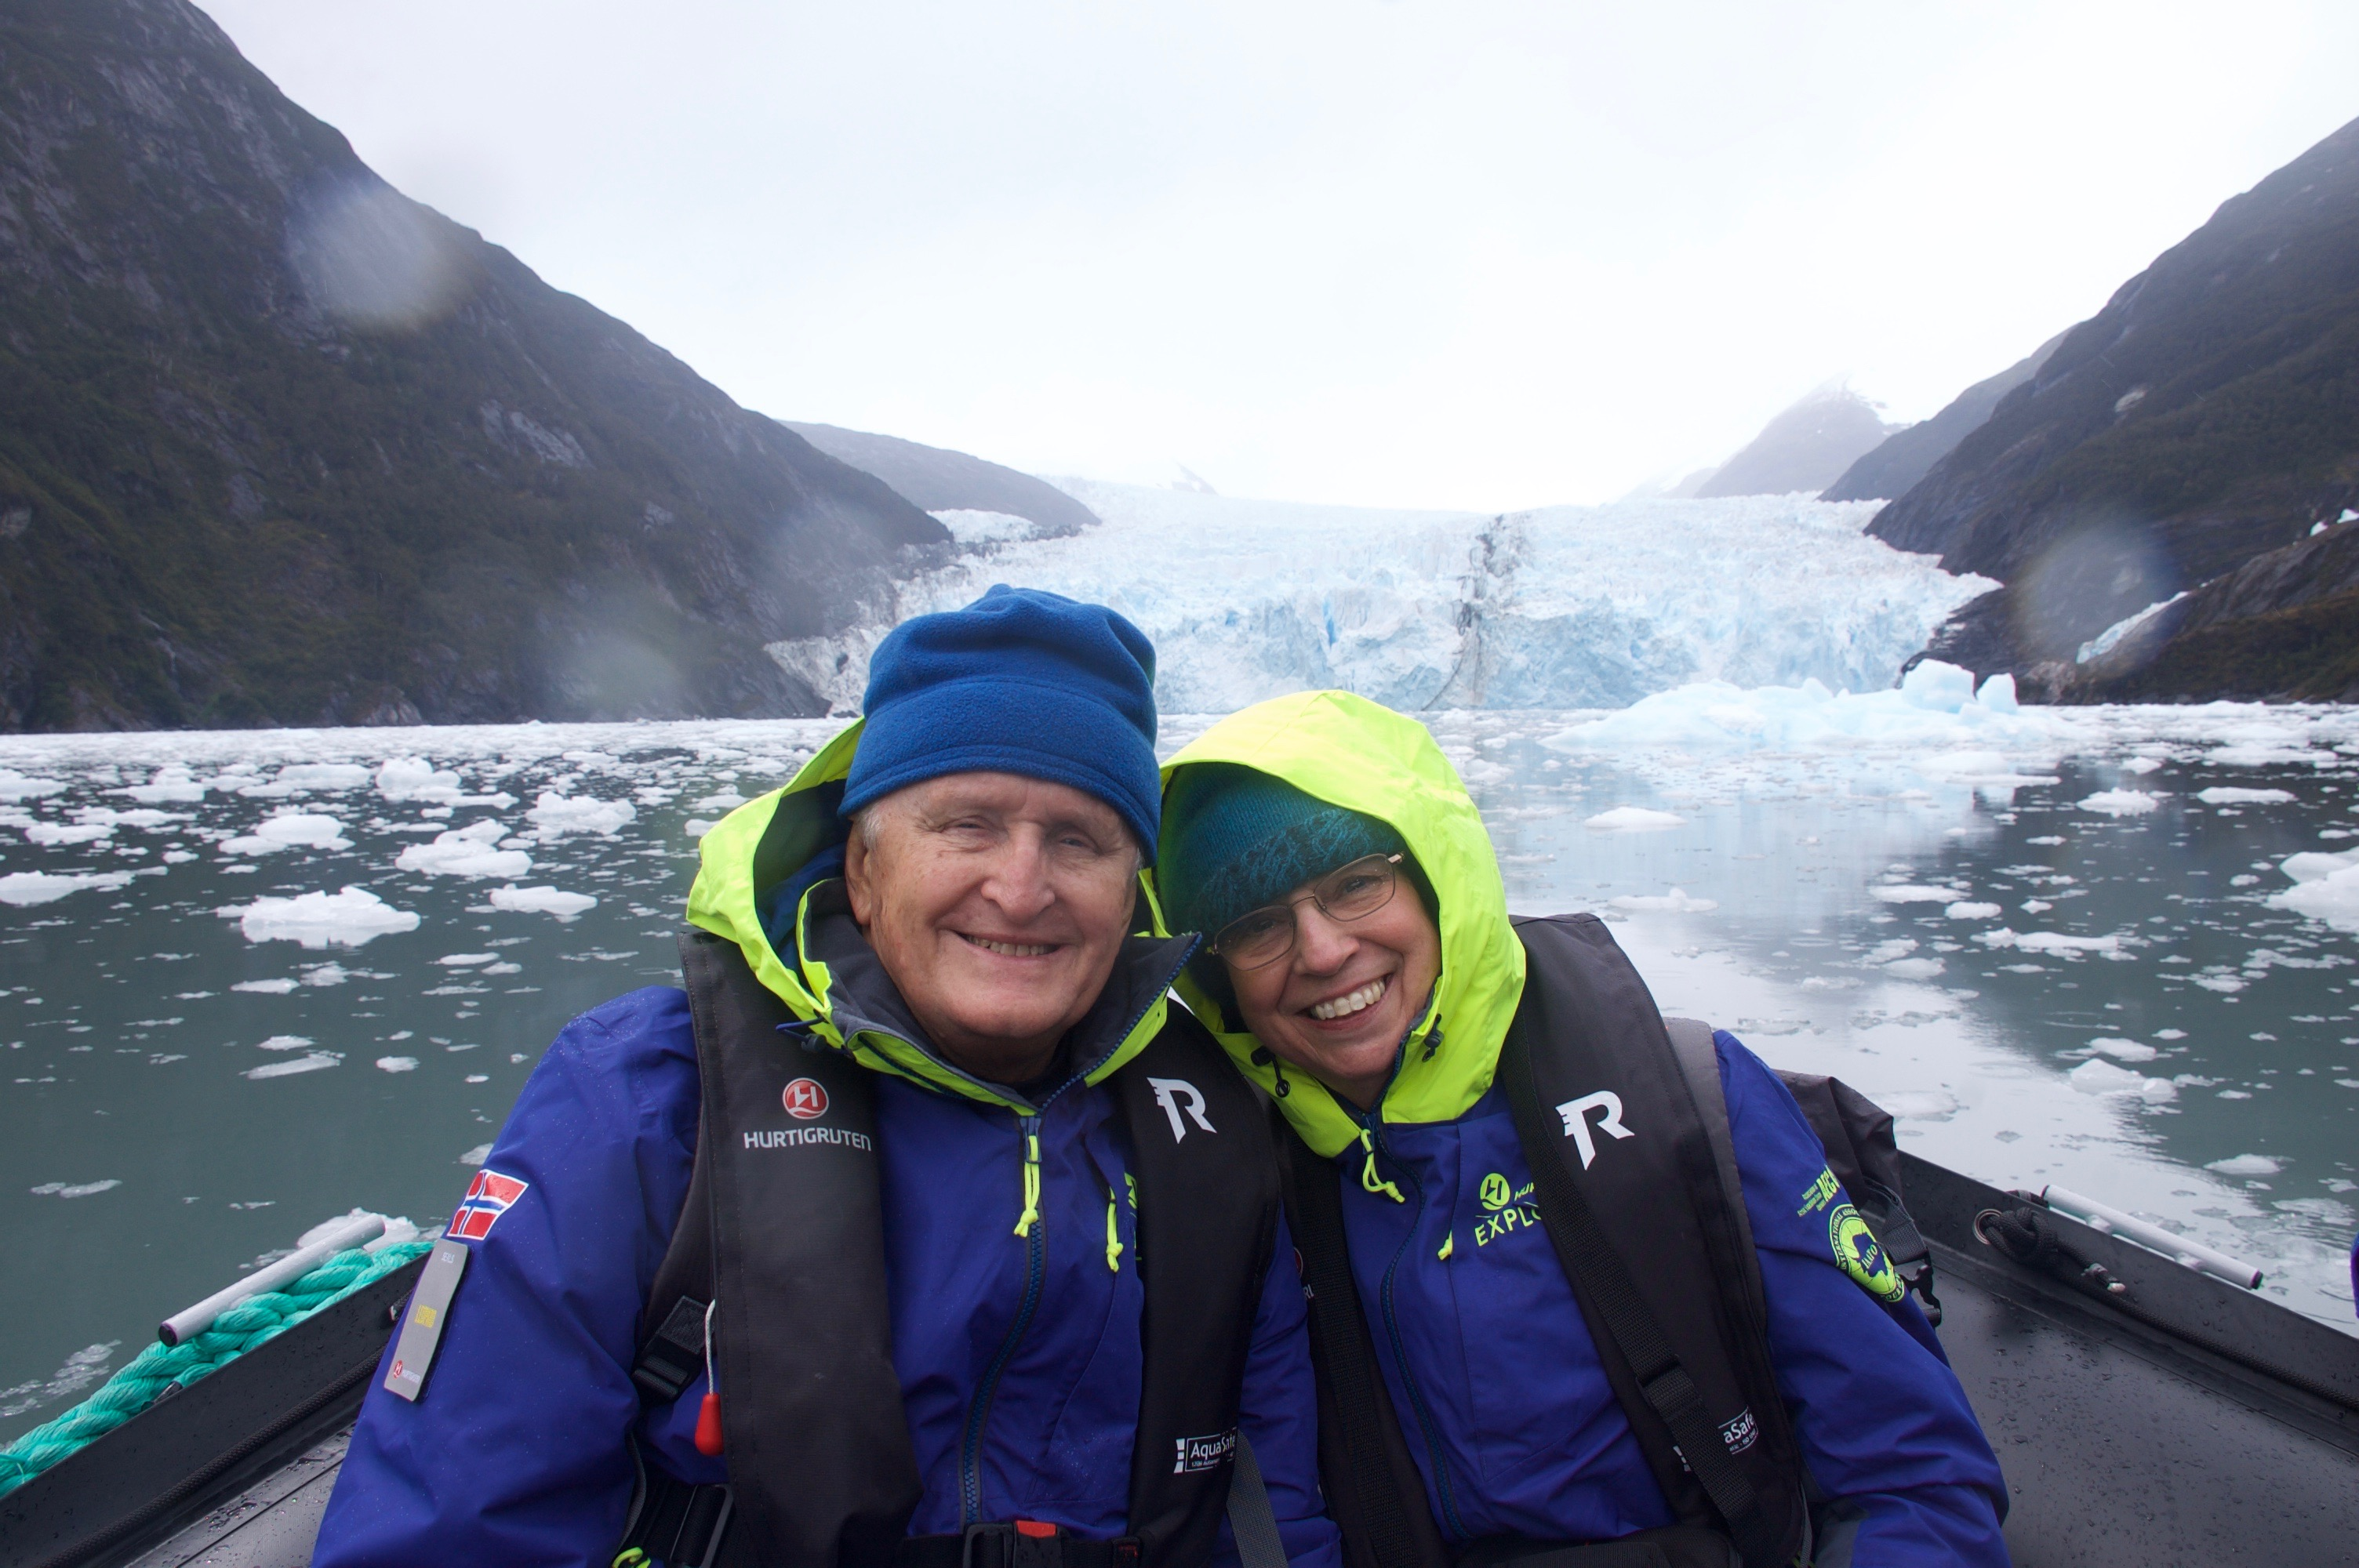

69: Mike & Judy Billingsley in the Garibaldi Fjord, Patagonia, Chile.

Bruce Griffiths sent a photo with Dave and Janet Anderson taken at a Green Bay Packers exhibition game, or so I thought. Bruce provided the rest of the story when asked for details. “Not an exhibition game, but the only shareholder meeting in all major league U.S. professional sports (baseball, basketball, hockey and football) that includes the fans. As a Green Bay Packers Owner (four shares – I have three sons) I get four tickets to the annual shareholders’ meeting held on the hallowed ground of Lambeau Field, and invited Dave and Janet to join Gail and me. Usually about 15,000 (of the several 100,000) shareholders show up to hear about the company (including a financial statement) and the team. It’s a unique moment in American sports and I was happy to share it with Dave and Janet.”

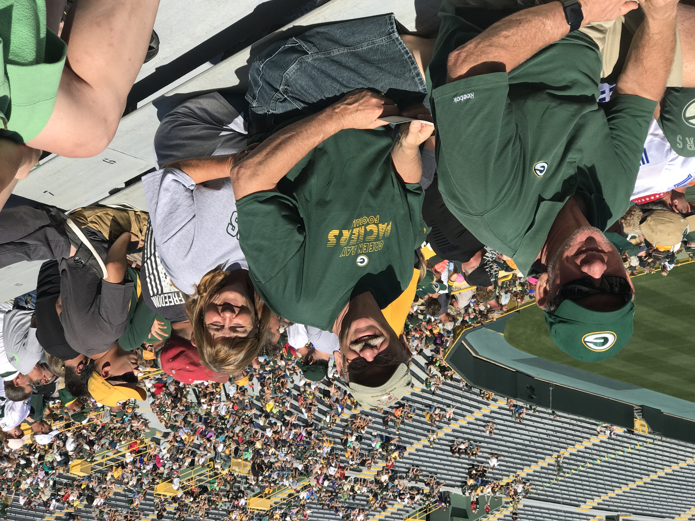

69: Bruce Griffiths with Dave & Janet Anderson at Lambeau Field, Green Bay

Bettymarie and Barry Kane took a two week cruise to Scotland and Norway, followed by three days in Iceland. “Since I could have gotten orders to the Shetlands or Keflavik as part of the LORAN program, I was glad to visit those two places. Funny coincidence - on the first day of the cruise, we ran into Paul and Jane Pluta on the ship. They only live 30 miles from us in North Carolina, and we meet in Europe.”

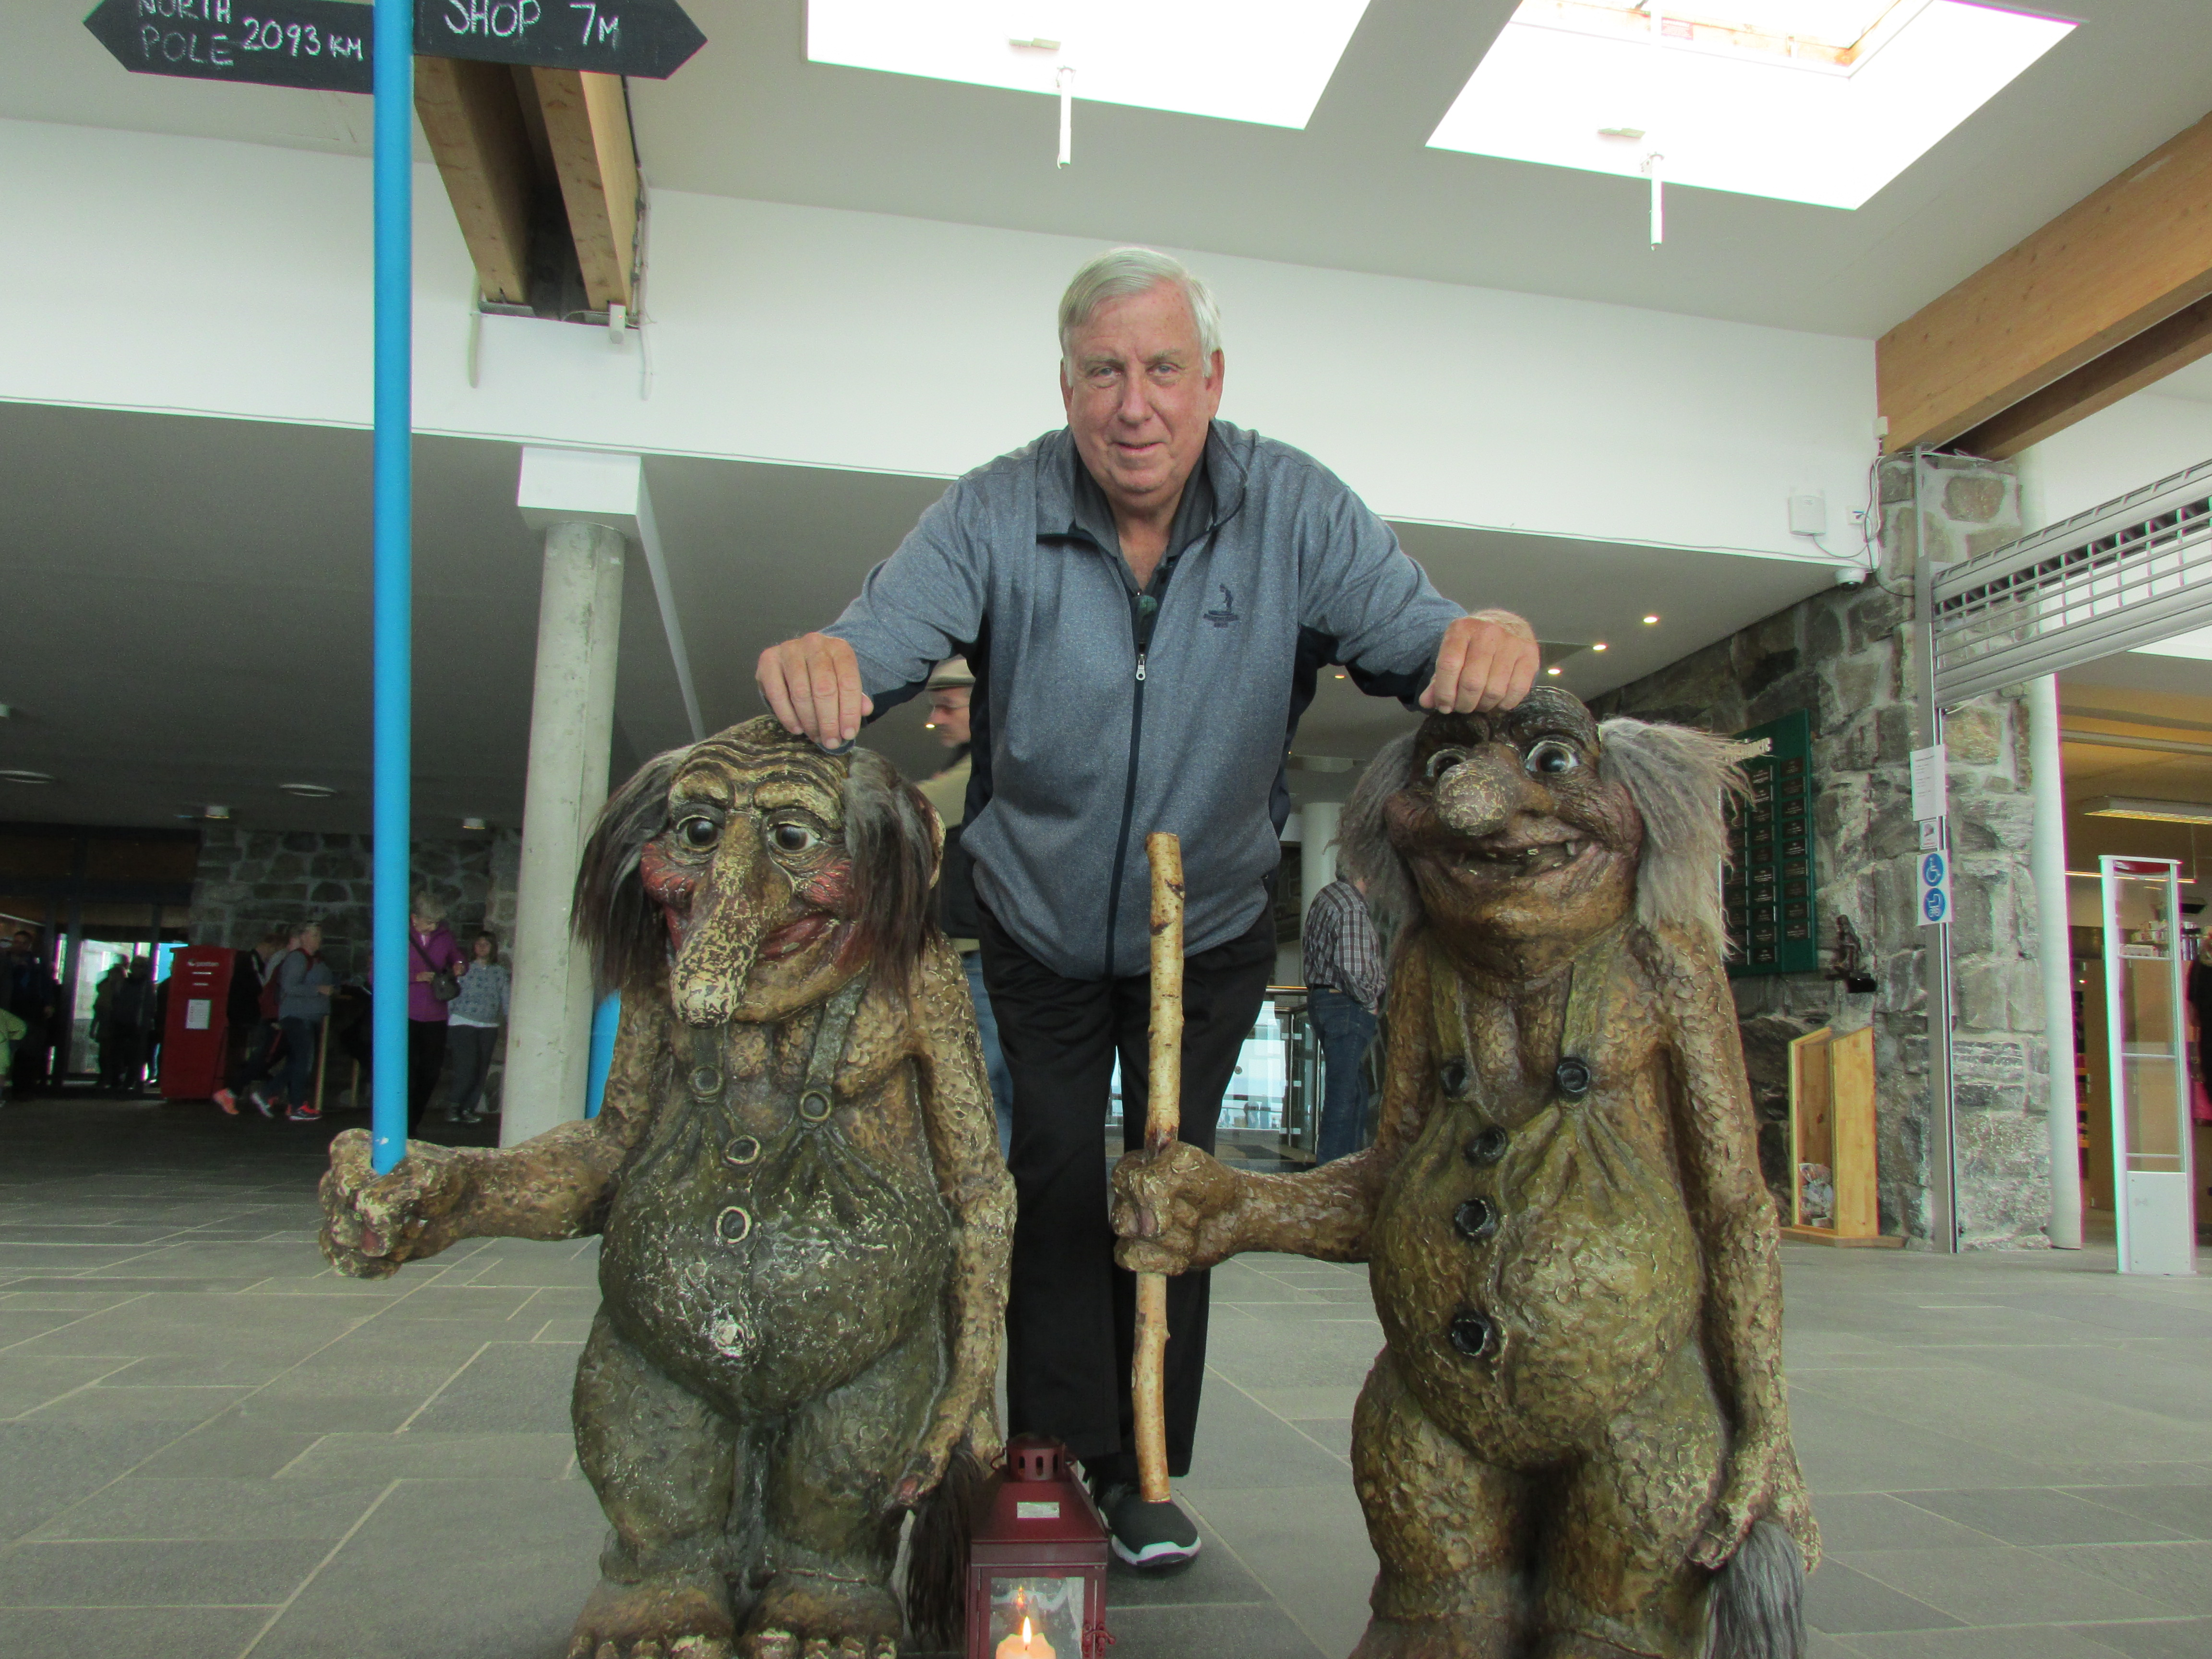

69: Barry Kane and the Trolls in Norway

Tim Cenna had an idea to start a section called Dumb Ensign Stories where we can have a laugh on ourselves. Tim points out that we all did something dumb as an ensign on our first assignment out of the Academy. His example: “The Commanding Officer of Firebush told me I was taking the ship out the day after I reported aboard. With all the training we had for that (cough, cough), I pulled my Knight's Seamanship out and memorized the sequence of commands. Next morning I confidently shouted out ‘take in number five’. Would you believe the Firebush may have been the only ship in the Coast Guard that didn't use a five line? The Chief Bos'n had some good fun with the Young Ensign after that.”

Jack Bergman was elected in the November 2016 Federal Elections as the US Representative to Michigan’s First Congressional District, which includes the Lower Peninsula cities of Traverse City and Marquette, and he is chairman of the House Veterans’ Affairs Subcommittee on Oversight and Investigations. Readers may have seen Jack on national news after the shooting at the Republican practice on Wednesday, June 14th for the 56th Congressional Baseball Game for Charity. Jack was on the field but fortunately was not injured in this tragedy.

Rod and Cindy Schultz traveled from Oahu, Hawaii, to Ohio in late July and joined Jim and Judy Hull at the annual Hull Family Reunion. In mid-August, Rod and Cindy visited Mike and Rosalee Mierzwa in Galveston on their way to an IOOF convention in St. Louis. Mike retired at the beginning of the year from his position as Port Director for Galveston. This column is being written on September 2nd (the Pokress’ and Gravino’s leave in three days for a two week trip to the UK, and Class Notes submission is September 17th), and phone calls to Mike in Galveston went to voice mail, so the impact of Hurricane Harvey on Mike and Rosalee is unknown. I spoke with Rich Ford in Houston, and although they received over 50 inches of rain, Rich and Annette had no flooding or damage. A phone call to Rick Barlow, who has a home address of Livingston in the Alumni Directory, found him in the Boston area, traveling the East Coast in a fifth wheeler. Rick and Helen left the Houston area a few years ago and have been seeing the North American Continent since leaving Texas.

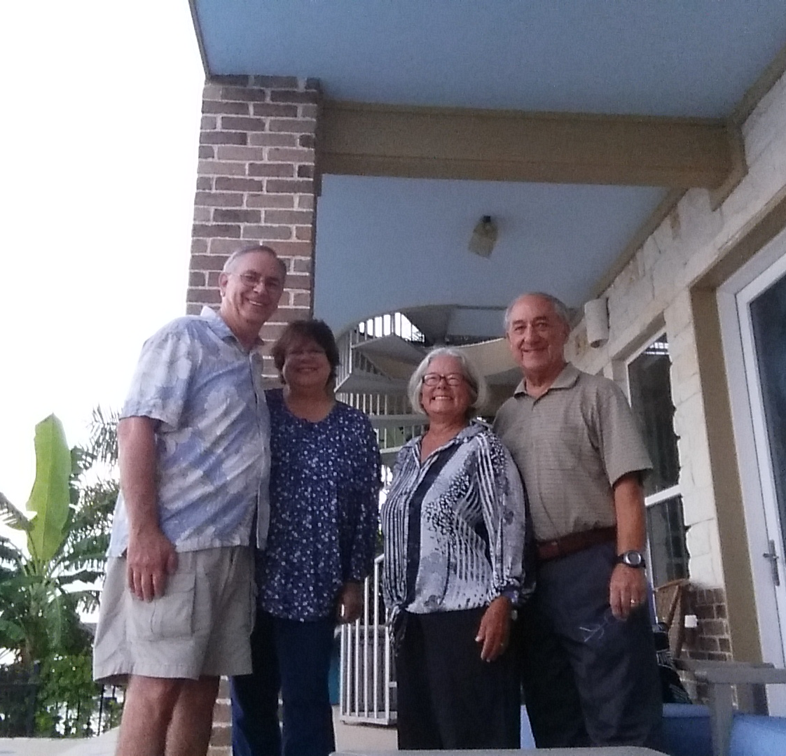

69: Rod & Cindy Schultz and Mike & Rosalee Mierzwa in Galveston

