October 2019
’69 CLASS CORRESPONDENT

CAPT Bob Gravino
2 Summer Street
Ipswich, MA 01938
(978) 356-0825 (H)
E-mail: rcgravino@aol.com
Website: http://www.uscga69.org

In Memoriam
Norma Kay Donnee
August 16, 2019

Bob Donnee’s wife, Norma Kay, passed away unexpectedly on August 16th in Mobile, Alabama. Bob and Norma Kay were married for 41 years and had two daughters and two grandchildren. Pete and Susan Lenes attended Norma Kay’s funeral on August 21st in Mobile. Pete commented: “Bob was very thankful and surprised to see us. It was a very nice and well attended service. Norma Kay was well loved by family and friends. Bob still plans to attend the 50th and said he would see the rest of us there.” The Class sends our condolences to Bob; more details to follow in the next Class Notes.
Jerry and Kris Hale celebrated their 50th wedding anniversary in mid-July at the Inn at Black Starr Farms in Suttons Bay, Michigan, on the Leelanau Peninsula north of Traverse City, with their four children and many grandchildren. Jerry’s high school class advisor, who suggested he apply to the Coast Guard Academy, was one of many friends and family members in attendance. The accompanying photo was taken at the event and includes Kris and Jerry’s children; Ben, Laura, Kendra and Nat.

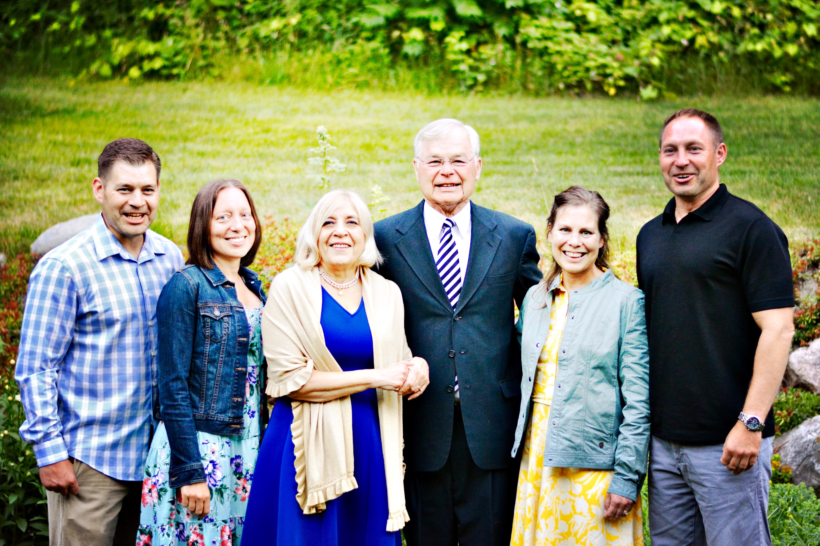

1969: Jerry & Kris Hale with children at 50th Wedding Anniversary Celebration

Kathy and I celebrated our 50th in mid-July in Ireland with our daughter Kelly and husband Scott; son Tim and wife Tara; and grandsons Liam, Finn, Dominic and Joseph, visiting Dublin, Galway, the southwest coast, and points in between. Family attractions included Kathy’s ancestral homestead near Athlone and the University of Galway, where Kelly spent her junior year on a study abroad program. The photo includes our Irish bus driver, who kept us safe driving on the wrong side of the road.

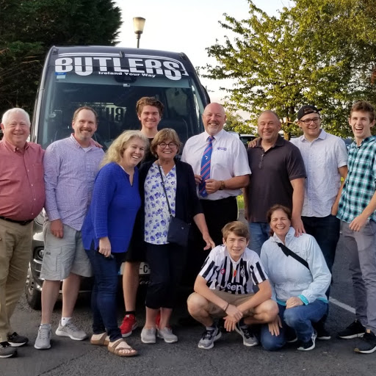

1969: Bob & Kathy Gravino & Family on 50th Wedding Anniversary Celebration in Ireland

Bob and Barbara Thorne were hosted at a special dinner in New London in honor of their 50th in June by family and friends, including their son and his family from Prague, Czech Republic. The Class owes Bob and Barbara a special thanks for all that they have put into planning our 50th Reunion, as well as the previous reunions that they’ve organized. Significant planning has gone into preparations for the 50th Reunion. Bob has been ably assisted by Paul Bodenhofer on reunion events, Wayne Gronlund and Mike Sprague on the Golden Tide Rips, Jeff Robbins as transportation coordinator, Bruce and Gail Griffiths and Jane Snyder on the Memorial Service and Bob Pokress handling Swag. We thank you, ladies and gentlemen!

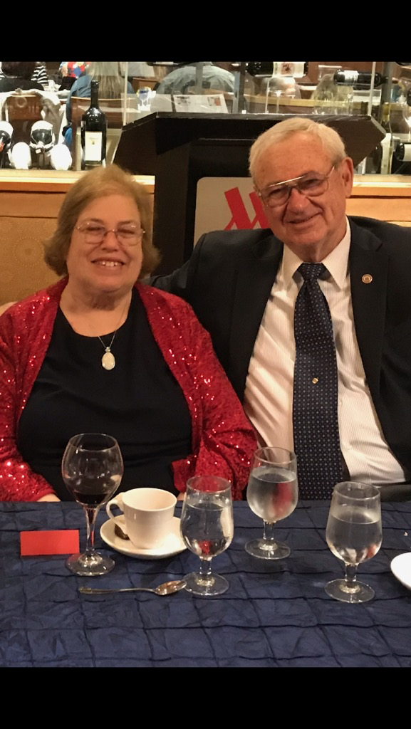

1969: Bob & Barbara Thorne celebrating 50th Wedding Anniversary

The photo of Pete Aalberg standing in front of a VW Bug in Maine was posted on Face Book, and an appropriate comment could have read ‘Giant Maine lobster attacks Pete Aalberg's VW Bug!’ Pete was asked for an explanation, and his reply: “This VW parks wherever it wants”.

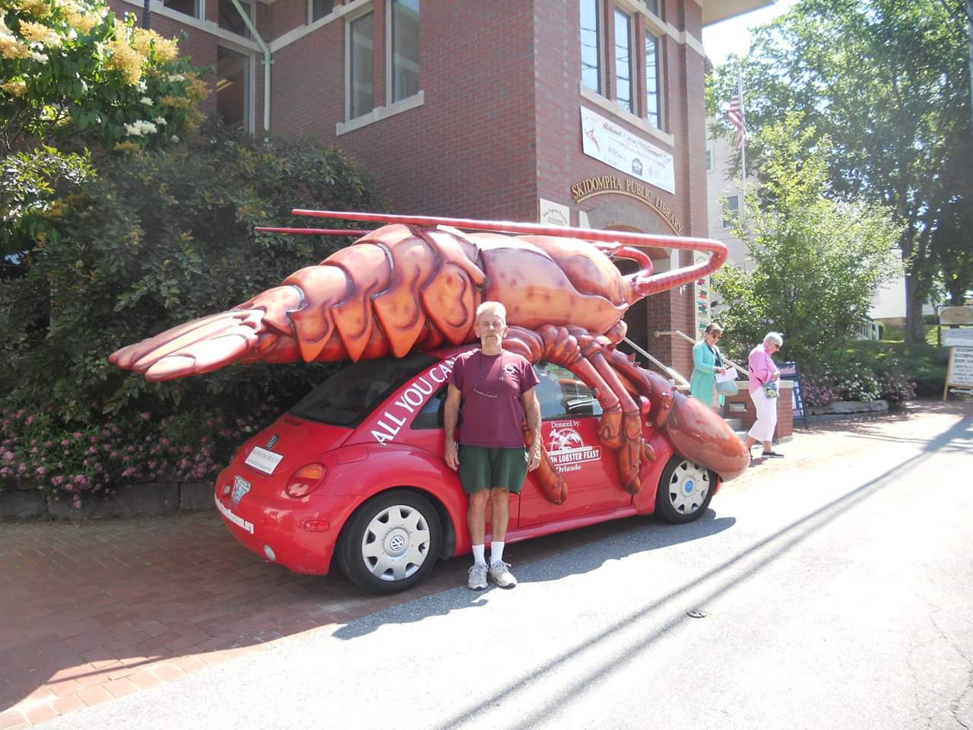

1969: Pete Aalberg and the Monster Maine Lobster VW Bug

The photo of Bruce and Gail Griffiths was taken before the storm of the century hit the Grindle Lake area on July 19th. The tornado that passed through Oconto County, Wisconsin, brought down 30 big trees on their property and severely damaged their cottage, mobile home and dock. Everyone at Bruce’s cottage came through unscathed, but there was a fatality nearby. Bruce’s comment: “We’re thankful for USAA!”

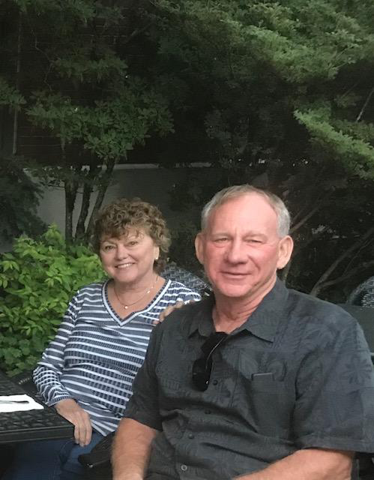

1969: Bruce & Gail Griffiths before the Wisconsin Tornado

The August Alumni Bulletin column shared Butch Hartney’s thoughts on his experience on CGC Eagle during the cadet cruise from Copenhagen to Antwerp in May. Bill Bissell and Bob Pokress won the lottery to sail on the Eagle for a cruise off the New England coast in August, and they agreed to share their thoughts on the professional training that cadets receive today.
Bill Bissell’s comments: “The professional training that cadets receive today is significantly better, and how they are taught is greatly improved over what we experienced. There have been major changes, and 90% of them are for the better. The Eagle cruise has radically changed. There is a full-time officer staff and a large full-time enlisted crew, supplemented by a few Academy instructors. Not as much time is spent on the Eagle, and that is especially true during the abbreviated Swab Summer. That means that 2/c cadets are not as conversant with the intricacies of a sailing ship and all its lines. The enlisted crew are Mast Captains and Yardarm Captains, and the Sailing Master is a full-time Eagle officer assisted by a warrant bosun. 2/c cadets shadow the Mast Captains and Yardarm Captains. The Eagle set less sail during our cruise; a small crew and Swabs who knew almost nothing made this necessary. Tops'ls and lower Stays'ls were set, including the Fore, as were the Courses and the Lower Spanker. Like other Tall Ships, and the original Horst Wessel, Eagle now has a split Mizzen Spanker. Eagle never set the T'gallant, Royal, Jibs or the Upper Stays'ls. Course corrections were made to adjust for wind variations as opposed to bracing around the yards. Again, 2/c cadets were shadowing as JOODs.
Safety is a major concern. The climbing harness is substantial and requires that climbing evolutions be done in a very precise manner. The use of the harness dramatically lengthens sail evolutions. For those of us who raced up to the Royal yardarm, slid down backstays and descended from the Upper Tops'l yard to the Lower Tops'l yard without Laying In and Laying Out, this is a major change. No one on the Eagle, other than Bob and I, had ever heard of those activities, let alone witnessed them. Each major evolution is preceded by a meeting of all departments. I believe this is a CG-wide procedure that was being demonstrated in its real word application aboard Eagle. The evolution was explained by the lead department. Every other department was asked for input and required to give a risk analysis of high, medium or low. The Captain at times would ask questions of the 2/c cadet shadowing the department head. The Captain made the final decision. An identical meeting was held post evolution to critique what had happened, and the Captain would again question the 2/c cadets. There are two motor surfboats and no pulling boats, and there were no boat drills. Coast Guard ship training is front and center, and I believe it is a reason for minimizing sail evolutions. Twice each day there is a training period. Three stations are set up and the cadets rotate through those positions. The Focs'l has knots, heaving line, and abandon ship gear training conducted by the enlisted crew. The Fantail has damage control training using fire hoses and wearing OBAs, conducted by the enlisted crew. Finally, there is training in the engineering spaces, again conducted by the enlisted crew.
The Academy has returned to teaching Celestial Navigation! Piloting training is part of the on-watch duties. A chart table is set up between the helm and the tiny Bridge. 2/c and Swabs do piloting on a paper chart throughout a watch. Their fix within a circle is checked every 30 minutes by a GPS fix within a triangle. The 2/c cadets did a good job of getting the Swabs to use compasses, dividers and parallel rules. This procedure was put on steroids when entering or leaving a harbor; the number of cadets involved tripled. Celestial navigation included daily noon latitude sites, and there were star and planet classes using laser penlights that were very effective for the Swabs. The 2/c cadets took celestial fixes. Every night before entering or leaving port, there was an all cadets meeting on the mess deck. The 2/c cadet shadowing the Operations Officer would give a briefing using GPS charts on the Mess Deck screen. It was very well done, and the Captain always had some thought provoking questions.
In conversations with cadets, I learned that the current Swab Summer starts a few days later and ends much earlier than in 1965. This is due to the earlier start of the academic year. I believe the 1965 summer lasted about 60+ days. The 2019 summer lasts about 36 days. Things we spent days on get covered in a day or less. We sailed dinghies every day for a week, and the Class of 2023 had 2 days. There haven't been pulling boats for decades. They had 1-2 days in the Academy harbor tugs. Swabs become 4/c Cadets at the end of the summer. They have a 24 hour hell day that is designed to teach teamwork on the last day of the summer. The duties that we performed during our Swab academic year no longer exist. I specifically asked the 2/c about the 21:45 - 22:00 Indoctrination break, and they had no idea what I was talking about. I did not ask about cleaning duties outside 4/c rooms!
Overall, the 2/c cadets did the best they could in getting the Swabs ready for the Eagle cruise, given their restricted time schedule. The enlisted crew is specially selected for the Eagle and clearly had some instruction on being trainers. The Swabs did better as time progressed, but there were many things that they were doing for the very first time. Eagle has made the right decision to minimize Internet access so that everyone has their ‘head in the boat”. Captain Michael Tudor (CGA ’97) was exceptional.”
Bob Pokress’ comments: “The Commanding Officer of the Eagle assumed command the week before Bill and I reported aboard. He was personally involved with the professional training of the cadets. He challenged everyone to assess what they had done during shipboard evolutions, asked questions at the conclusion of evolutions, and explained what to do under varying circumstances and conditions. The 2/c cadets’ shipboard responsibilities and seamanship knowledge was greater than ours when we were on the Eagle as 2/c. For example, the 2/c gave the morning Navigation Briefing to everyone on board, and they responded to a commanding officer who asked tough but professional questions. The 2/c were heavily involved in the professional training of the new Swabs, such as navigation to the 4/c during quarterdeck watches. The 2/c had written instructional responsibilities to teach 4/c seagoing and navigational basics while they stood underway watches.
From my observations, the ‘when I was a cadet’ blather often heard from alumni needs to be permanently discarded when describing the professional training of today’s cadets. Given the ship handling skills observed, these 2/c far surpass us when we were at the midpoint of our four years at the Academy. I suspect that today’s graduates are better ship drivers on their graduation day than our generation was on ours.”

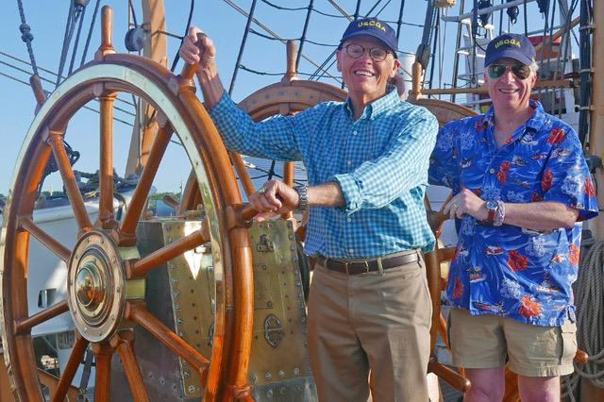

1969: Bill Bissell & Bob Pokress at the Helm during Summer of 2019 Eagle Cruise

